**Assignment-6**

**Using Special Operators in Conditions**

Q1. Write two different queries that would produce all orders taken on October 3rd or 4th, 1990.

Ans.

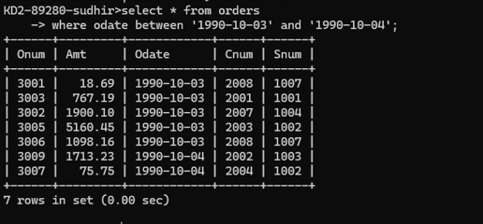

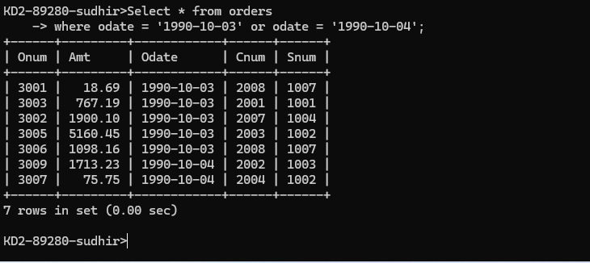

Q2. Write a query that selects all of the customers serviced by Peel or Motika. (Hint: the snum field relates the two tables to one another).

Ans.

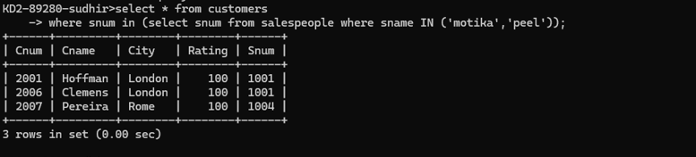

Q3. Write a query that will produce all the customers whose names begin with a letter from ‘A’ to ‘G’.

Ans.

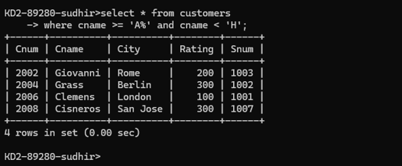

Q4. Write a query that selects all customers whose names begin with the letter ‘C’.

Ans.

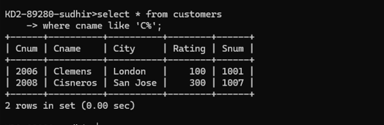

Q5. Write a query that selects all orders except those with zeroes or NULLs in the amt field.

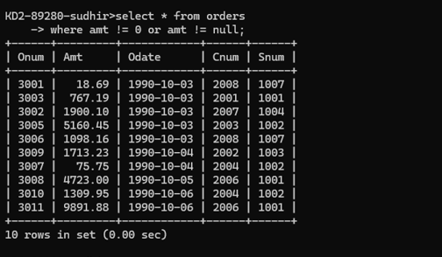Ans.