**Assignment –7**

**Summarizing Data with Aggregate Functions.**

Q.1) Write a query that counts all orders for October 3?

Ans. 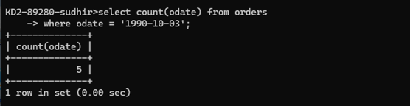

Q.2) Write a query that counts the number of different non-NULL city values in the Customers table?

Ans. 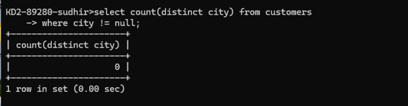

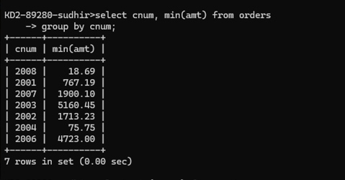Q.3) Write a query that selects each customer’s smallest order?

Ans.

Q.4) Write a query that selects the first customer, in alphabetical order, whose name begins with G?

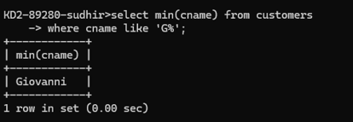Ans.

Q.5) Write a query that selects the highest rating in each city?

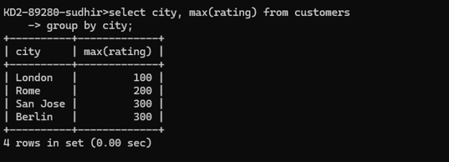Ans.

Q.6) Write a query that counts the number of salespeople registering orders for each day. (If a salesperson has more than one order on a given day, he or she should be counted only once.)?

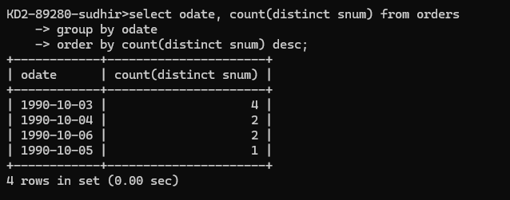Ans.