Assignment-5

Create file named grade.txt and write following contents in it. ( grep , cut )
---------------------
John Smith: A
Mary Johnson: B
Alex Rodriguez: C
Emily Wong: A
David Lee: B
James Johnson: A
Edwin Albert: B
---------------------
And compose commands to perform following operations
Q.1 Count the number of students. ( wc )?
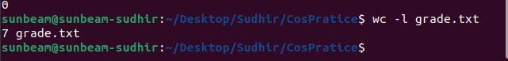

Q.2. List the students having grade A. ( grep ) ?
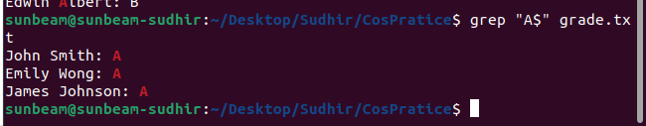
Q. 3. List the students not having grade B. ( grep ) ?
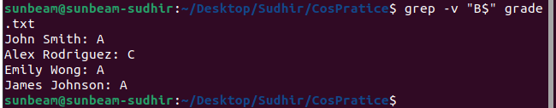

Q. 4. Print the count of students not having grade C. ( grep ) ?
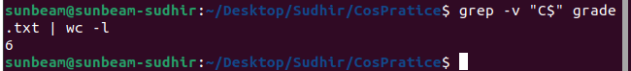
Q. 5. List the student/students whose name starts with E & having grade B. ( grep) ?
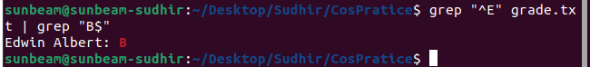

Q. 6. Show only Studetns first name & Last Name. ( cut ) ?
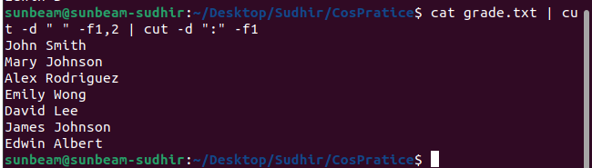

Q. 7. Show only grades. ( cut ) ?
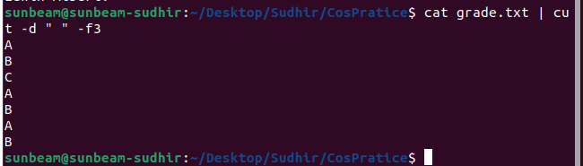

Q. 8. Show only first name & grades. ( cut ) ?

