Assignment 1

Q1. Create the following tables with the given structures and insert sample data as specified:

mysql> create table SALESPEOPLE (

-> Snum INT(4),

-> Sname VARCHAR(10),

-> City VARCHAR(10),

-> Comm FLOAT(3,2)

-> );

mysql> insert into salespeople values (1001,'Peel','London',.12),

-> (1002, 'serres', 'San Jose', .13)

-> (1004, 'Motika', 'London', .11),

-> (1007, 'Rifkin', 'Barcelona', .15),

-> (1003, 'Axelrod', 'New York', .10);

mysql> select \* from SALESPEOPLE;

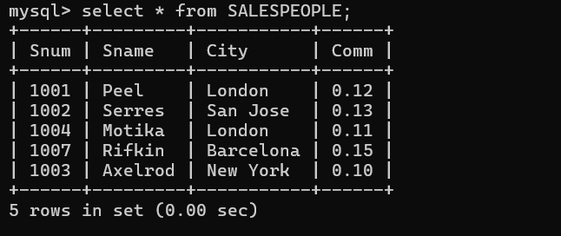

mysql> create table CUSTOMERS (

-> Cnum int(4),

-> Cname varchar(10),

-> City varchar(10),

-> Rating int(4),

-> Snum int(4)

-> );

mysql> insert into CUSTOMERS values (2001, 'Hoffman', 'London', 100, 1001),

-> (2002, 'Giovanni', 'Rome', 200, 1003),

-> (2003, 'Liu', 'San Jose', 200, 1002),

-> (2004, 'Grass', 'Berlin', 300, 1002),

-> (2006, 'Clemens', 'London', 100, 1001),

-> (2008, 'Cisneros', 'San Jose', 300, 1007),

-> (2007, 'Pereira', 'Rome', 100, 1004);

mysql> select \* from CUSTOMERS;

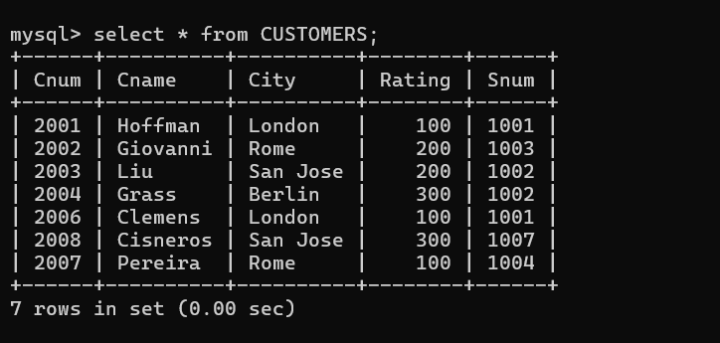

mysql> create table ORDERS (

-> Onum int(4),

-> Amt float(7,2),

-> Odate date,

-> Cnum int(4),

-> Snum int(4)

-> );

insert into ORDERS values (3001, 18.69, '1990-10-03', 2008, 1007),

-> (3003, 767.19, '1990-10-03', 2001, 1001),

-> (3002, 1900.10, '1990-10-03', 2007, 1004),

-> (3002, 1900.10, '1990-10-03', 2007, 1004),

-> (3005, 5160.45, '1990-10-03', 2003, 1002),

-> (3006, 1098.16, '1990-10-03', 2008, 1007),

-> (3009, 1713.23, '1990-10-04', 2002, 1003),

-> (3007, 75.75, '1990-10-04', 2002, 1002),

-> (3008, 4723.00, '1990-10-05', 2002, 2006),

-> (3010, 1309.95, '1990-10-06', 2004, 1002),

-> (3011, 9891.88, '1990-10-06', 2006, 1001);

select \* from ORDERS;

