**Assignment – 11**

**Subqueries**

1. Write a query that uses a subquery to obtain all orders for the customer named Cisneros. Assume you do not know his customer number (cnum).

KD2-89285-Salonee>select onum from orders where cnum=(select cnum from customers where cname='Cisneros');

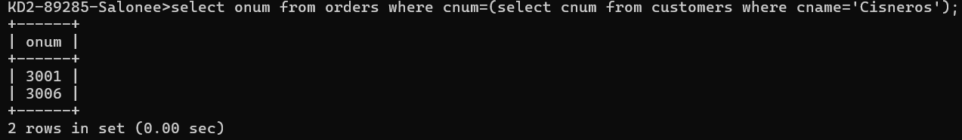

1. Write a query that produces the names and ratings of all customers who have above-average orders.

KD2-89285-Salonee>select cname, rating from customers where cnum IN (select cnum from orders where amt >(select avg(amt) from orders));

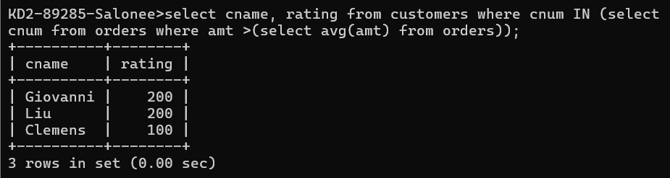

1. Write a query that selects the total amount in orders for each salesperson for whom this total

is greater than the amount of the largest order in the table.

KD2-89285-Salonee>select snum, max(amt), sum(amt) from orders group by snum having sum(amt) > (select max(amt) from orders);

