**Assignment – 12**

**Using the operators IN, ANY, and ALL**

1. Write a query that selects all customers whose ratings are equal to or greater than ANY of Serres’.

KD2-89285-Salonee>select * from customers where rating>=any(select rating fr

om customers where snum='1002');

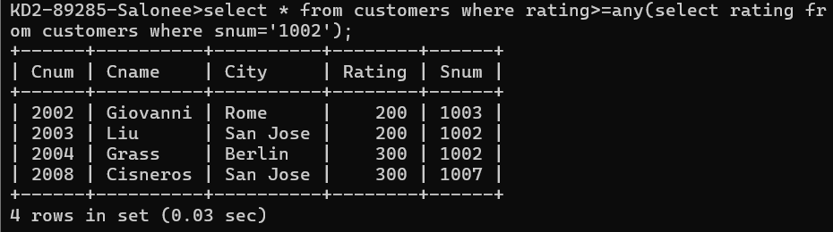

1. Write a query using ANY or ALL that will find all salespeople who have no customers located in their city.

KD2-89285-Salonee>select snum, city from salespeople where salespeople.city

<> all (select city from customers);

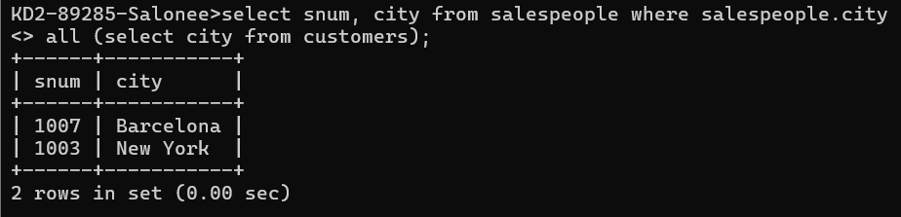

1. Write a query that selects all orders for amounts greater than any for the customers in London.

KD2-89285-Salonee>select * from orders where amt > any(select amt from orders where cnum in(select cnum from customers where city='London'));

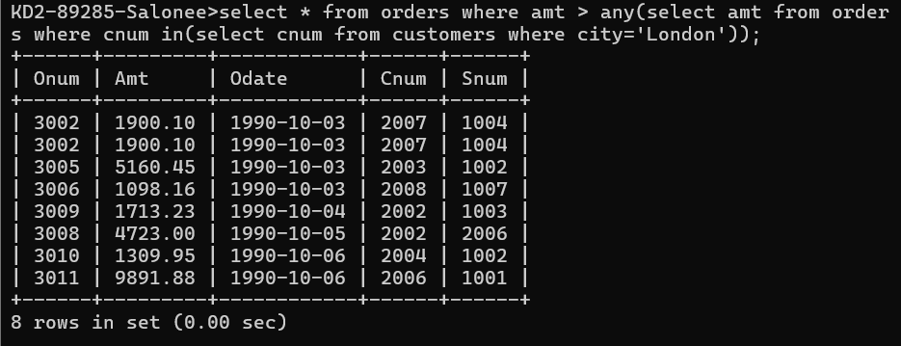

1. Write the above query using MIN or MAX.

KD2-89285-Salonee>select * from orders where amt > any(select min(amt) from

orders where cnum in(select cnum from customers where city='London'));

