**Assignment – 13**

**Using the UNION Clause**

1. Create a union of two queries that shows the names, cities, and ratings of all customers. Those with rating of 200 or greater will also have the words “High Rating”, while the others will have the words “Low Rating”.

KD2-89285-Salonee>select cname,city,'High Rating' rating from customers wher

e rating > 200 union select cname, city,'Low Rating' rating from customers w

here rating <=200;

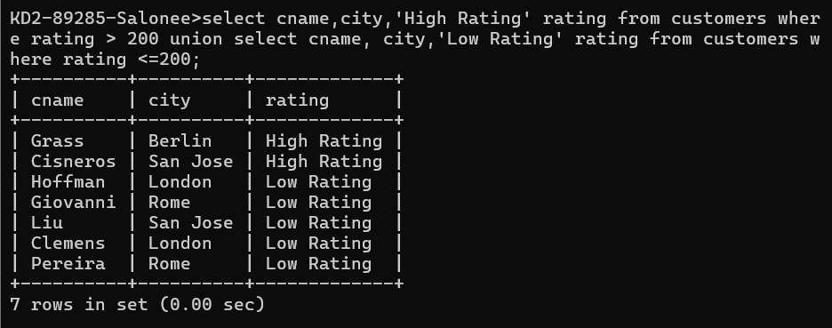

1. Write a command that produces the name and number of each salesperson and each customer with more than one current order. Put the results in alphabetical order.

KD2-89285-Salonee>select sname,snum from salespeople where snum IN(select snum from orders group by snum having count(onum)>1) UNION select cname, cnum

from customers where cnum IN(select cnum from orders group by cnum having count(onum)>1) order by sname;

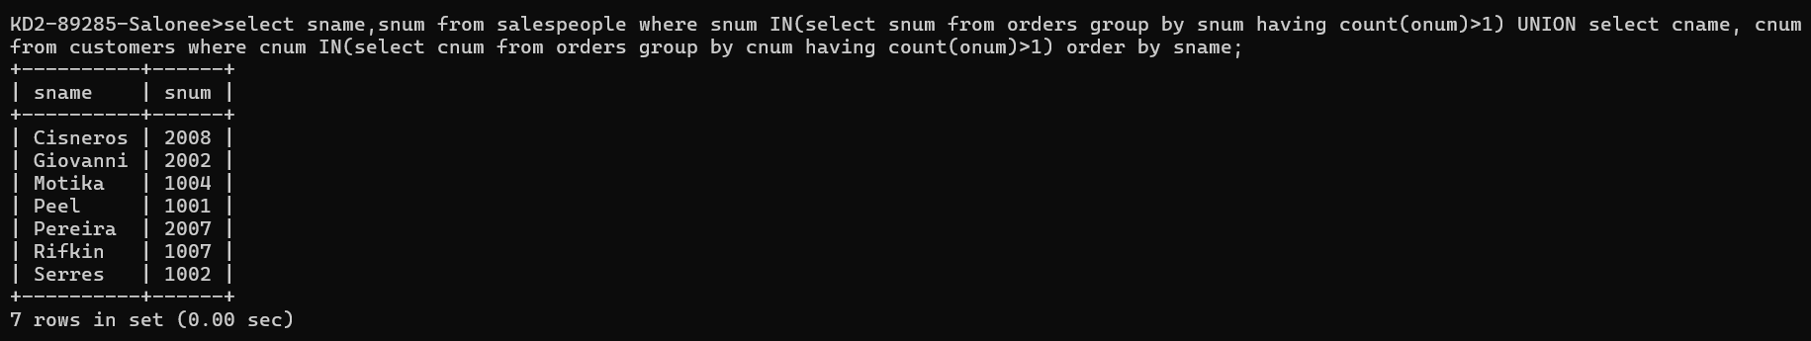

1. Form a union of three queries. Have the first select the snums of all salespeople in San Jose; the second, the cnums of all customers in San Jose; and the third the onums of all orders on October 3. Retain duplicates between the last two queries but eliminate any redundancies between either of them and the first.

KD2-89285-Salonee>select snum from salespeople where city='San Jose' union s

elect cnum from customers where city='San Jos' union all (select onum from o

rders where odate like '1990-10-03');

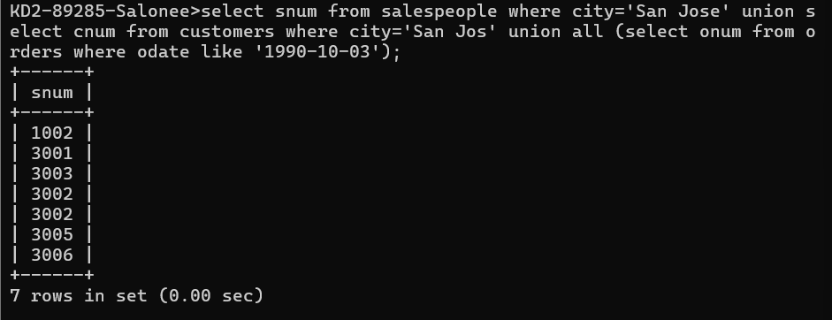

(Note: in the sample tables as given, there would be no such redundancy. This is besides the point.)