**Assignment – 14**

**Entering, Deleting, and Changing Field Values**

1. Write a command that puts the following values, in their given order, into the salespeople table: city – San Jose, name – Blanco, comm – NULL, cnum – 1100.

KD2-89285-Salonee>insert into salespeople (snum,sname,city, comm)

-> values('1100','Blanco','San Jose', NULL);

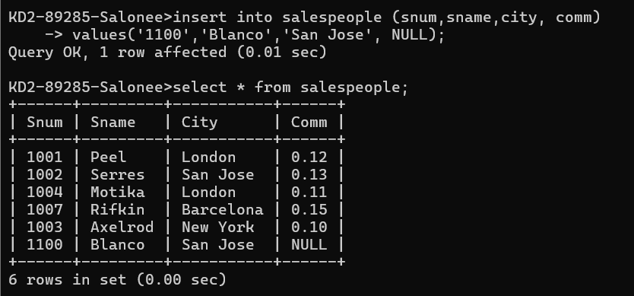

1. Write a command that removes all orders from customer Clemens from the Orders table.

delete from Orders where Cnum = 2006;

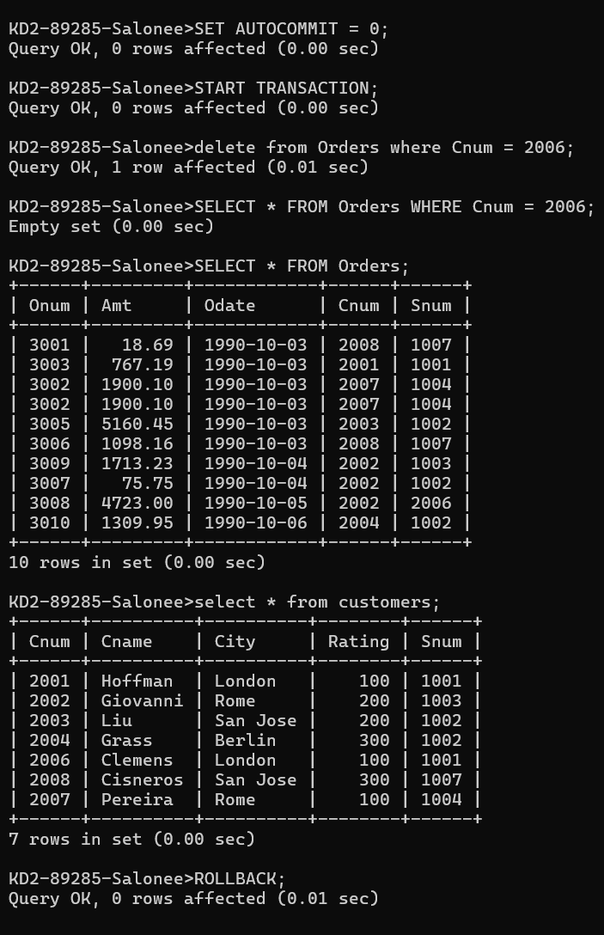

1. Write a command that increases the rating of all customers in Rome by 100.

update customers set rating= rating+100 where city='Rome';

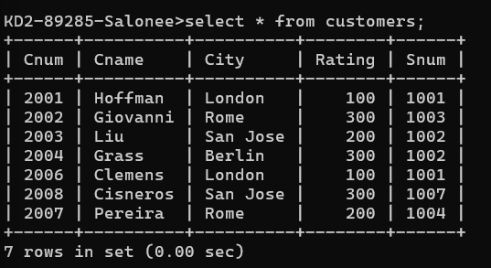

1. Salesperson Serres has left the company. Assign her customers to Motika.

KD2-89285-Salonee>update customers set snum=1004 where snum=1002;

