***Assignment – 19***

**Views.**

1. Create a view that shows all of the customers who have the highest ratings.

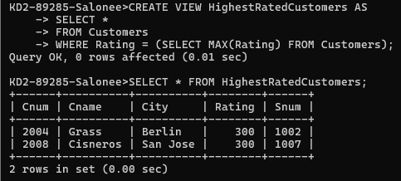

1. Create a view that shows the number of salespeople in each city.

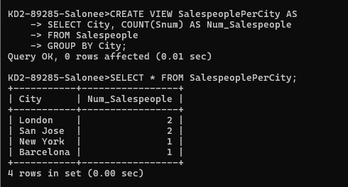

1. Create a view that shows the average and total orders for each salesperson after his or her name. Assume all names are unique.

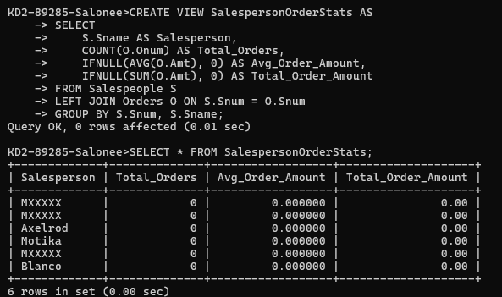

1. Create a view that shows each salesperson with multiple customers.

