Assignment 4

1. Write a select command that produces the order number, amount, and date for all rows in the Orders table.

KD2-89285-Salonee>SELECT Onum, Amt, Odate

-> FROM ORDERS;

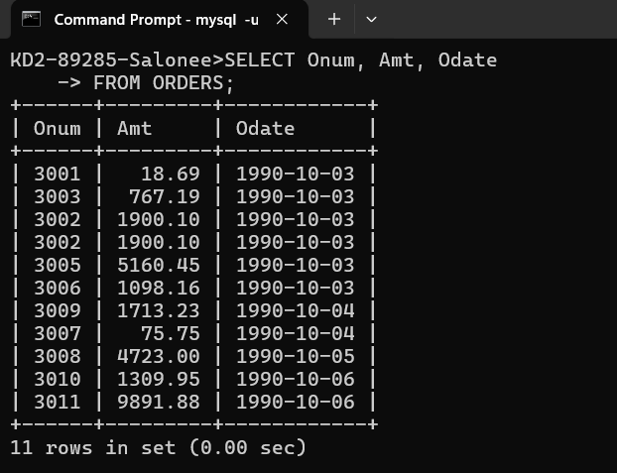

1. Write a query that produces all rows from the Customers table for which the salesperson’s number is 1001.

KD2-89285-Salonee>SELECT \*

-> FROM CUSTOMERS

-> WHERE Snum = 1001;

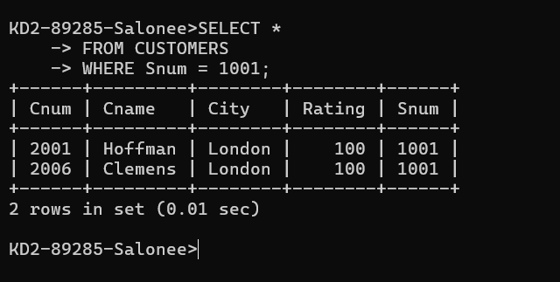

1. Write a query that displays the Salespeople table with the columns in the following order: city, sname, snum, comm.

KD2-89285-Salonee>SELECT City, Sname, Snum, Comm

-> FROM SALESPEOPLE;

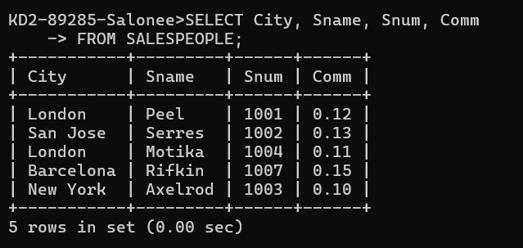

4) Write a select command that produces the rating followed by the name of each customer in San Jose.

KD2-89285-Salonee>SELECT Rating, Cname

-> FROM CUSTOMERS

-> WHERE City = 'San Jose';

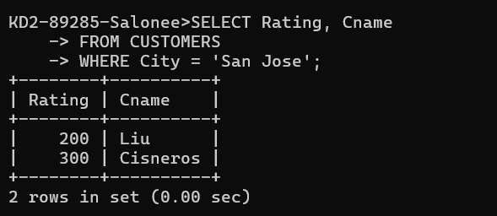

5) Write a query that will produce the snum values of all salespeople (suppress the duplicates) with orders in the Orders table.

KD2-89285-Salonee>SELECT DISTINCT Snum

-> FROM ORDERS;

