**Assignment 5 : Relational and Logical Operators**

**1) Write a query that will give you all orders for more than Rs. 1,000.**

KD2-89285-Salonee>select * from orders;

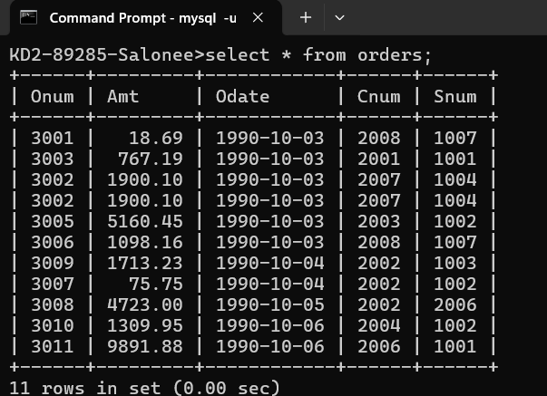

KD2-89285-Salonee>select * from orders where amt>1000;

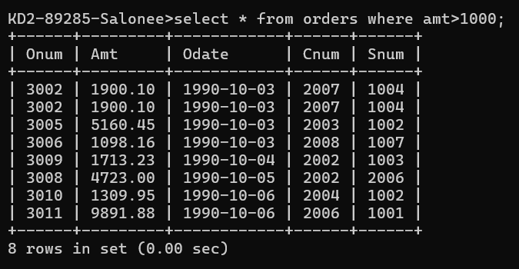

2) Write a query that will give you the names and cities of all salespeople in London with a commission above .10.

KD2-89285-Salonee>select * from salespeople;

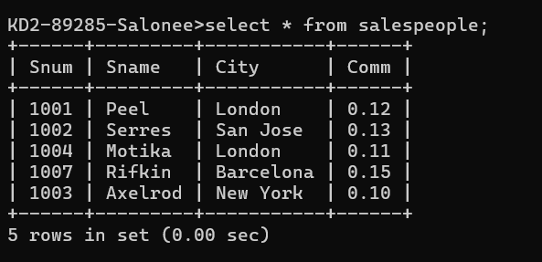

KD2-89285-Salonee>select sname,city from salespeople where city='London' and comm>.10;

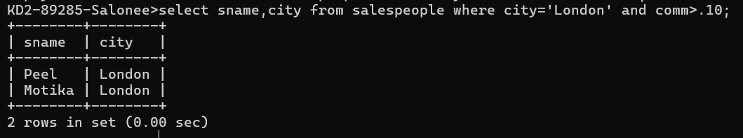

3) Write a query on the Customers table whose output will exclude all customers with a rating <= 100, unless they are located in Rome.

KD2-89285-Salonee>select * from customers;

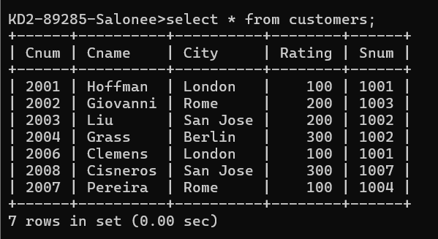

KD2-89285-Salonee>select * from customers where rating<=100 or city='Rome';

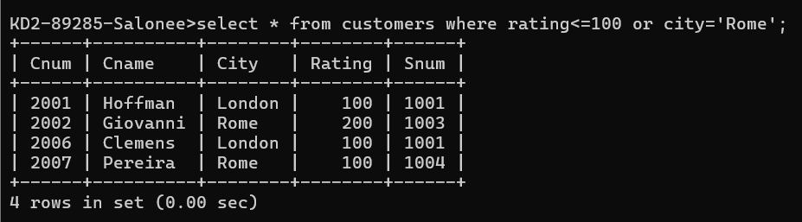

4) What will be the output from the following query?

KD2-89285-Salonee>select * from orders;



KD2-89285-Salonee>select * from orders where (amt<1000 OR NOT (odate='1990-1

0-03' AND cnum>2003));

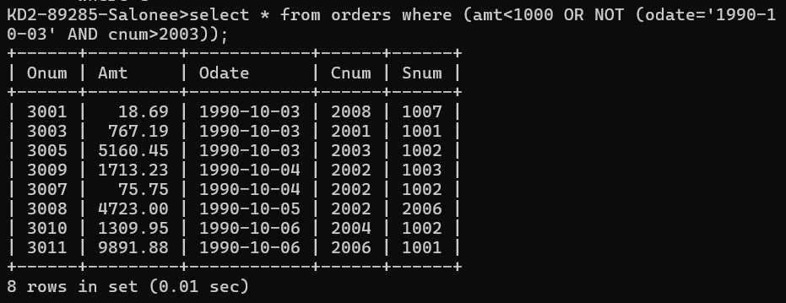

5) What will be the output of the following query?

KD2-89285-Salonee>select * from orders;



KD2-89285-Salonee>select * from orders where NOT ((odate='1990-10-03' OR snum>1006) AND amt>=1500);

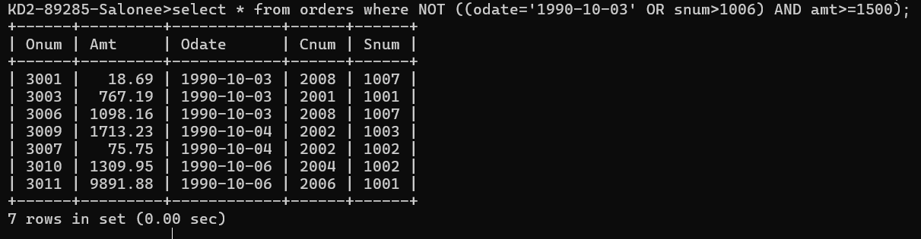

6) What is a simpler way to write this query?

Select snum, sname, city, comm From Salespeople where (comm > .12 OR comm <.14);

KD2-89285-Salonee>select * from salespeople where comm between .12 and .14;

