**Assignment 6**

**Using Special Operators in Conditions**

1. Write two different queries that would produce all orders taken on October 3rd or 4th, 1990.

KD2-89285-Salonee>select * from orders;

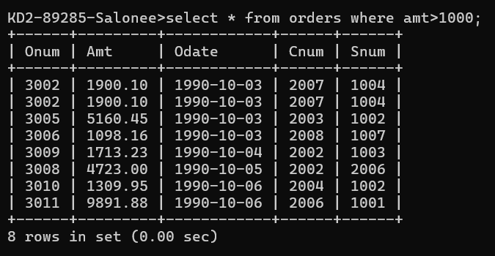

KD2-89285-Salonee>select * from orders where odate between '1990-10-03' AND '1990-10-04';

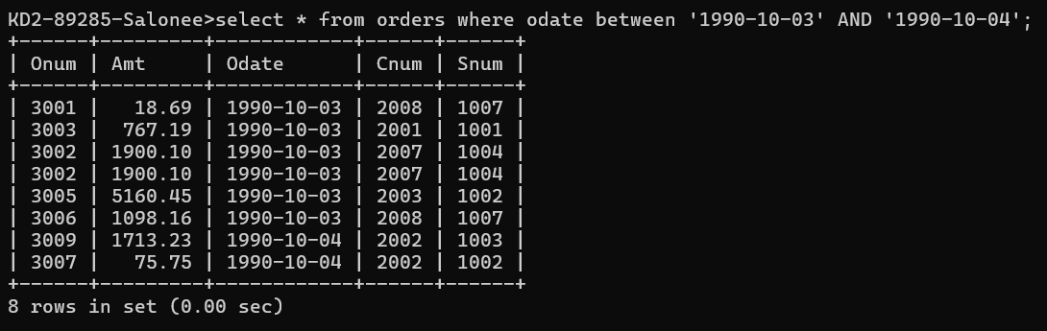

KD2-89285-Salonee>select * from orders where odate='1990-10-03' OR odate='1990-10-04

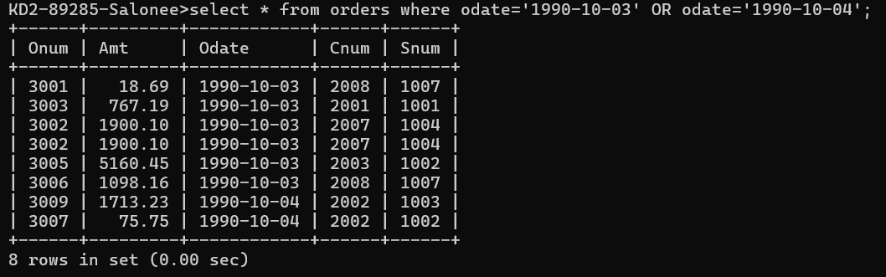

2) Write a query that selects all of the customers serviced by Peel or Motika.

(Hint: the snum field relates the two tables to one another).

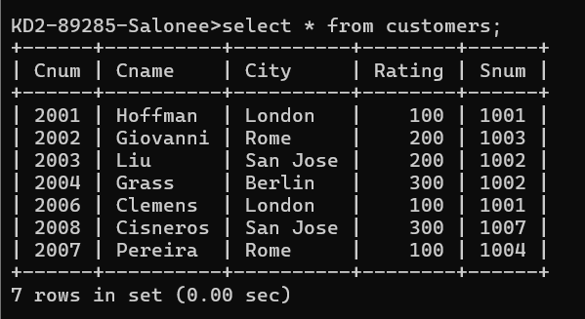

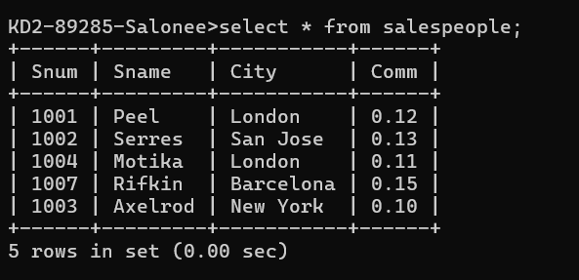

select * from customers where snum=1001 or snum=1004;

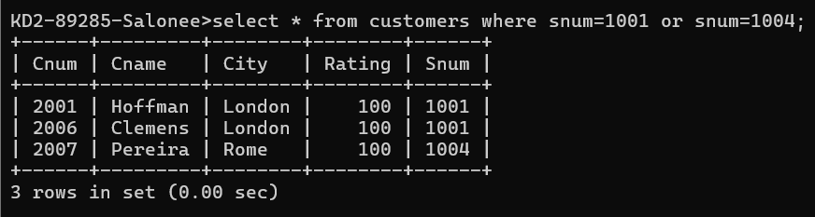

Or

KD2-89285-Salonee>select * from customers where snum IN (1001,1004);

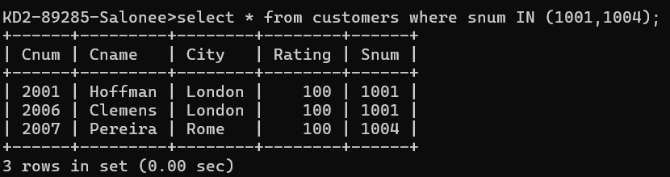

1. Write a query that will produce all the customers whose names begin with a letter from ‘A’ to ‘G’.

KD2-89285-Salonee>select * from customers where Cname>='A' AND Cname <'H';

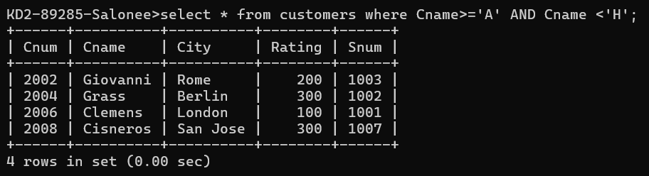

KD2-89285-Salonee>select * from customers where Cname LIKE 'A%' OR Cname LIKE 'B%' OR Cname LIKE 'C%' OR Cname LIKE 'D%' OR Cname LIKE 'E%' OR Cname LIKE 'F%' OR Cname LIKE 'G%';

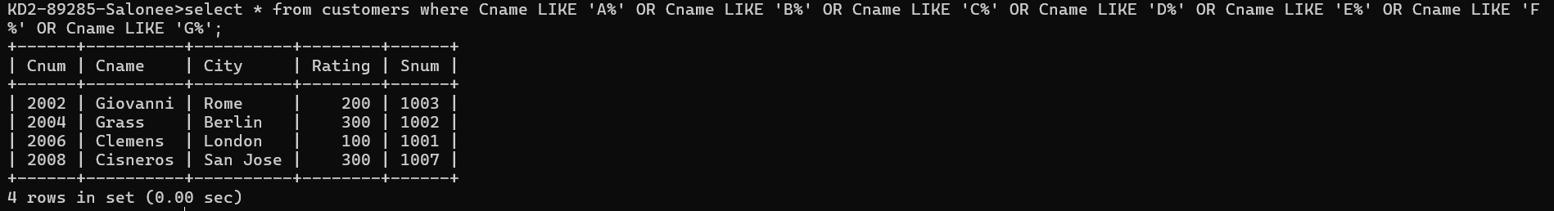

4) Write a query that selects all customers whose names begin with the letter ‘C’.

KD2-89285-Salonee>select * from customers where Cname LIKE 'C%';

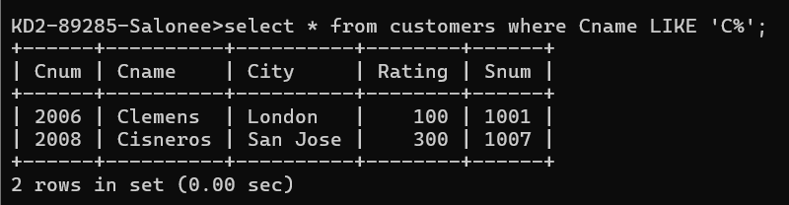

5) Write a query that selects all orders except those with zeroes or NULLs in the amt field.

KD2-89285-Salonee>select * from orders;



KD2-89285-Salonee>select * from Orders where Amt IS NOT NULL AND Amt <> 0;

