**Assignment –7**

**Summarizing Data with Aggregate Functions**

1) Write a query that counts all orders for October 3.

KD2-89285-Salonee>select count(*) as Order_Count from orders where odate='1990-10-03%';

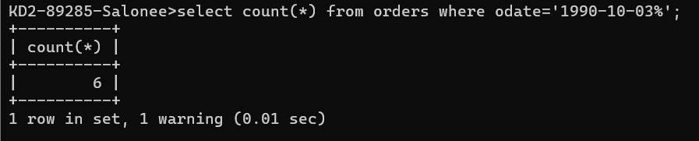

2) Write a query that counts the number of different non-NULL city values in the Customers table.

KD2-89285-Salonee>select count(Distinct city) as Unique_City from customers where city is not null;

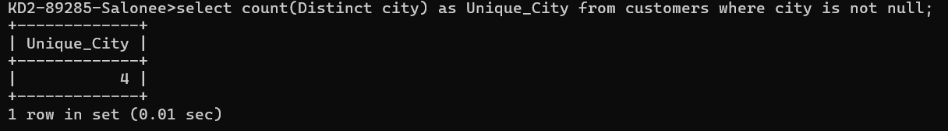

3) Write a query that selects each customer’s smallest order.

KD2-89285-Salonee>select Cnum, min(Amt) as "Smallest Order" from orders group by Cnum;

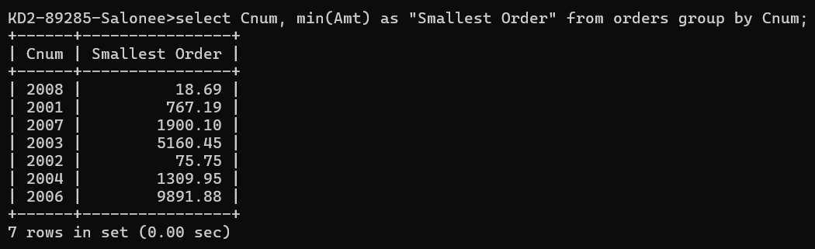

4) Write a query that selects the first customer, in alphabetical order, whose name begins with G.

KD2-89285-Salonee>select * from customers where cname LIKE 'G%' order by cname;

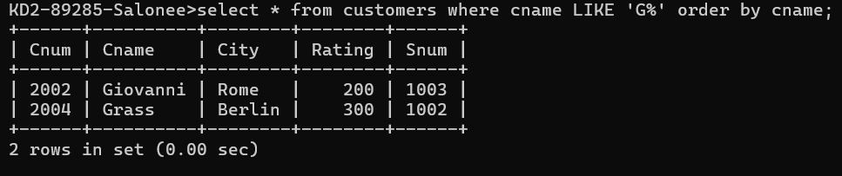

5) Write a query that selects the highest rating in each city.

KD2-89285-Salonee>select City, MAX(Rating) as "Highest Rating" from customers group by city;

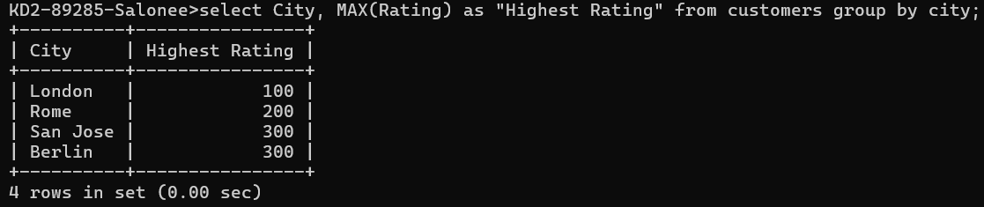

6) Write a query that counts the number of salespeople registering orders for each day. (If a salesperson has more than one order on a given day, he or she should be counted only once.).

KD2-89285-Salonee>select Odate, count(Distinct Snum) as "Salespeople Count"

from orders group by Odate;

