**Assignment –8**

**Formatting Query output**

1. Assume each salesperson has a 12% commission. Write a query on the orders table that will produce the order number, the salesperson number, and the amount of the salesperson’s commission for that order.

KD2-89285-Salonee>select Onum, Snum, Amt*0.12 as "Commission" from orders;

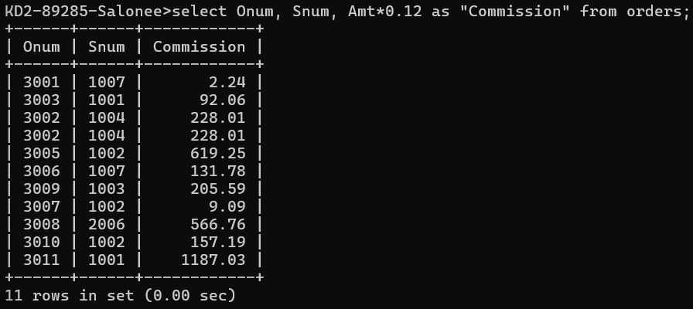

1. Write a query on the Customers table that will find the highest rating in each city. Put the output in this form:

For the city (city), the highest rating is : (rating).

KD2-89285-Salonee>select City, max(Rating) as "Highest Rating" from customer

s group by city;

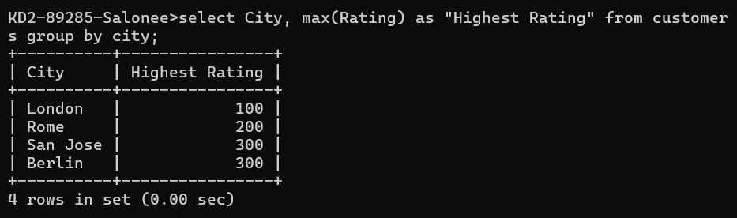

1. Write a query that lists customers in descending order of rating. Output the rating field first, followed by the customer’s name and number.

KD2-89285-Salonee>select Rating, Cname, Cnum from customers order by rating

desc;

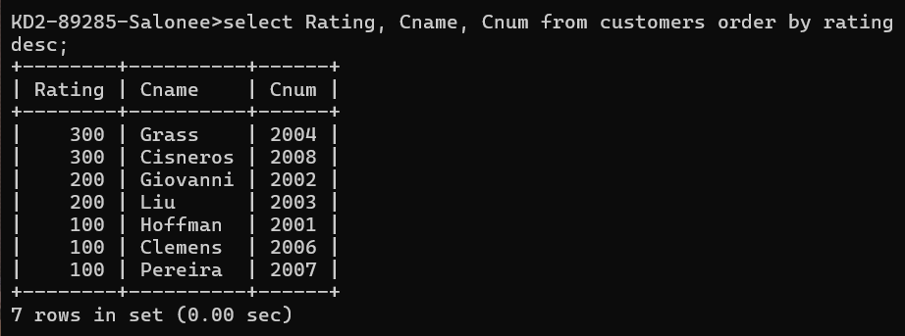

1. Write a query that totals the orders for each day and places the results in descending order.

KD2-89285-Salonee>select Odate, Sum(Amt) as "Total Sales" from orders group by Odate order by "Total Sales" Desc;

