**Assignment – 9**

**Querying Multiple Tables at Once**

1. Write a query that lists each order number followed by the name of the customer who made the order.

KD2-89285-Salonee>select onum,cname from orders, customers where orders.cnum=customers.cnum;

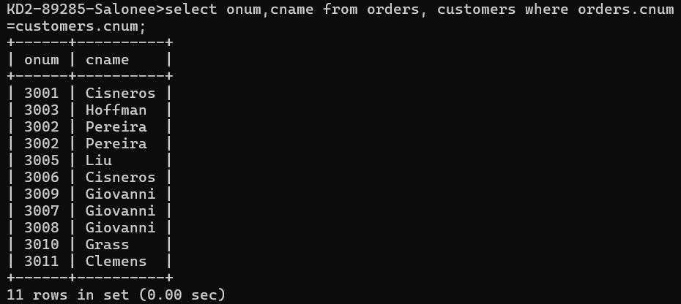

1. Write a query that gives the names of both the salesperson and the customer for each order along with the order number.

KD2-89285-Salonee>select sname, cname, onum from salespeople, customers, orders where salespeople.snum=customers.snum and customers.cnum=orders.cnum;

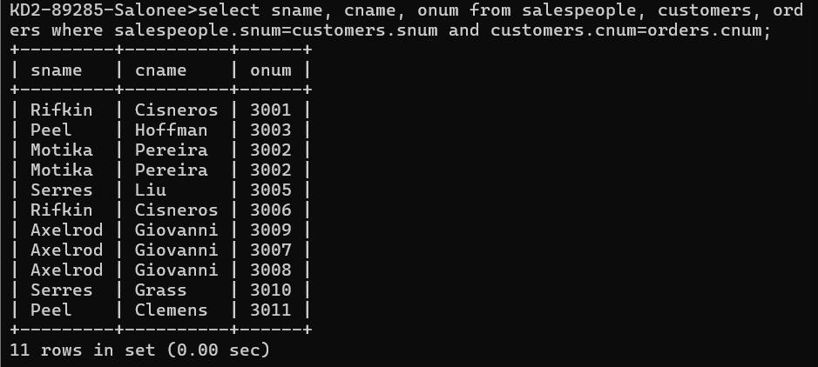

1. Write a query that produces all customers serviced by salespeople with a commission above 12%. Output the customer’s name, the salesperson’s name, and the salesperson’s rate of commission.

KD2-89285-Salonee>select cname, sname, comm from customers, salespeople where customers.snum=salespeople.snum and comm>0.12;

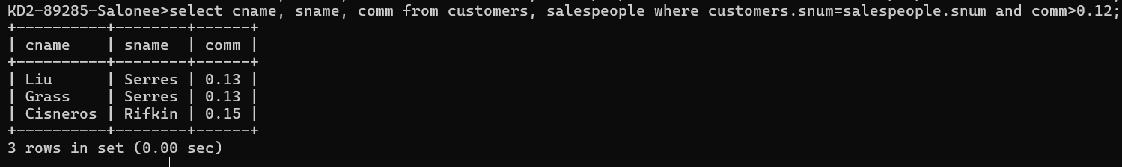

1. Write a query that calculates the amount of the salesperson’s commission on each order by a

customer with a rating above 100.

KD2-89285-Salonee>select onum, comm*amt from customers, orders,salespeople where rating>100 and customers.snum=orders.snum order by 1;

