1)

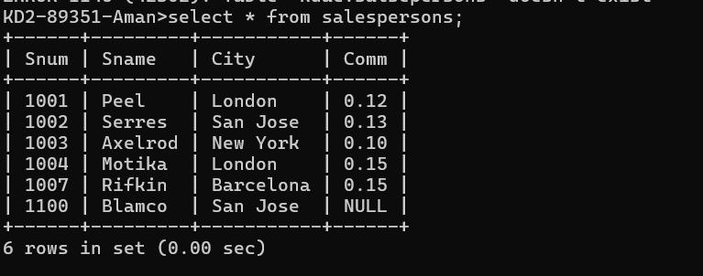

2) 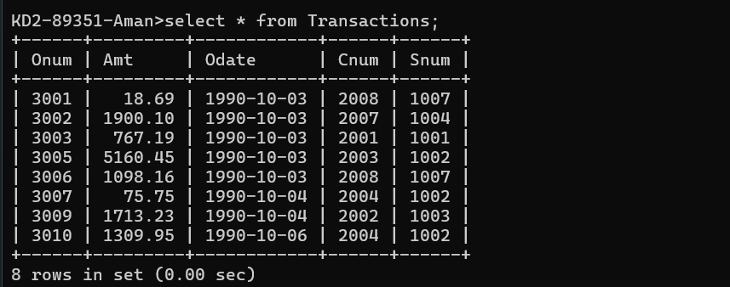

3)

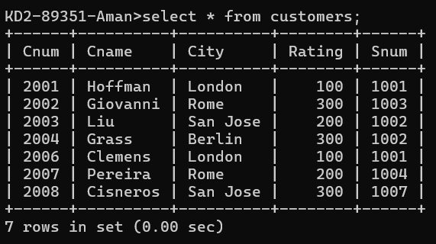

4)update customers set Snum =(select Snum from salespersons where Sname =) where Snum = (Select Snum from salespersons where Sname =’serres’);

