Assignment -8

1. Assume each salesperson has a 12% commission. Write a query on the orders table that will produce the order number, the salesperson number, and the amount of the salesperson’s commission for that order.

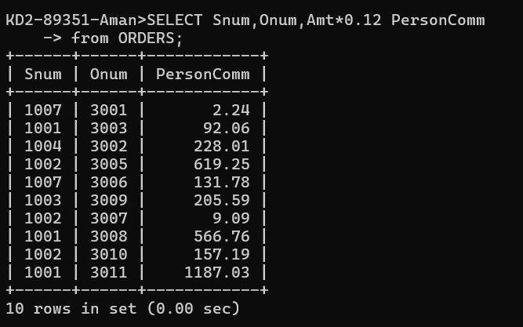

2)

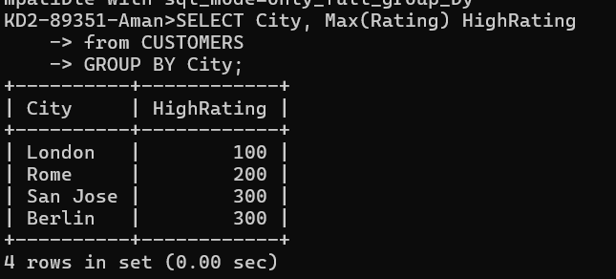

3)

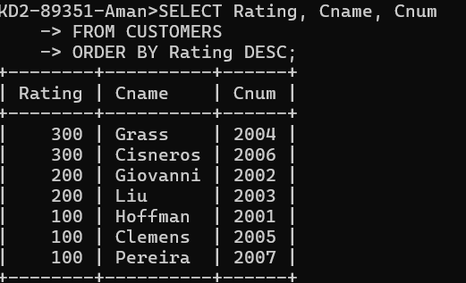

4)

