Data Structures and Algorithms - Assignment 4
- https://leetcode.com/problems/two-sum
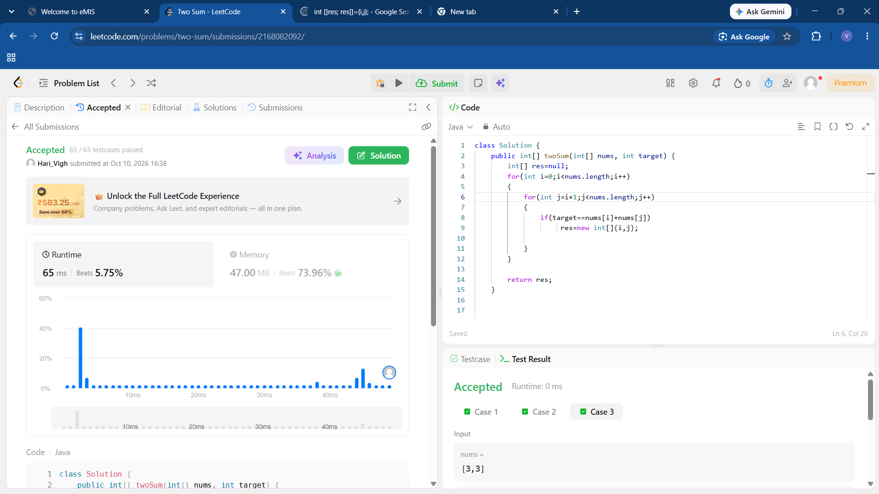

- https://leetcode.com/problems/two-sum-ii-input-array-is-sorted/description/
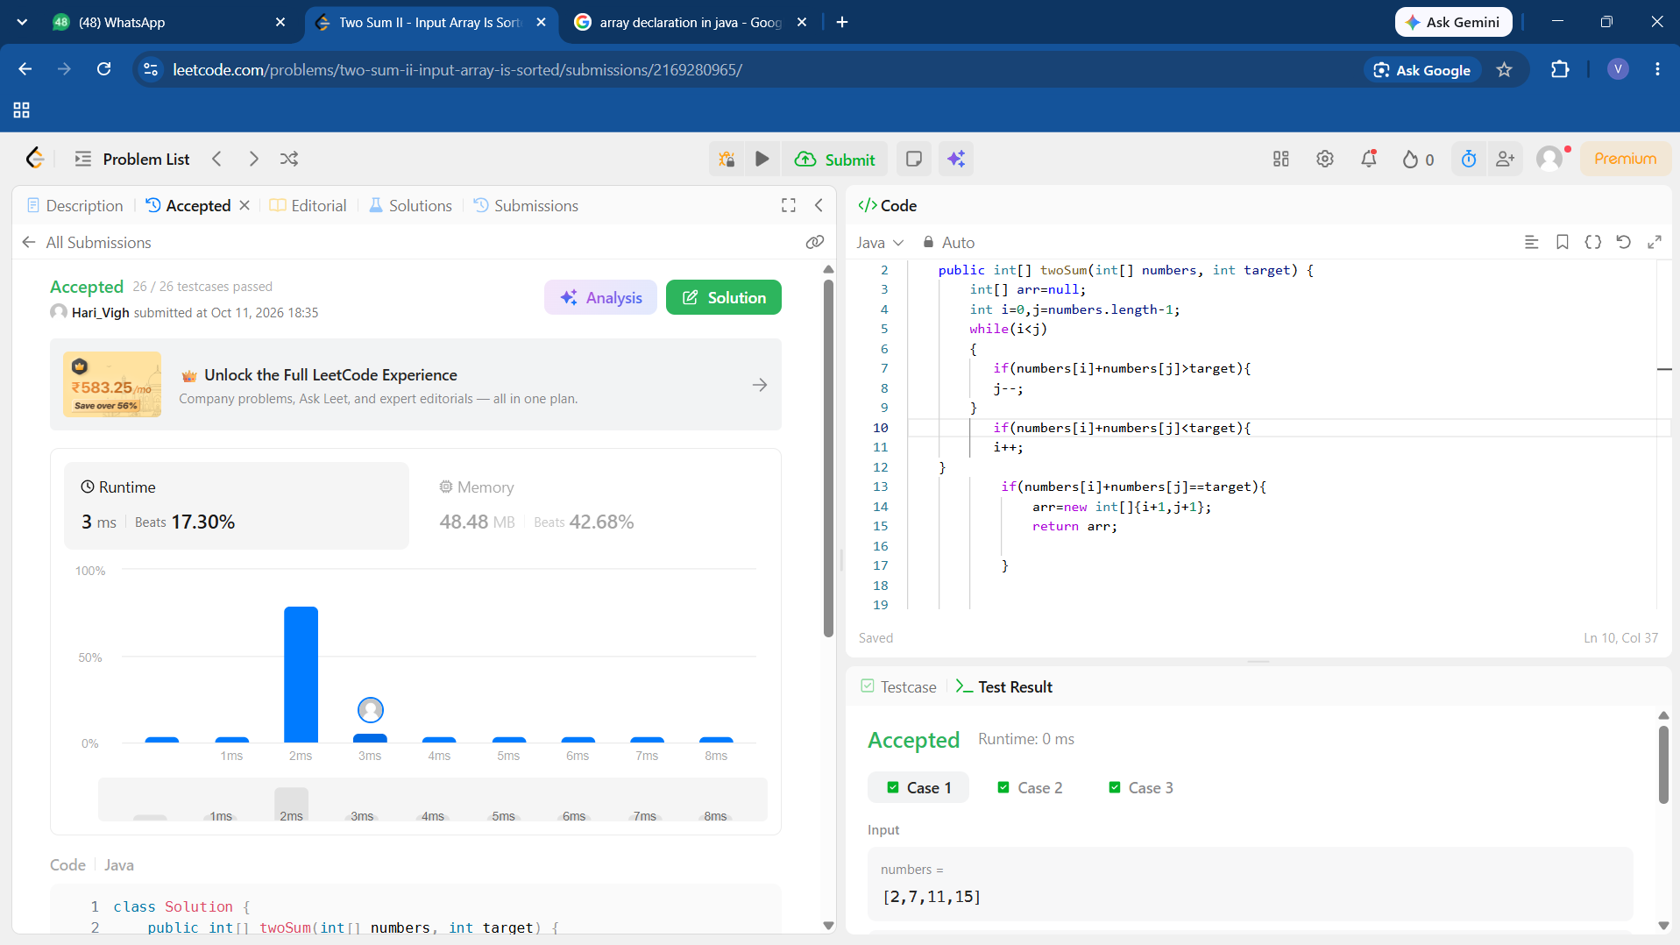

- https://leetcode.com/problems/container-with-most-water/
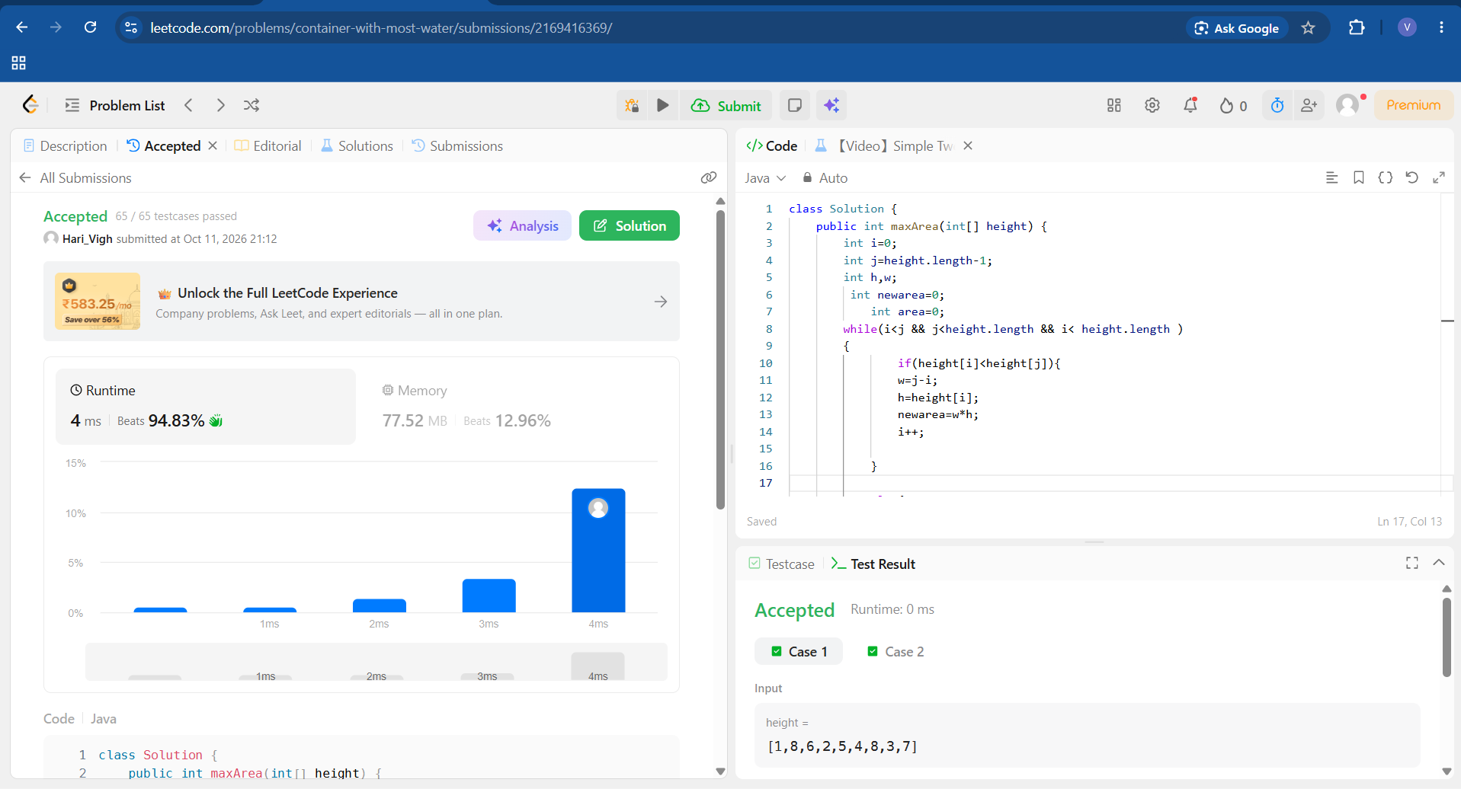
- https://leetcode.com/problems/delete-the-middle-node-of-a-linked-list/description
