Assignment No 1
CREATE TABLE S (S# CHAR(5) NOT NULL, Sname CHAR(20), status SMALLINT, city CHAR(15));

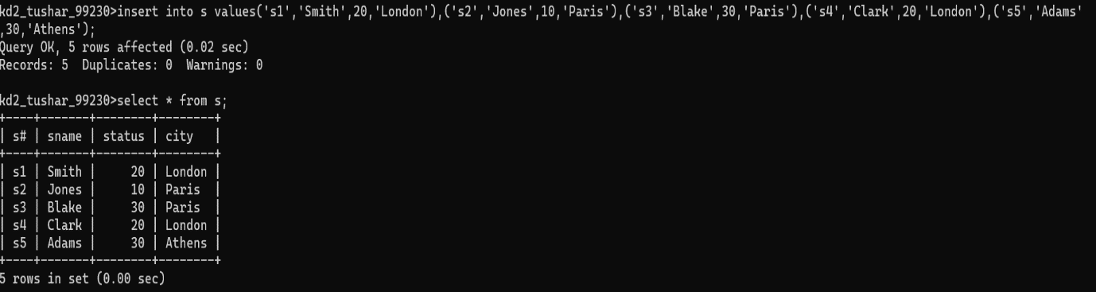

CREATE TABLE J (J# CHAR(4) NOT NULL, Jname CHAR(10), City CHAR(15));

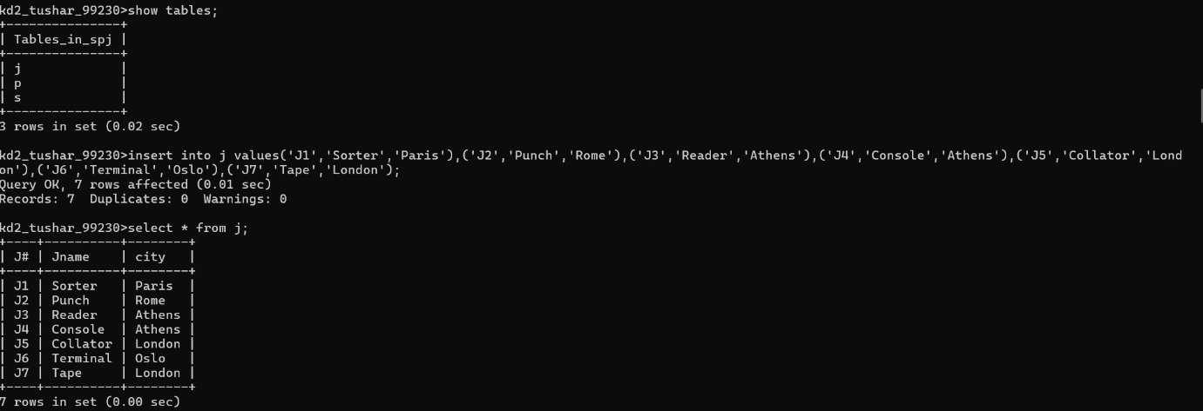

CREATE TABLE P (P# CHAR(6) NOT NULL, Pname CHAR(20), color CHAR(6), weight SMALLINT, city CHAR(15));

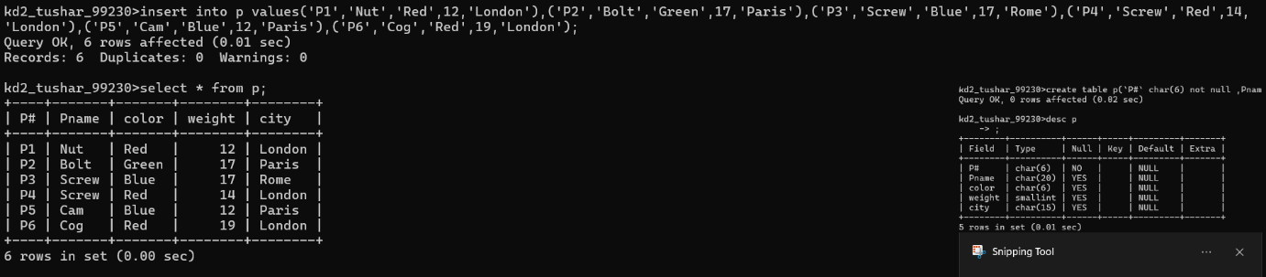

CREATE TABLE sp (S# CHAR(4) NOT NULL, P# CHAR(4) NOT NULL, J# CHAR(4) NOT NULL, QTY INT);
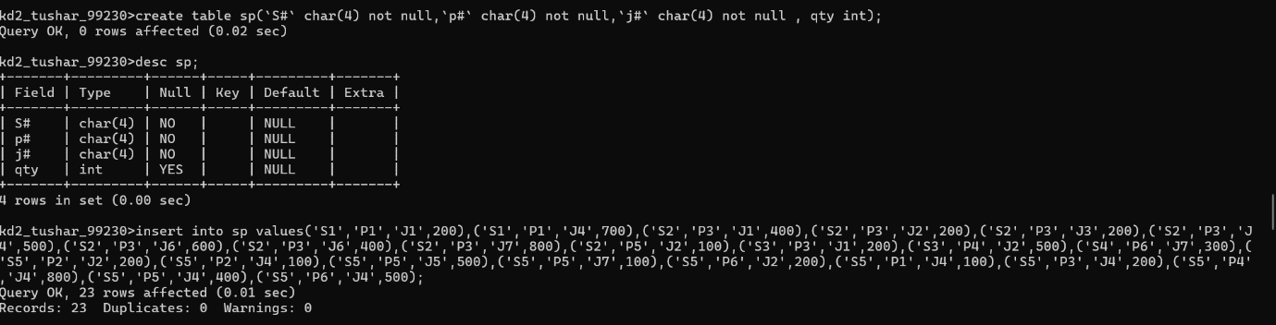

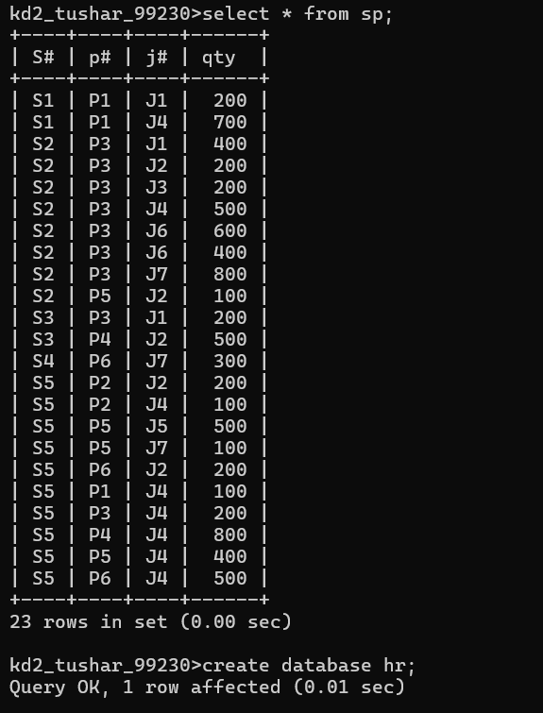

Answer the following questions (by observations only – not queries).

1. How many orders data is present in the database?
->10 orders

2. How many customers are present in the database?
->7 customers
3. How many salespeople are present in the database?
->5 salespeople

4. On which date order with highest amount is placed?
->1990-10-04

5. For which order salesman got maximum commission? Hint: you need to
refer data of two tables.
->3011

6. Which salesmen are handling more than two customers? Hint: you need to
refer data of two tables.
->No salesman handle more than two orders.

7. Which city have single customer?
->Berlin

8. Which city has multiple salespeople?
->London

9. What is name of customer and salesman of the maximum amount order?
->Customer - Clemens
Salesman - Peel

10. Study relationship between the tables in sales database.
->The sales database contains three related tables: customers, orders, and salespeople.
The orders table connects customers using cnum and salespeople using snum.
The customers table also contains snum, linking each customer to their salesperson.

