Assignment IV

- count the no. of words ,characters and lines from above 2 file.(man wc)
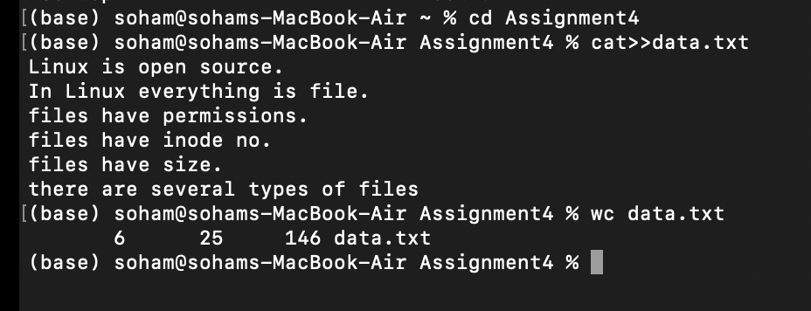

- list the lines having word "files" (man grep)
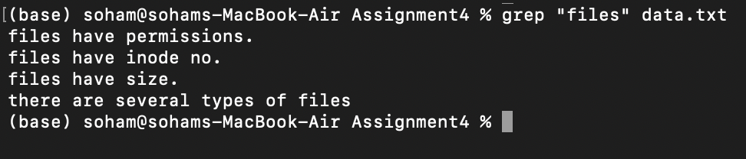

- list the lines having word "file" (man grep)
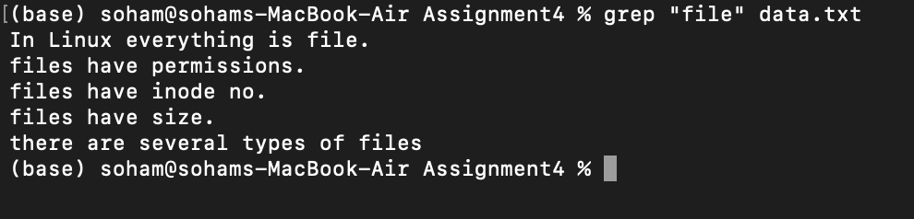

- list the lines which don't have word "files" (man grep)
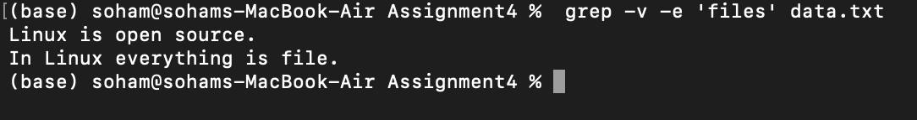

- list the lines having word "have" . (man grep)
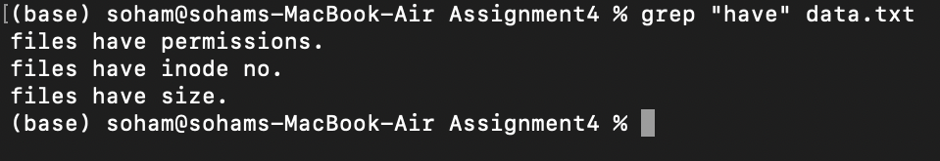

- list the lines starts with letter "f" (man grep)
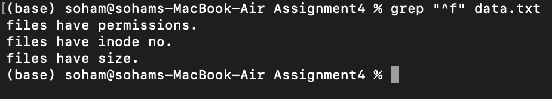

- list the lines ends with "." (man grep)
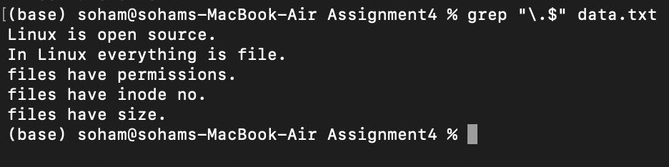

- list only first two lines.(man head)
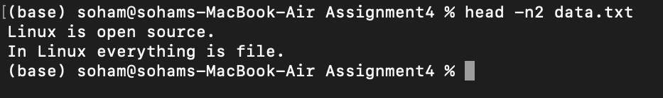

- list only last three lines.(man tail)
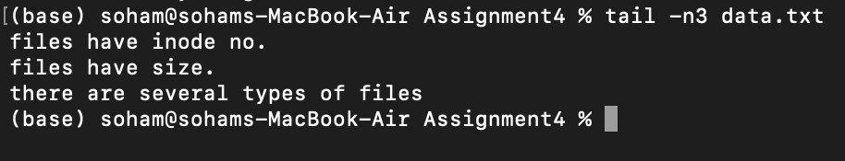

- list line no.3,4 and 5 . (man head and tail)
