|  |
| --- |
| **A**  **PROJECT REPORT ON** |
|  |
|  |
| **Book My Charge Station** |
|  |
|  |
| SUBMITTED IN  PARTIAL FULFILLMENT OF  **DIPLOMA IN ADVANCED COMPUTING (PG-DAC)** |
|  |
|  |
|  |
|  |
|  |
|  |
|  |
| **BY**  **Ms. RUCHA DHARAK**  **Mr. SHUBHAM BANSODE**  **Mr. AKASH KAKAD**  **Ms. RUTUJA HATGINE** |
|  |
|  |
| **UNDER THE GUIDENCE OF**  **RUGVEDA KULKARNI** |
|  |
|  |
| AT |
| **SUNBEAM INSTITUTE OF INFORMATION TECHNOLOGY,**  **Karad** |

|  |  |
| --- | --- |
|  | |
| **SUNBEAM INSTITUTE OF INFORMATION TECHNOLOGY,**  **Karad** | |
|  | |
|  | |
|  | |
|  | |
| **CERTIFICATE** | |
|  | |
| This is to certify that the project | |
|  | |
| **Book My Charge Station** | |
|  | |
| Has been submitted by | |
|  | |
| **Ms. RUCHA DHARAK**  **Mr. SHUBHAM BANSODE**  **Mr. AKASH KAKAD**  **Ms. RUTUJA HATGINE** | |
|  | |
|  | |
| In partial fulfillment of the requirement for the Course of **PG Diploma in Advanced Computing (PG-DAC September 2023)** as prescribed by The **CDAC** ACTS, PUNE. | |
|  | |
|  | |
| Place: Karad | Date: 19th-Feb-2024 |
|  | |
|  | |
|  | |
|  | |
|  | |
| **Rugveda Kulkarni** | **Mr. Pratik Ninganur** |
| **Project Guide** | **Course Coordinator** |

**ACKNOWLEDGEMENT**

A project usually falls short of its expectation unless aided and guided by the right persons at the right time. We avail this opportunity to express our deep sense of gratitude towards **Mr. Prashant Lad (Center Coordinator, SIIT, Karad)** and **Mr. Pratik Ninganur (Course Coordinator, SIIT ,Karad)**.

We are deeply indebted and grateful to them for their guidance, encouragement and deep concern for our project. Without their critical evaluation and suggestions at every stage of the project, this project could never have reached its present form.

Last but not the least we thank the entire faculty and the staff members of Sunbeam Institute of Information Technology, Karad for their support.

SHUBHAM BANSODE

DAC September 23 Batch,

SIIT Karad

**INDEX**

|  |  |  |
| --- | --- | --- |
|  | **INTRODUCTION** | 1 |
|  | 1.1 Introduction | 2 |
|  | **Product Overview and Summary** |  |
|  | 2.1 Purpose | 6 |
|  | 2.2 Scope | 7 |
|  | 2.3 User Classes and Characteristics | 8 |
|  | 2.4 Design and Implementation Constraints | 11 |
|  | **REQUIREMENTS** |  |
|  | 3.1 Functional Requirements | 13 |
|  | 3.2 Non - Functional Requirements | 13 |
|  | 3.2.1 Usability Requirement | 13 |
|  | 3.2.2 Performance Requirement | 14 |
|  | 3.2.3 Reliability Requirement | 14 |
|  | 3.2.4 Portability Requirement | 15 |
|  | 3.2.5 Security Techniques | 15 |
|  | **PROJECT DESIGN** |  |
|  | 4.1 Data Model |  |
|  | 4.1.1 Database Design | 16 |
|  | 4.2 Process Model |  |
|  | 4.2.1 Data Flow Diagram (DFD) | 23 |
|  | **TEST REPORT** | 24 |
|  | **PROJECT RELATED STATISTICS** | 27 |
|  | **CONCLUSION** | 28 |

**LIST OF FIGURES**

|  |  |  |
| --- | --- | --- |
| **Section** | **Figure Title** | **Page** |
| **2.4** | **Customer Use Case Diagram** | 11 |
| **2.4** | **aDMIN Use Case Diagram** | 12 |
| **2.4** | **sTATION oWNER Use Case Diagram** | 12 |
| **4.1.1** | **Database Design** | 16 |
| **4.2.1** | **Data Flow Diagram (DFD)** | 22 |

**1. INTRODUCTION**

"Powering Up" is a concise book that unfolds the story of the Book My Charge Station application, a game-changer in the world of electric vehicles. This easy-to-read narrative takes you on a journey from the app's inception to its transformative impact on how we charge our electric cars.

Discover the app's user-friendly features, like finding charging stations on the go and hassle-free payment options. The book explains how smart technology, including AI and blockchain, is used to make charging efficient and secure.

Learn about the app's positive influence on the environment by encouraging more people to switch to electric vehicles. Real-life examples and success stories showcase the app's role in making sustainable transportation accessible to all.

As you wrap up the book, get a glimpse into the future, exploring how the Book My Charge Station application continues to shape the way we charge our electric vehicles, paving the way for a cleaner and greener future.

**2. PRODUCT OVERVIEW AND SUMMARY**

**2.1 Purpose**

The increasing popularity and rising number of electric vehicles have resulted in extensive demand for efficient, reliable, and effective infrastructures of electric vehicle charging stations (EVCSs). However, the development and implementation of such infrastructure pose severe challenges towards the power quality, security, and stability of the power system. This paper presents a holistic understanding of the challenges, mitigation approaches, and available technologies and protocols related to EVCS network deployment. This review aims to provide insights to develop sustainable and efficient EVCS infrastructure while overcoming the challenges and optimizing the benefits.

**2.2 Scope**

User Registration and Authentication: Implement functionality for users to register accounts on the platform and authenticate themselves securely.

Charge Station Listings: Allow charge station owners to list their stations on the platform, providing details such as location, available charging ports, supported vehicle types, pricing, and operating hours.

Booking and Reservation System: Enable users to search for available charge stations based on location, date, time, and other criteria. Users should be able to reserve a charging slot at their preferred station in advance.

Payment Integration: Integrate payment gateways to facilitate secure transactions for booking charge stations. Users should be able to make payments online through the platform.

User Management Dashboard: Provide charge station owners with a dashboard to manage their station listings, view booking requests, approve or reject reservations, and track revenue generated.

Real-Time Monitoring: Implement features for station owners and users to monitor the availability of charging ports in real-time and receive notifications about booking confirmations, cancellations, and other relevant updates.

Feedback and Rating System: Allow users to provide feedback and ratings based on their experience with different charge stations. This helps improve service quality and reliability.

Admin Panel: Develop an administrative panel to manage user accounts, handle disputes or complaints, monitor system performance, and perform other administrative tasks.

Mobile-Friendly Interface: Design the platform to be responsive and accessible across various devices, including smartphones, tablets, and desktop computers.

Security and Data Privacy: Implement robust security measures to protect user data, payment information, and other sensitive details. Comply with relevant data protection regulations to ensure user privacy.

Scalability and Future Expansion: Build the platform with scalability in mind to accommodate future growth and expansion. Consider potential features such as support for electric vehicle fleets, integration with smart grid technologies, and partnerships with electric vehicle manufacturers.

**2.3 User Classes and Characteristics**

In the context of the "Book My Charge Station" project, various user classes with distinct characteristics can be identified based on their roles and interactions with the platform. Here are some user classes and their characteristics:

Electric Vehicle Owners:

Characteristics : Individuals or organizations owning electric vehicles.

Require access to charging stations for their vehicles.

Actions: Search for available charging stations.

Book charging slots based on their requirements.

Make payments for reservations.

Provide feedback and ratings for charge stations.

Charge Station Owners:

Characteristics : Individuals or businesses that operate electric vehicle charging stations. Manage the availability and operation of their stations.

Actions : List their charging stations on the platform. Set pricing and availability schedules. Monitor booking requests and manage reservations.

Receive payments for charging services. Respond to user feedback and address concerns.

Platform Administrators:

Characteristics : Responsible for overseeing the entire platform.

Ensure smooth operation, security, and compliance.

Actions : Manage user accounts and access permissions.

Handle disputes or issues reported by users.

Monitor system performance and security.

Implement updates and enhancements to the platform.

Ensure compliance with regulations and policies.

Guest Users:

Characteristics : Individuals who visit the platform without registering.

Limited access to certain features and functionalities.

Actions : Browse available charging stations.

View general information about stations and services.

Sign up for an account to access full features.

Service Providers (Optional):

Characteristics : Third-party providers offering additional services related to electric vehicles or charging stations.

Examples include maintenance services, equipment suppliers, or energy providers.

Actions : Integrate their services with the platform.

Collaborate with charge station owners to enhance offerings.

Provide value-added services to platform users.

**2.4 Design and Implementation Constraints**

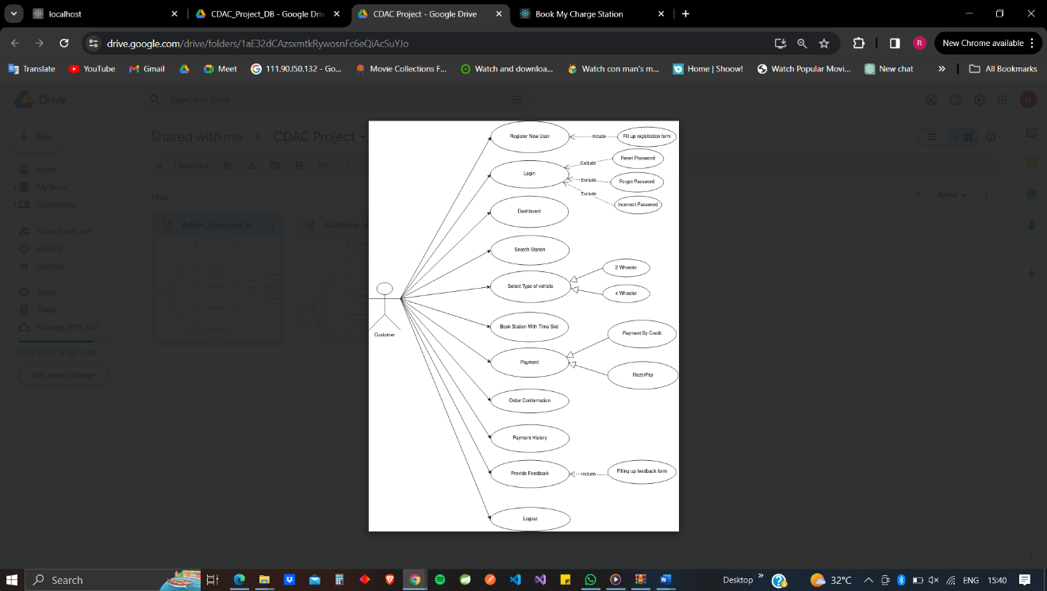

**fIG. Customer Use Case Diagram**

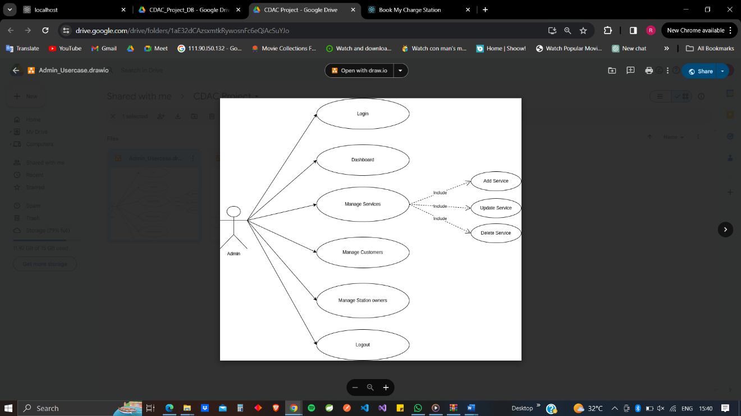

**FIG. Admin Use Case Diagram**

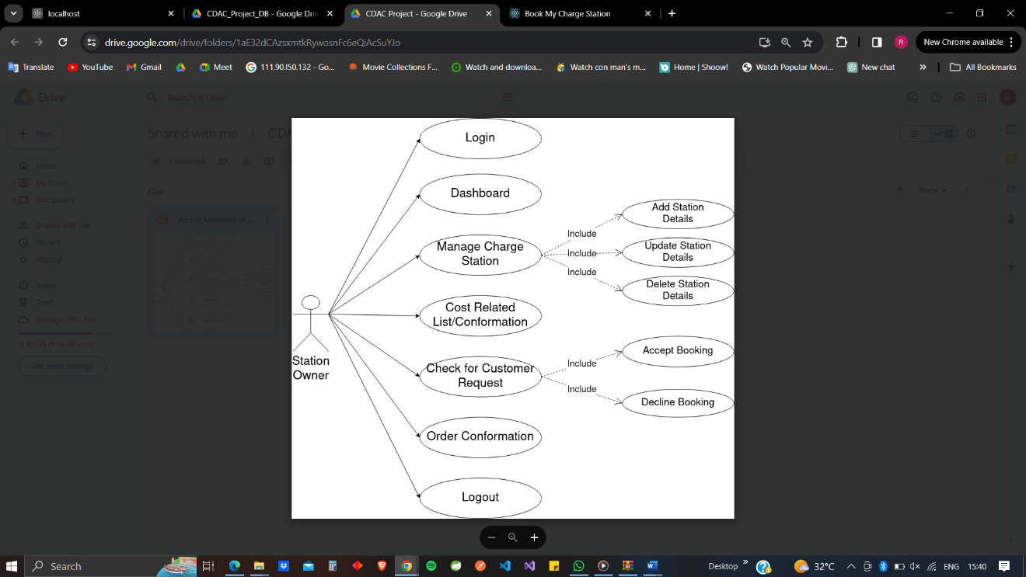

**FIG. Station Owner Use Case Diagram**

**3. REQUIREMENTS**

**3.1 Functional Requirements**

For Front End Development - React.js, Material UI

For Back End Development – Node.js

Database – MySql

**3.2 Non - Functional Requirements**

**3.2.1 Usability Requirement**

Description: The platform should be intuitive and easy to use for both electric vehicle owners and charge station owners.

Specifics:

Clear and user-friendly interface.

Intuitive navigation for searching and booking charging stations.

Responsive design for seamless access across devices.

Accessibility features to accommodate users with disabilities.

**3.2.2 Performance Requirement**

Description: The platform should deliver efficient performance to handle user interactions, queries, and transactions swiftly.

Specifics:

Quick response times for search queries and booking requests.

Minimal loading times for web pages and mobile applications.

Scalability to accommodate increasing user traffic and data volume.

Optimal resource utilization to prevent system slowdowns or crashes during peak usage periods.

**3.2.3 Reliability Requirement**

Description: The platform should operate reliably without frequent disruptions or downtime.

Specifics:

High system availability to ensure uninterrupted access to charging station information and services.

Fault tolerance mechanisms to handle system failures and recover gracefully.

Regular backups and data recovery procedures to prevent loss of critical information.

Monitoring tools to proactively identify and address potential issues before they impact users.

**3.2.4 Portability Requirement**

Description: The platform should be accessible from various devices and platforms, offering flexibility and convenience to users.

Specifics:

Compatibility with different web browsers, operating systems, and mobile devices.

Consistent user experience across platforms, regardless of screen size or resolution.

Support for modern web standards and technologies to ensure cross-platform compatibility.

**3.2.5 Security Techniques**

Description: The platform should implement robust security measures to protect user data, transactions, and system integrity.

Specifics:

Encryption of sensitive data during transmission and storage.

User authentication and authorization mechanisms to control access to platform features.

Implementation of secure coding practices to mitigate common vulnerabilities such as SQL injection and cross-site scripting (XSS).

Regular security audits and vulnerability assessments to identify and remediate potential threats.

Compliance with relevant data protection regulations and industry standards (e.g., GDPR, PCI-DSS).

**4. PROJECT DESIGN**

**4.1 Data Model**

**4.1.1 Database Design**

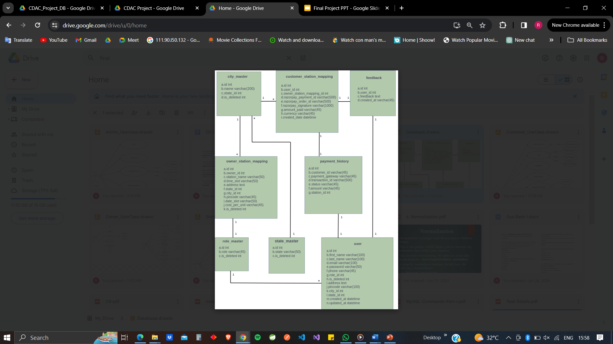

**Fig. Database Design**

**4.1 Data Model**

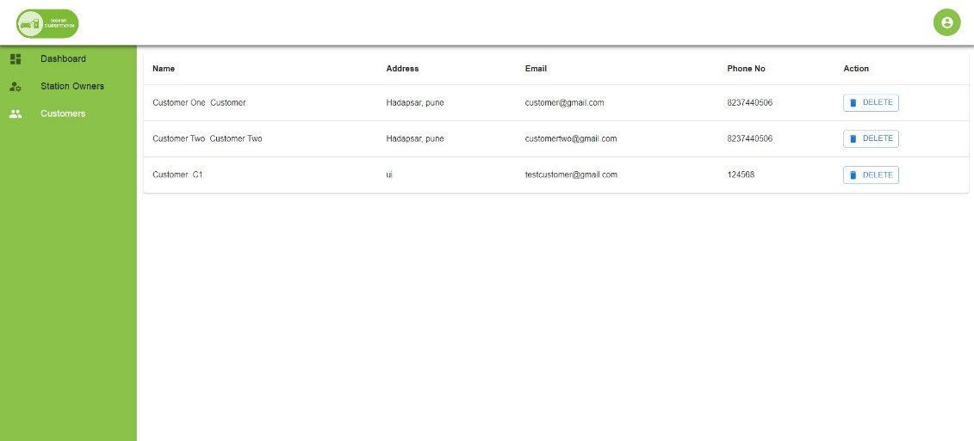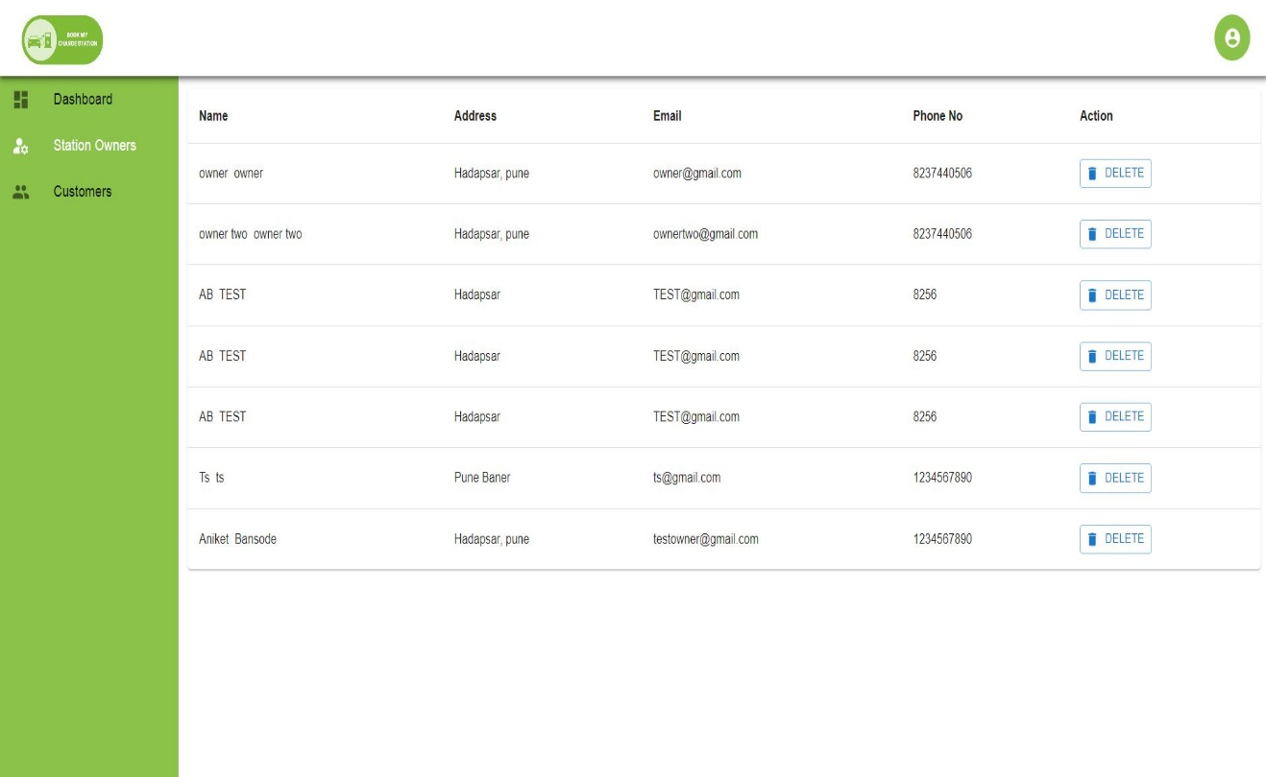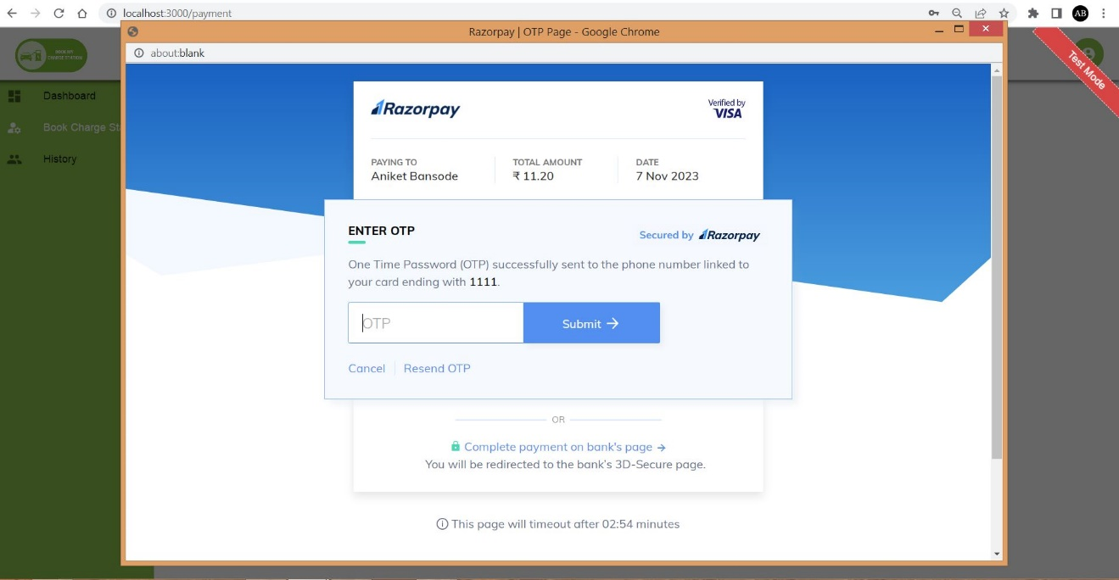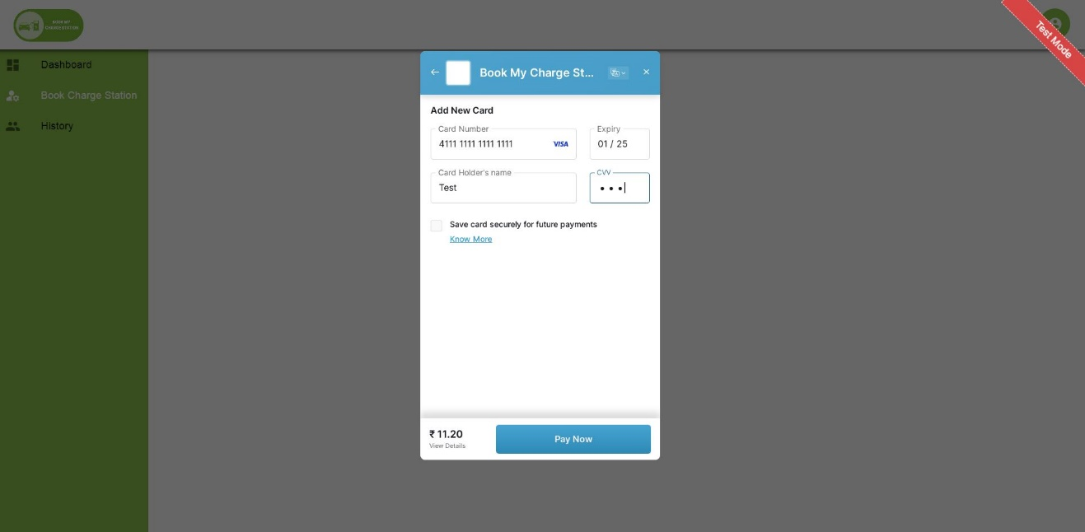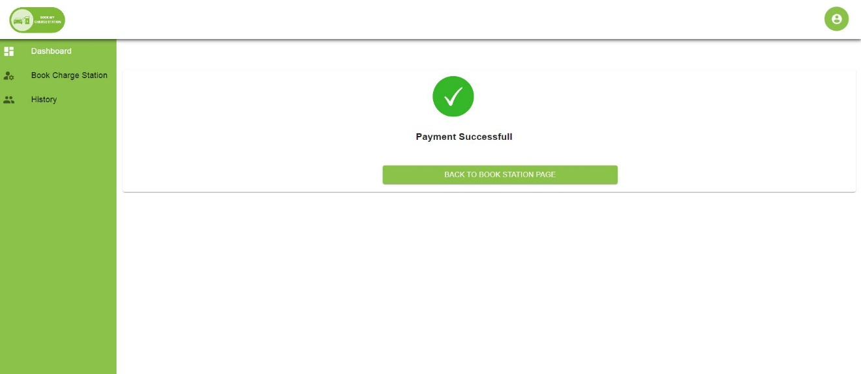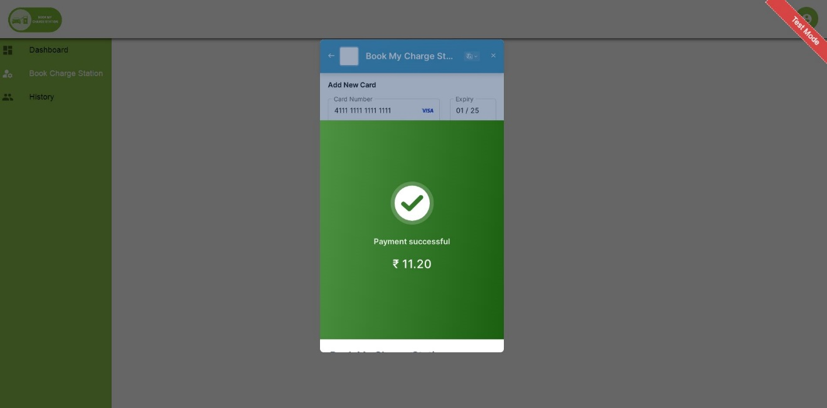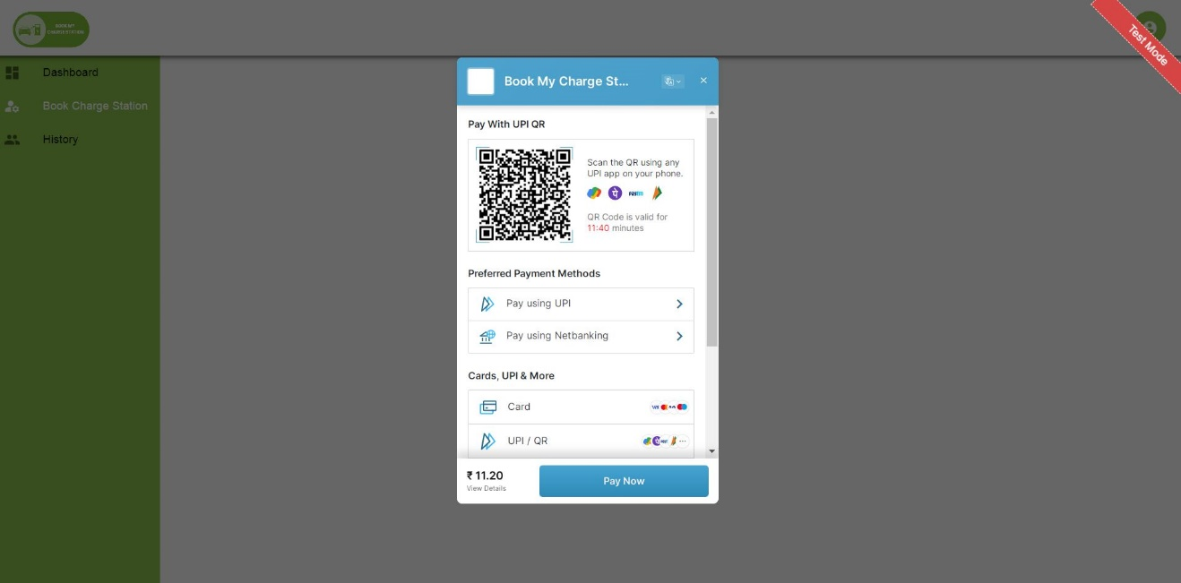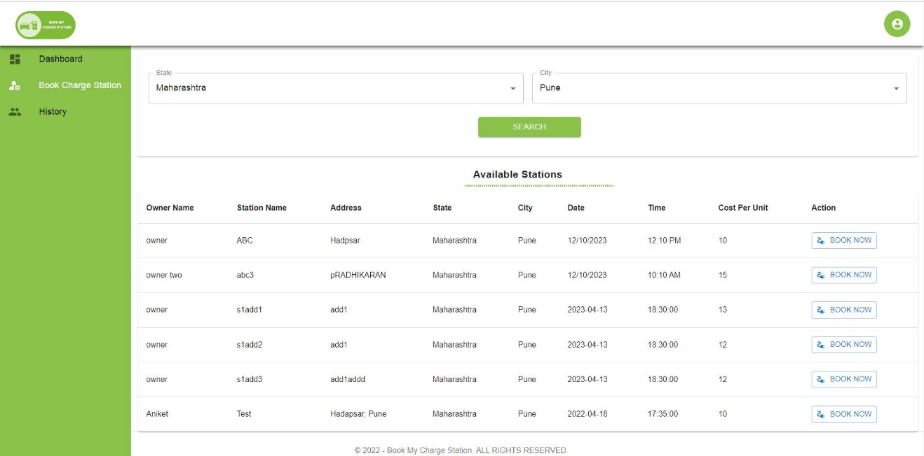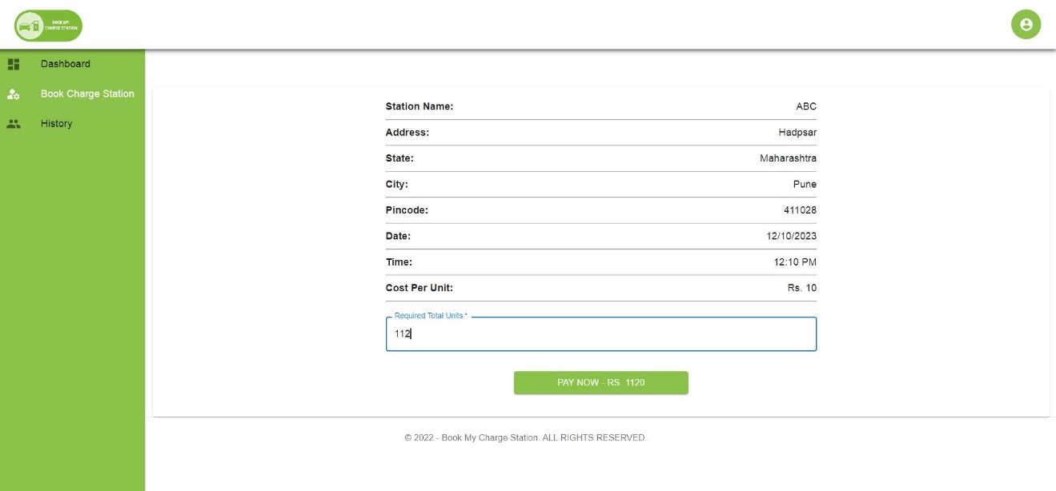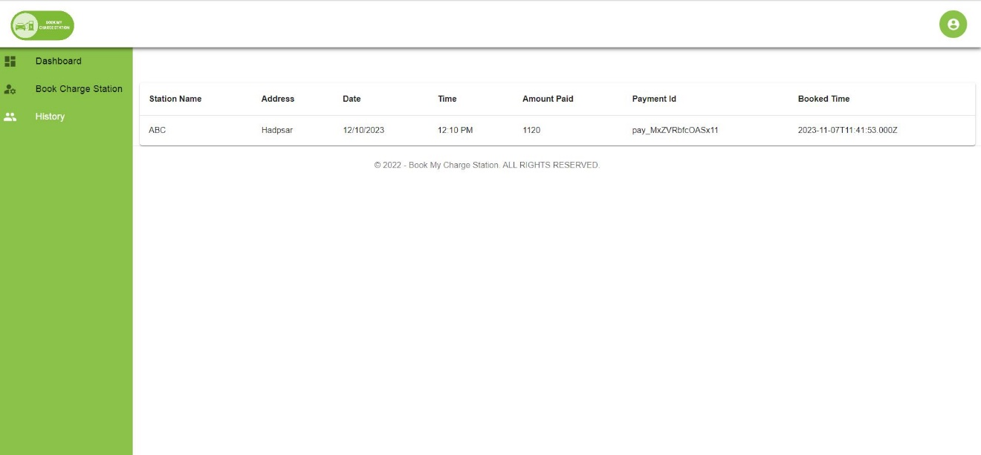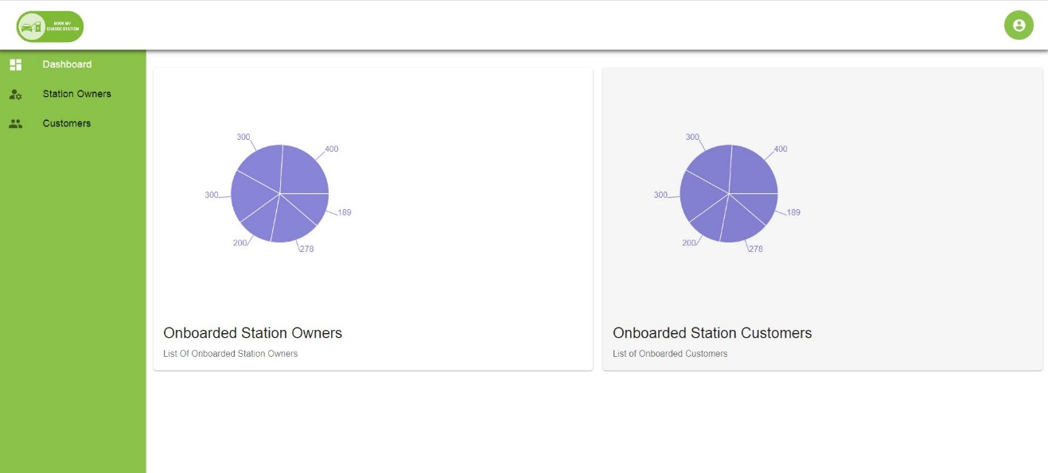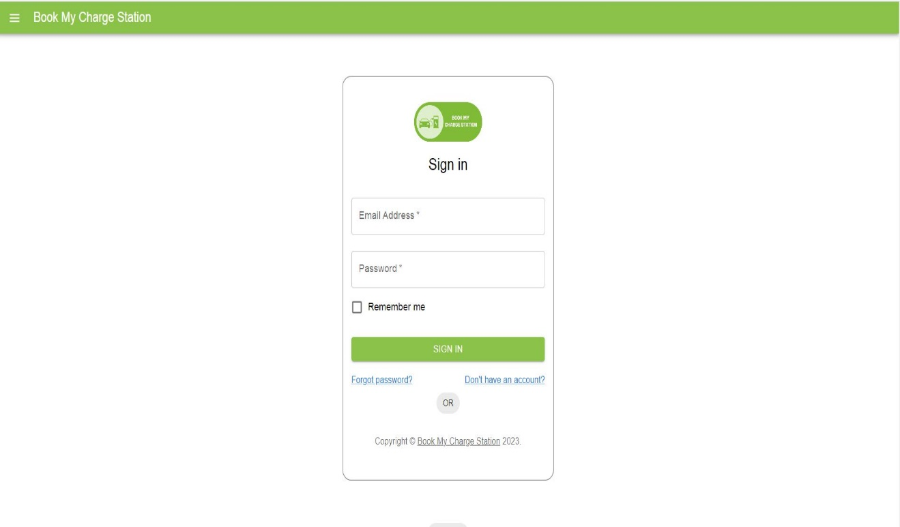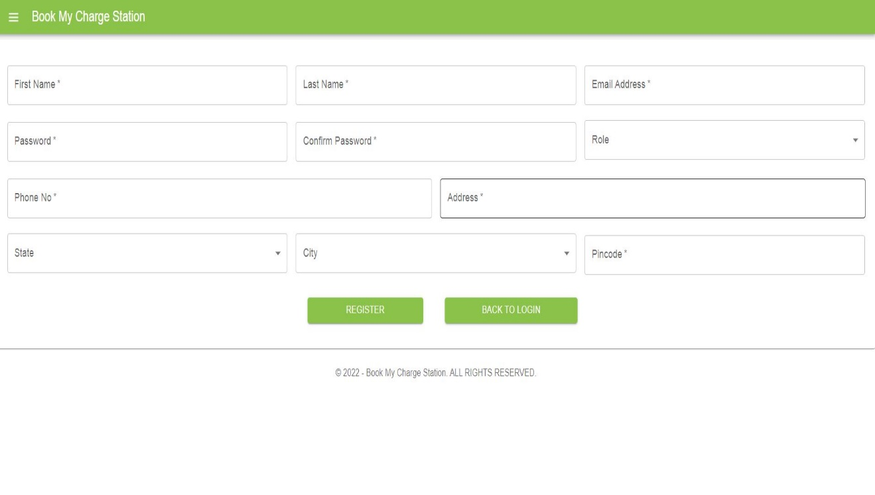

**4.2.1 Data Flow Diagram (DFD)**

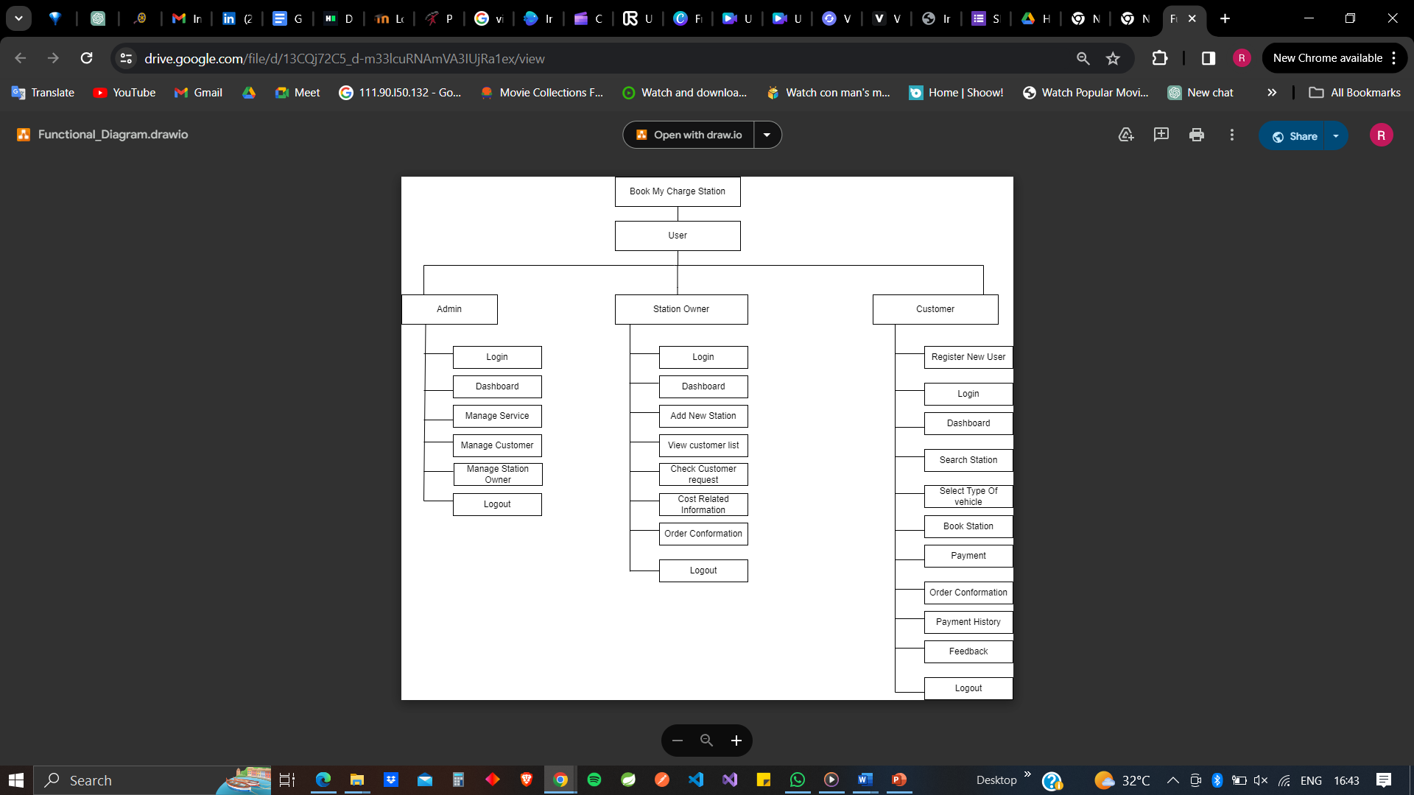

**5. TEST REPORT**

**Testing Approach**

Functional Testing: Ensured that all features and functionalities of the platform work as expected.

Performance Testing: Evaluated the responsiveness and scalability of the platform under various load conditions.

Security Testing: Identified and addressed potential vulnerabilities and security risks in the platform.

Usability Testing: Gathered feedback from users to assess the platform's ease of use and user experience.

Test Results

**Functional Testing Results:**

All core features, including user registration, charging station search, booking, and payment processing, function correctly.

Minor issues related to UI inconsistencies and error handling were identified and addressed.

**Performance Testing Results:**

The platform demonstrated satisfactory performance under normal load conditions.

Response times for search queries and booking requests remained within acceptable limits.

Scalability tests indicated that the platform can handle increased user traffic without significant degradation in performance.

**Security Testing Results:**

Vulnerability assessments revealed several potential security vulnerabilities, including XSS and SQL injection.

Remediation measures, such as input validation and data sanitization, were implemented to mitigate these risks.

Regular security audits and monitoring mechanisms were established to ensure ongoing security compliance.

**Usability Testing Results:**

User feedback highlighted areas for improvement in terms of interface clarity and navigation.

Adjustments were made to enhance the user experience and streamline common tasks such as station search and booking.

The testing process confirmed the overall functionality, performance, and security of the Book My Charge Station platform. While minor issues and areas for improvement were identified, the platform meets the requirements and expectations set forth during the development phase.

**Recommendations**

Continued monitoring and testing to identify and address any emerging issues or vulnerabilities.

Regular user feedback collection and usability assessments to ensure ongoing improvement of the platform's user experience.

Implementation of additional security measures and best practices to further enhance the platform's resilience against potential threats.

This Test Report provides a comprehensive summary of the testing activities conducted for the Book My Charge Station platform and outlines key findings, conclusions, and recommendations for future enhancements and maintenance.

**6. PROJECT RELATED STATISTICS**

In conclusion, the testing process for the "Book My Charge Station" application aimed to assess its functionality, usability, and overall performance. Throughout the testing phase, the team executed a comprehensive set of test cases, covering various scenarios and aspects of the application.

The key findings and observations from the testing process are summarized as follows:

**Functionality**: The core functionalities of the application were generally found to be effective and in line with expectations.

Identified and reported issues were addressed promptly by the development team.

**Usability**: The user interface was intuitive, contributing to a positive user experience.

Usability testing revealed minimal issues, and the overall navigation was smooth.

**Performance**: Performance testing indicated that the application could handle expected loads without significant issues.

Response times were within acceptable limits.

**Security**: No major security vulnerabilities were detected during security testing.

The application demonstrated a satisfactory level of security.

**Compatibility**: The application exhibited compatibility with various devices and operating systems as per the testing scope.

While the application performed well across multiple dimensions, it's important to note that continuous monitoring and periodic testing are recommended to ensure ongoing quality and address potential issues that may arise with future updates.

In light of the testing results, the "Book My Charge Station" application is deemed suitable for release, pending any final adjustments or improvements based on the identified issues. The testing team recommends ongoing vigilance in monitoring user feedback and addressing any emerging issues promptly.

This conclusion is based on the testing activities performed up to [date], and any subsequent updates or changes to the application may not be reflected in this report.

**7. CONCLUSION**

In summary, the testing process for the "Book My Charge Station" application revealed positive results. The application demonstrated effective functionality, a user-friendly interface, and satisfactory performance. Security vulnerabilities were minimal, and compatibility across various devices was confirmed. While the app is recommended for release, ongoing monitoring and user feedback consideration are advised for continuous improvement.