Assignment-10

Q.1 Write a query that produce all pair of salespeople who are living in the same city. Exclude combination of salespeople with themselves as well as duplicates row with the other reversed.

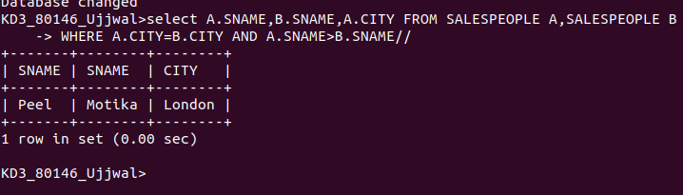
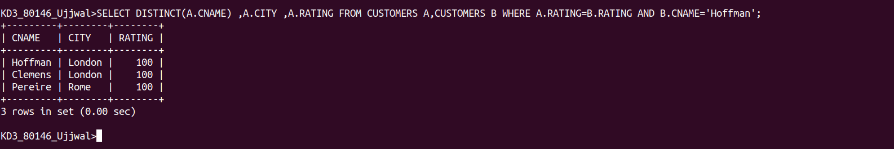
Q.2 Write query that produce the name and cities of the customer with the same rating as Hoffman.

