ASSIGNMENT 6
1 WRITE TWO DIFFERNT QUERES THAT WOULD PRODUCE ALL ORDERS TAKEN ON
ON OCT 3RD OR 4TH 1990.

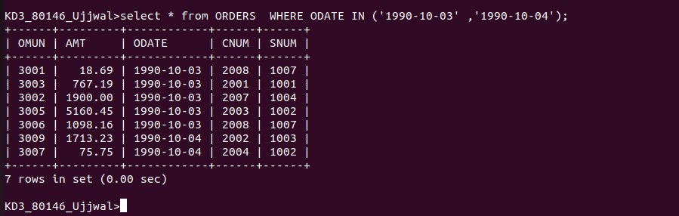

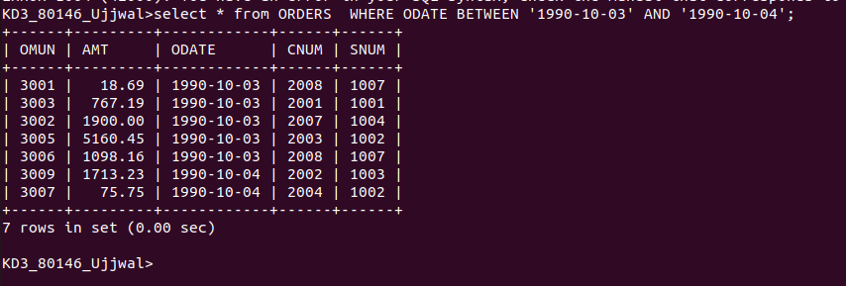

2 WRITE A QUERY THAT SELECTS ALL OF THE CUSTOMERS SERVICED BY PEEL OR
MONIKA ( HINT THE Snum field RELATES THE TWO TABLE TO ONE ANOTHER

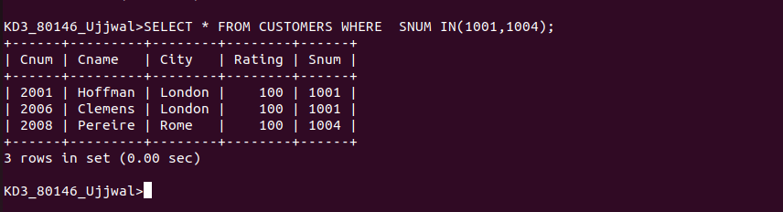

3 WRITE A QUERY THAT WILL PRODUCE ALL THE CUSTOMERS WHOSE NAME BEGIN WITH A LETTER FROM ‘A’ TO ‘G’

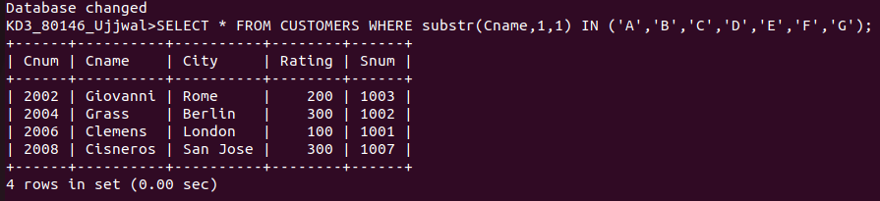

4 write a query that selects all customers whose name begin with the latter ‘c’

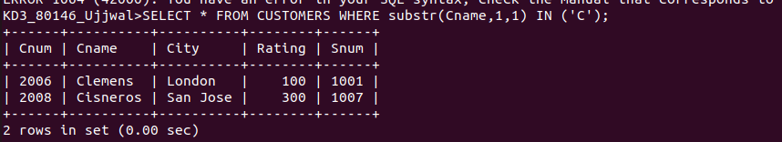

5 write a query that selects all orders except those with zeros or null in the AMT
FIELD ;

