Assignment 8
`1
Assume each salesperson has 12 % commission wrte a query on orders table that will produce the order number , the salesperos number , and the amount of the sales pperson commission fro that orders

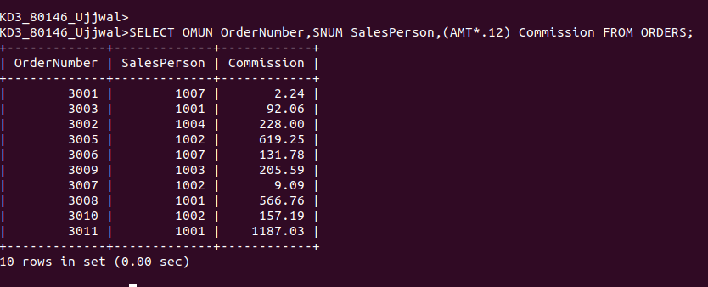

2 Write a query on the customers table that will find the highest in each city put the output in this form:
for the city (city),the highest rating is : (rating)

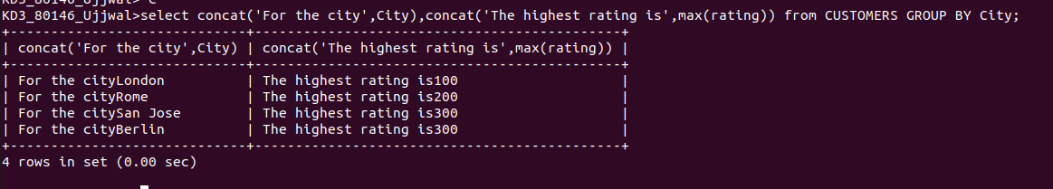

3 write a query that lists customers in descending orders of rating .output the rating field first ,followed by the customer s name and numbers;



4 write a query that total the orders from each day and places the result in descending order.

