ASSIGNMENT NO. 12

Using the operators IN , ANY ,ALL.
Q.1. Write a query that slects all customers whose rating are equal to or
greater than ANY of SERRES

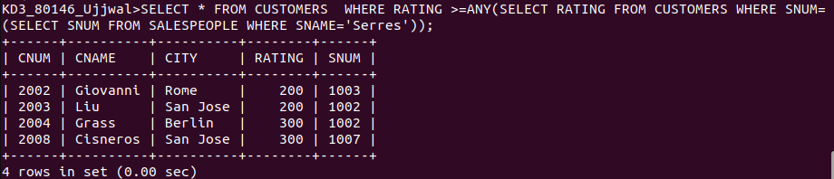
Q.2. Write a querty using ANY or ALL that will find all salespeople who hane no customer located in their city.

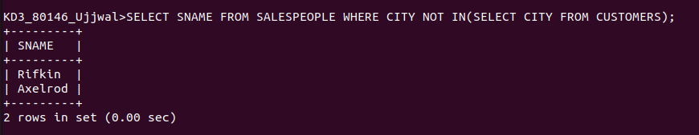

S

Q.3. Write a query that selects all orders for amounts greater than any for the customers in London.
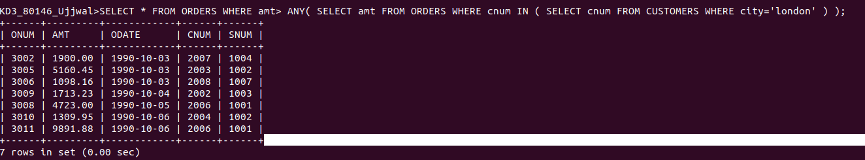

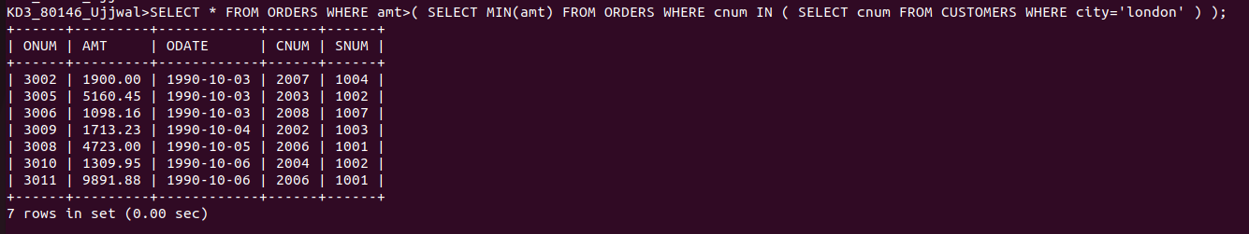
Q.4. Write the above query using MIN or MAX.

