ASSIGNMENT NO. 14

Entering, Deleting and changing field values.
Q.1. Write a command that puts the following values;in their given order,into the salespeople table : city- san jose, name – blanco, comm- null,cnum=1100

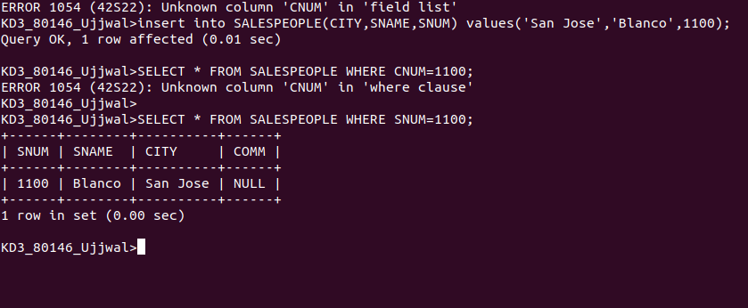

Q.2. Write a command that removes all orders from customers Clemens from the order table.

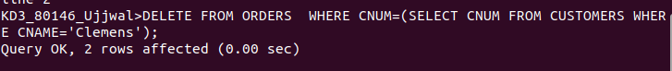

Q.3. Write a command that increses the rating of all customers in Rome by 100.

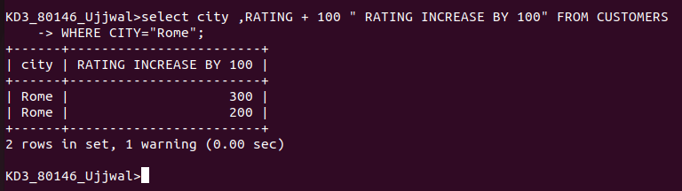

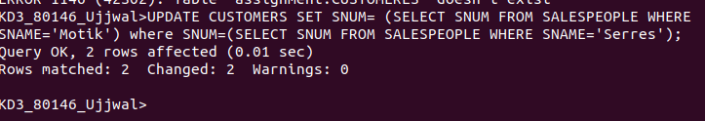
Q.4. Salesperson Serres has left the companyAssign her customers to Motika.

