Assignment 7

Summarizing data query that count all orders from oct 3

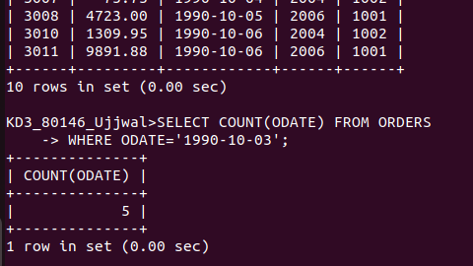

2 write a query that count the number of different non – null city values in customers tables.

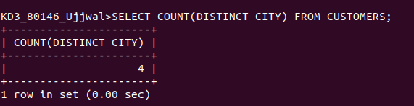

3 write a query that select each customers smallest order.

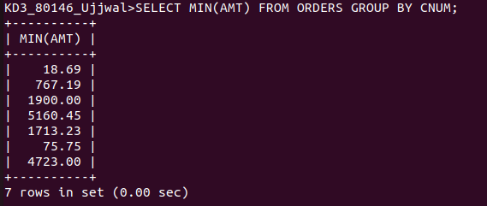

4 WRITE A QUERY THAT SELECTS THE FIRST CUSTOMERS IN ALPHBETICAL ORDERS, WHOSE NAME BEGINE WITH ‘G’

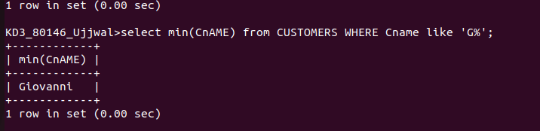

5 Write a query that select the highest rating in each city

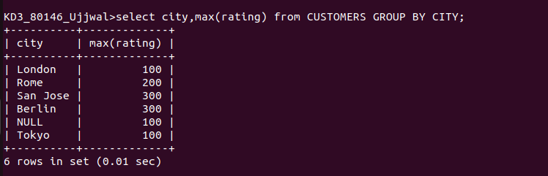

6 write a query that counts the number of salespeople registering orders for eah day .(if a salesperson has more than one order on given day he or she be counted only once).
