ASSIGNMENT -9

WRITE A QUERY THAT LIST EACH ORDERS NUMBER FOLLOWS BY THE NAME BY THE NAME OF THE CUSTOMER WHO MADE THE ORDERS

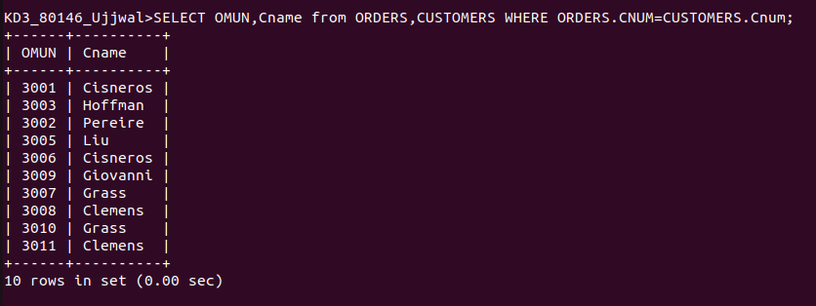

WRITE A QUERY THAT GIVES THE NAME OF BOTH THE SALESPERSON AND THE CUSTOMERS FROM EACH ORDERS ALONG WITH THE ORDERS

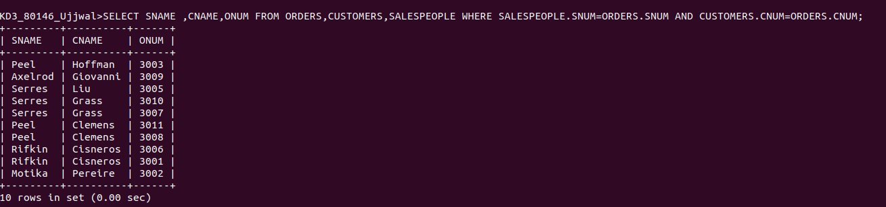

WRITE A QUERY THAT PRRODUCES ALL CUSTOMERS SERVICED BY SALESPEOPLES WITH A COMMISSION ABLVE 12% OUTPUT THE CUSTOMERS NAME THE SALESPEOPLES NAME AND THE SALESPERSONS RATE OF COMMISSION

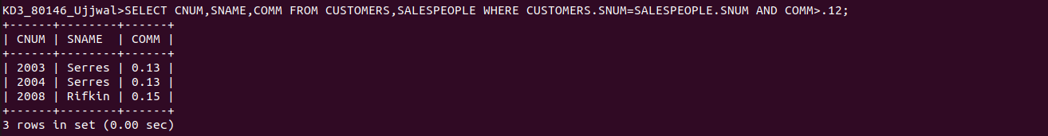
1

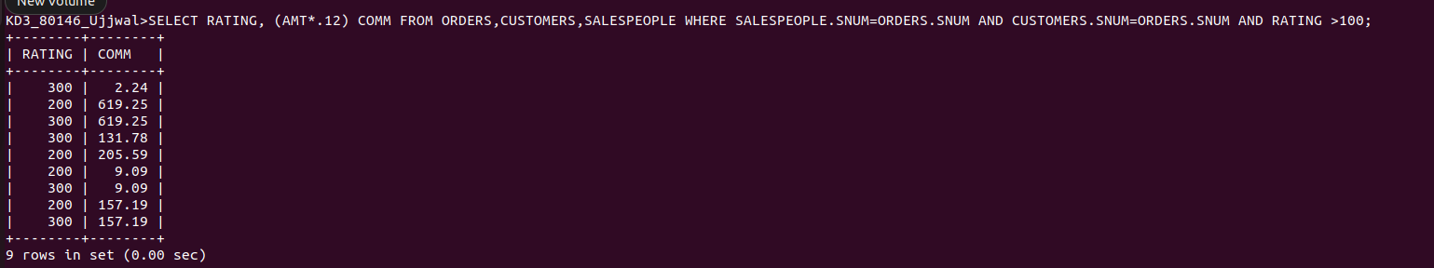
WRITE A QUERY THAT CALCULATE THE AMOUNT OF THE SALESPEOPLES COMMISSION ON EACH ORDERS BY A CUSTOMERS WITH A RATING ABOVE 100.

