1 Cal

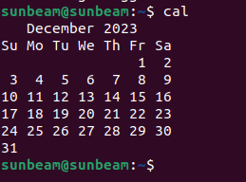

2 Cat insert

3 cat

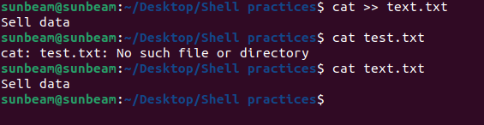

4 cp
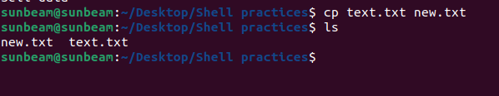

5 date
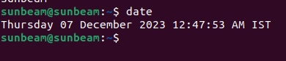

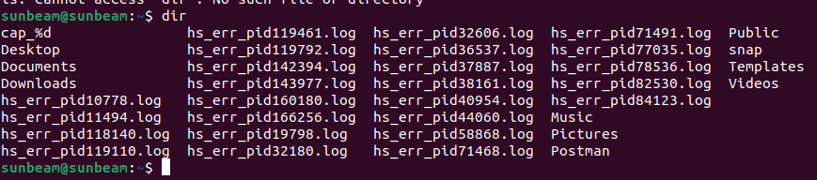
6 dir

7 hostname
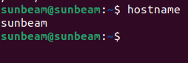

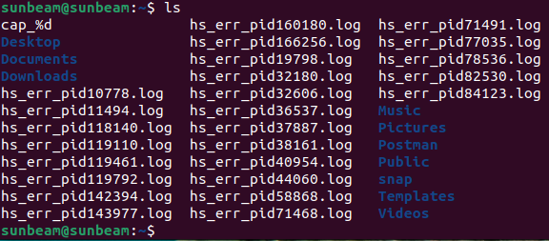
8 ls

9 pwd

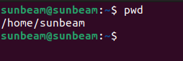

10 env

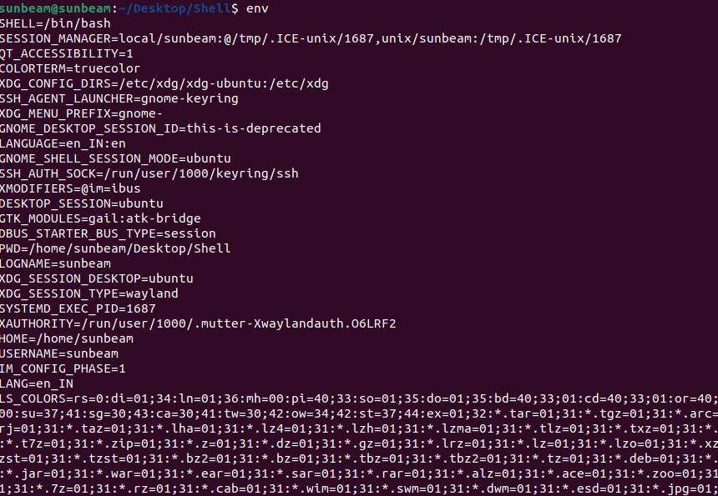

11 mv

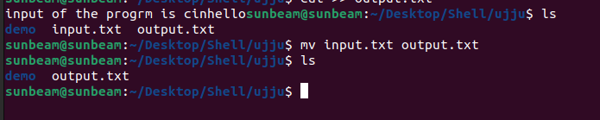
12 rev



tac
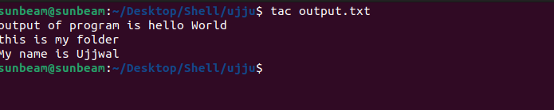

wc



mkdir



cd practice

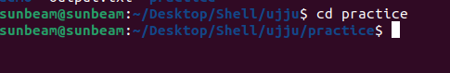

rm

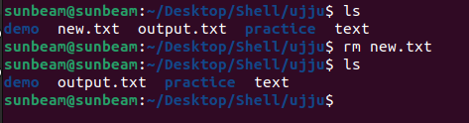

rmdir

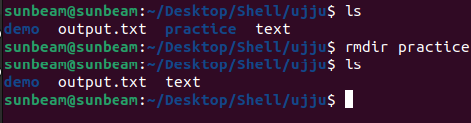

touch
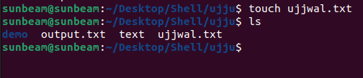

touch
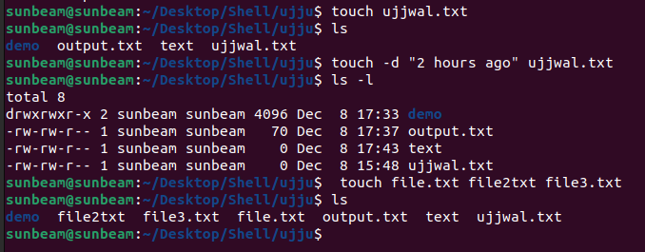

sort

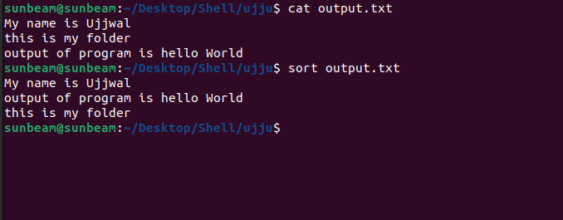

uniq


head tail

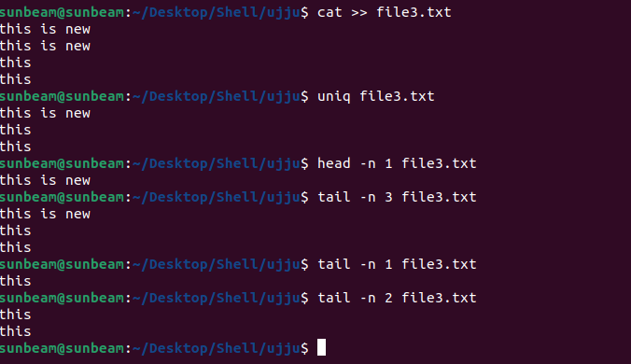

factor


echo



ps

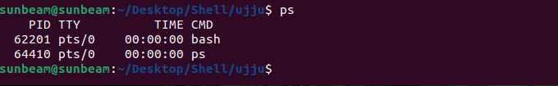

kill

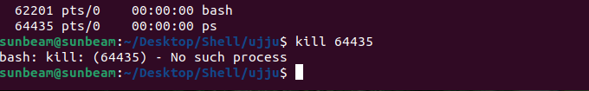

username

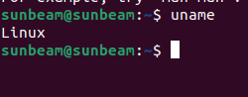

username -a

