|  |
| --- |
| **A**  **PROJECT REPORT ON** |
|  |
|  |
| Sai Darshan Online Booking Portal |
|  |
|  |
| SUBMITTED IN  PARTIAL FULFILLMENT OF  **DIPLOMA IN ADVANCED COMPUTING (PG-DAC)** |
|  |
|  |
|  |
|  |
|  |
|  |
|  |
| **BY**  **Mugdha Moghe ,Himanshu Rathore , Prashant Rathore ,Unnati Joshi.** |
|  |
|  |
| **UNDER THE GUIDENCE OF**  **Rugveda Kulkarni** |

|  |  |
| --- | --- |
| **SUNBEAM INSTITUTE OF INFORMATION TECHNOLOGY,**  **Karad** | |
|  | |
|  | |
|  | |
|  | |
| **CERTIFICATE** | |
|  | |
| This is to certify that the project | |
|  | |
| Sai Darshan online Booking Portal | |
|  | |
| Has been submitted by | |
|  | |
| **Mugdha Moghe** | |
|  | |
|  | |
| In partial fulfillment of the requirement for the Course of **PG Diploma in Advanced Computing (PG-DAC September 2023)** as prescribed by The **CDAC** ACTS, PUNE. | |
|  | |
|  | |
| Place: Karad | Date: 19th-Feb-2024 |
|  | |
|  | |
|  | |
|  | |
|  | |
| **Rugveda Kulkarni** | **Mr. Pratik Ninganur** |
| **Project Guide** | **Course Coordinator** |

# **SHRI SAI DARSHAN ONLINE**

# **BOOKING PORTAL**

## **Introduction**

It is an online portal for all the Sai Devotees to book the darshan slot on for Sai Darshan at Shridi. Its offering the bookings for pooja and aarti too. Where the devotee can look for the availability of the respective slots for the chosen date.

Its a user friendly platform where all types of people can make bookings and respective payments. The website also offers all the Sai Darshan Trust facilities like accommodation.

## The user can book rooms at the Bhakt Niwas Sthan associated with the SHRI SAIBABA SANSTHAN TRUST,SHIRDI

**Technology Used**

* J2EE
* MySQL
* React JS

**List Of Tables**

|  |  |
| --- | --- |
| **Section** | **Table Title** |
| 1 | Secure_Users |
| 2 | Address |
| 3 | Darshan |
| 4 | Pooja |
| 5 | Arti |
| 6 | Accommodation |

**Table Structures**

1. **Secure_Users**

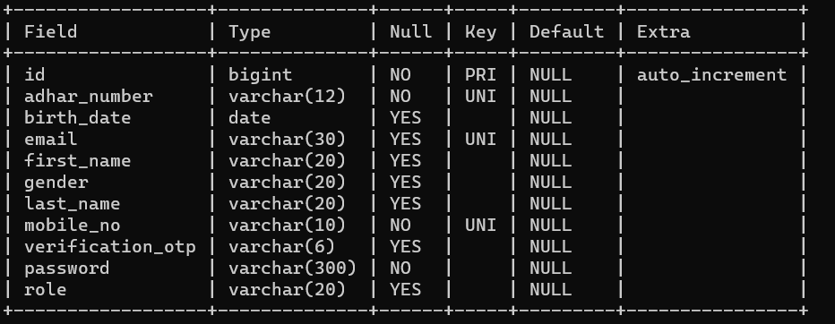

1. **Address**

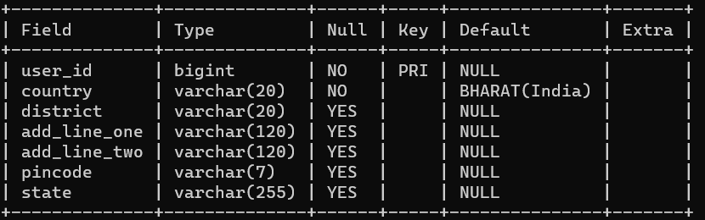

1. **Darshan**

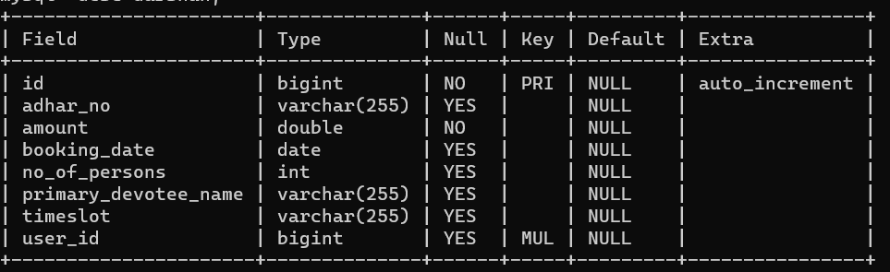

1. **Pooja**

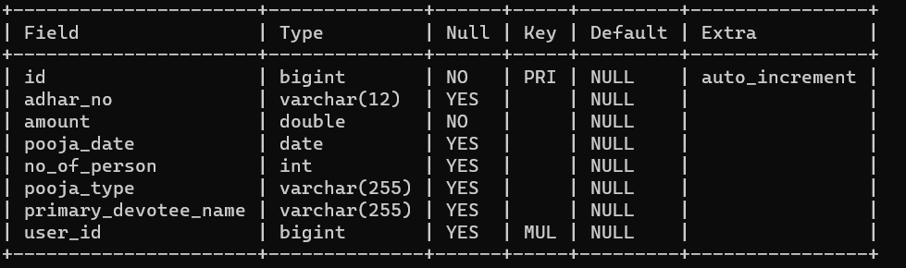

1. **Arti**

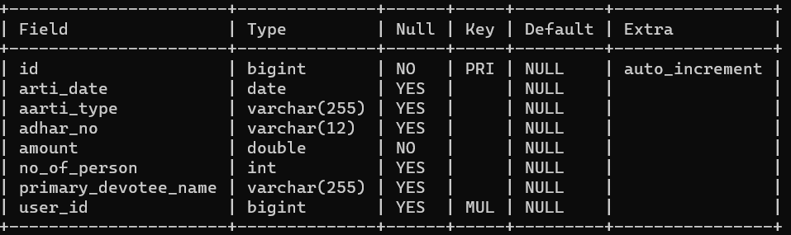

1. **Accommodation**

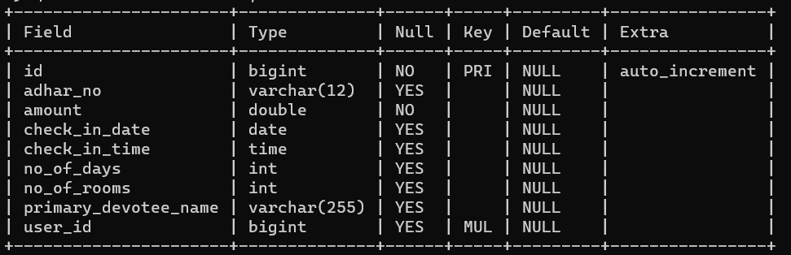

**Functional Requirements**

1. **Overall UML Diagram**

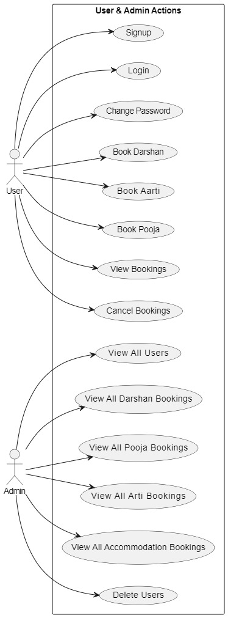

**Admin:**

-Admin would be having a unique login id and password.

-For Admin, there would be a dashboard available where he/she can toggle through the devotee data and also can create a manager account  and keep the payment and transaction record.

-Admin Can delete the users and can see all the bookings of all types.

**Devotees:**

-New users can Register on to the website as well as view all the functionalities such as Darshan, Aarti, Pooja, Accommodation all the other latest news or updates.

-For logging in, the user needs to enter in the valid mail id and password.

-Accordingly, the data would be checked for the existing user and he/she would be granted with the access to log in.

-After logging in, user can update the profile/ change the password/ check the transaction history.

-After logging in users can set up their address details.

1. **Admin**

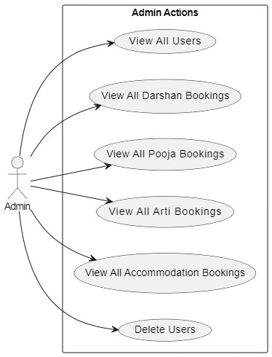

**Admin:**

-Admin would be having a unique login id and password.

-For Admin, there would be a dashboard available where he/she can toggle through the devotee data and also can create a manager account  and keep the payment and transaction record.

-ONLY Admin has access to manage the premium functionalities like Accommodation.

-Can handle grievances if any.

1. **Devotees**

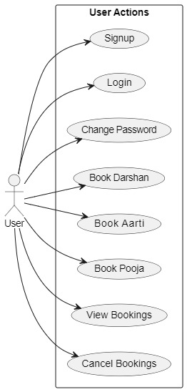

**User:**

-New users can Register on to the website as well as view all the functionalities such as Darshan, Aarti, Pooja, Accommodation all the other latest news or updates.

-For logging in, the user needs to enter in the valid mail id and password.

-Accordingly, the data would be checked for the existing user and he/she would be granted with the access to log in.

-After logging in, user can update the profile/ change the password/ check the transaction history.

-Only after logging in, the user can make the transactions.

-While making the transactions there are certain limitations on number of bookings for each of the Darshan, Pooja, Aarti functionalities and accordingly, amount will be calculated for each booking.

**Database Design**

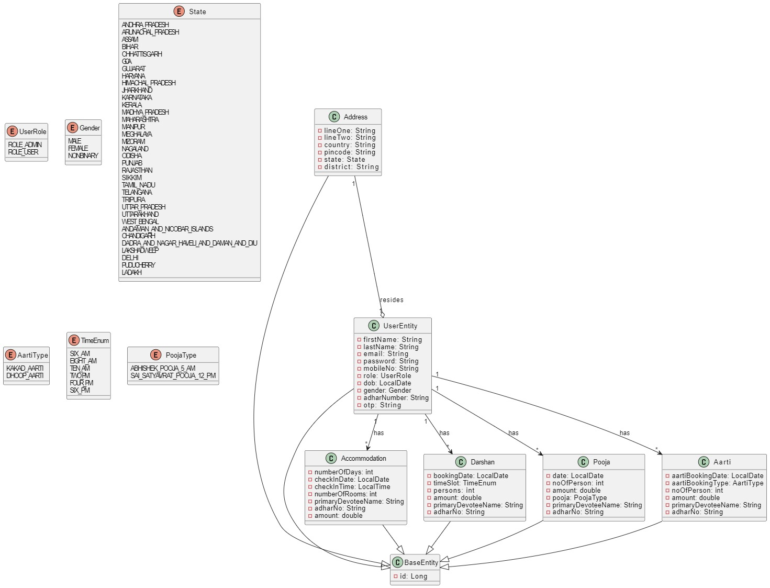

**E-R Diagram**

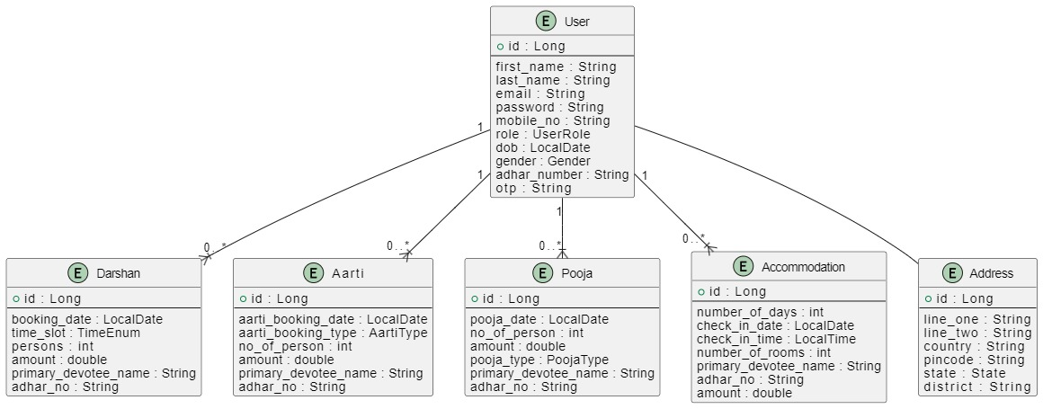

**Functional Requirements:**

**User:**

-New users can Register on to the website as well as view all the functionalities such as Darshan, Aarti, Pooja, Accommodation, Donation, Membership and all the other latest news or updates.

-For logging in, the user needs to enter in the valid mail id and password OR using a mobile number he/she can enter the OTP.

-Accordingly, the data would be checked for the existing user and he/she would be granted with the access to log in.

-After logging in, user can update the profile/ change the password/ check the transaction history.

-Only after logging in, the user can create a wishlist and make the transactions.

-While making the transactions there are certain limitations on number of bookings for each of the Darshan, Pooja, Aarti functionalities and accordingly, amount will be calculated for each booking. 

**Admin:**

-Admin would be having a unique login id and password.

-For Admin, there would be a dashboard available where he/she can toggle through the users/ devotee/managers data and also can create a manager account  and keep the payment and transaction record.

-ONLY Admin has access to manage the premium functionalities like Accommodation.

-Can handle grievances if any.

**Non-Functional requirements:**

-Captcha generation for each login.

-Auto OTP generation for login using mobile number.

-Auto confirmation mail generation for each new registration.

-Security checking for passwords.

-Secure payment portal.

-Payment status updating mail to user (After each transaction).



