**ASSIGNMENT1**

**Q1 –** SALESPEOPLE

Snum int(4)

Sname varhar(10)

City varchar(10)

Comm float(3,2)

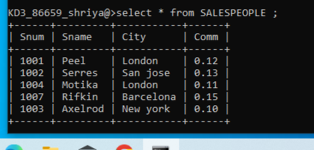

**Q2 –** CUSTOMERS

Cnum int(4)

Cname varchar(10)

City varchar (10)

Rating int (4)

Snum int (4)

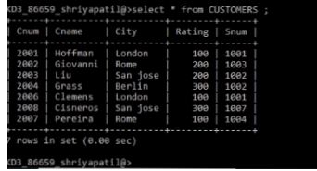

**Q3-** ORDERS

Onum int(4)

Amt float(7,2)

Odate date

Cnum int(4)

Snum int(4)

