OS commands:
1. man
-commands to get help about another commands.

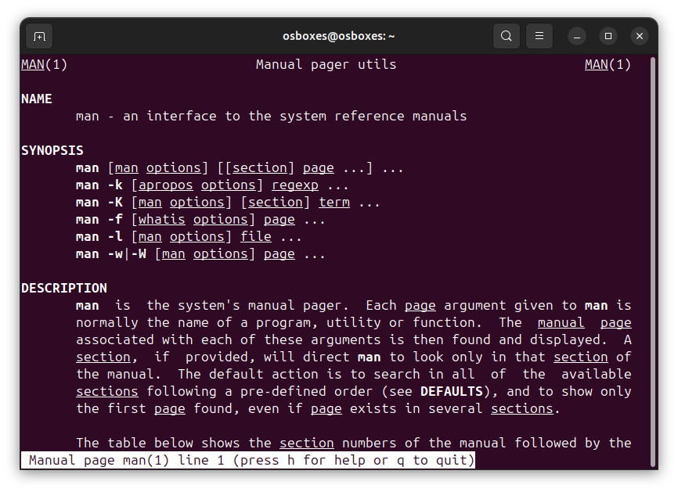
2.Uname:
-prints user information on which currently you are working.
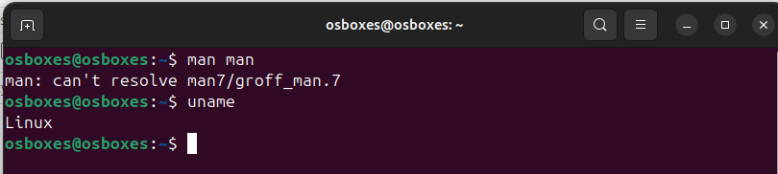
3.Pwd:
-print current directory in which we are working.

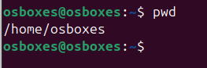

4.hostname :
- it will Print hostname on the machine.

5.Date:
6.cal:
O/P :
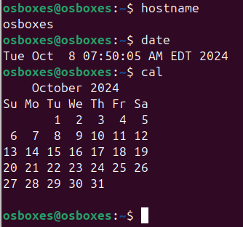

7. ls,dir

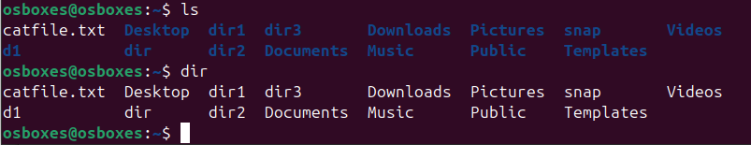
8. cat:

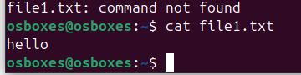

9.cat >>

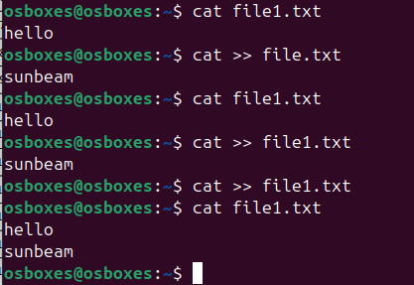
10. cp

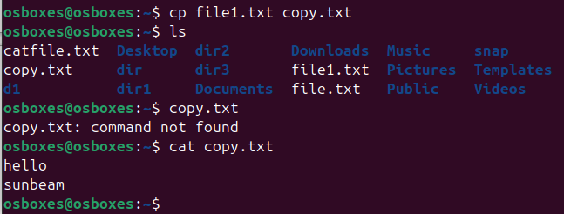
11. mv


12. mv

-To rename a file

13. tac, rev
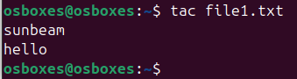
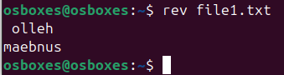
14. wc:

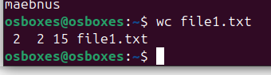
15. mkdir

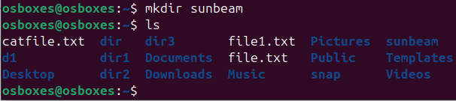
16.cd

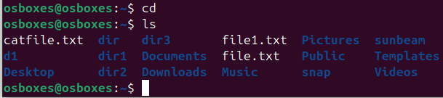
17. rm
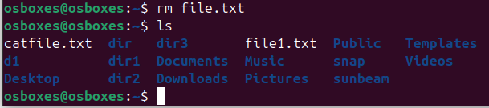

18.rmdir
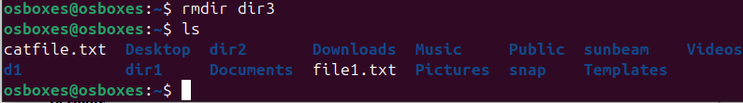
19.touch

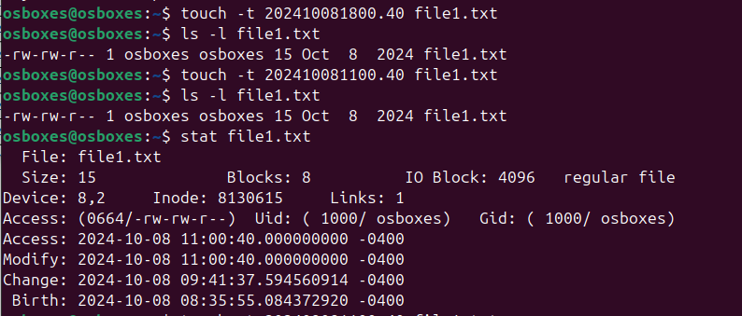
20. Sort:

21. Uniq:

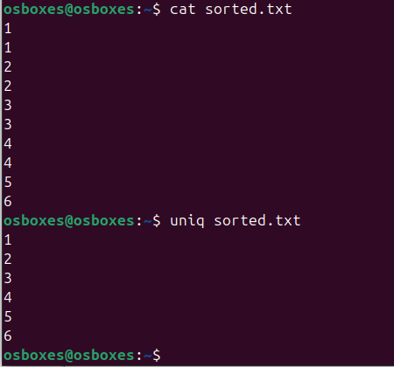

22. head:
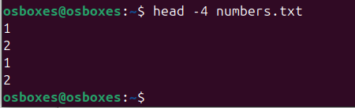

23. tail
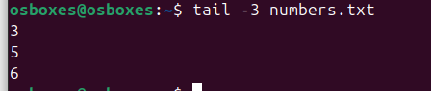

24. factor

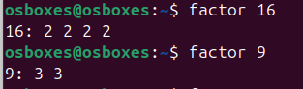

25. alias:

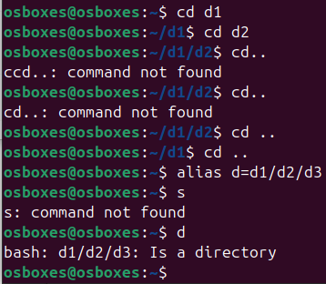

26.

