**Assignment 3**

Q1. Write a menu driven program to calculate volume of the box(length * width * height). Provide parameterless, parameterized(with 3 parameters) and single paramaterized constructor. Create the local objects in respective case and call the function to caluclate area. Menu options -> 1. Calculate Volume with default values 2. Calculate Volume with length,breadth and height with same value 3. Calculate Volume with different length,breadth and height values.

ANS:

#include <iostream>

using namespace std;

class box{

    int length;

    int breadth;

    int height;

public:

    box(){

        length = 10;

        breadth = 12;

        height = 15;

    }

    box(int n){

        length = n;

        breadth = n;

        height = n;

    }

    box(int l, int b, int h){

        length = l;

        breadth = b;

        height = h;

    }

    void volumedef1(){

         int vol1 = height*breadth*length;

         cout<<"Volume is "<<vol1<<endl;

    }

    void volumedef2(){

         int vol2 = height*breadth*length;

         cout<<"Volume is "<<vol2<<endl;

    }

    void volumedef3(){

         int vol3 = height*breadth*length;

         cout<<"Volume is "<<vol3<<endl;

    }

};

int menu(){

    int n;

    cout<<"For default value enter 1 "<<endl;

    cout<<"For Three Parameter enter 2 "<<endl;

    cout<<"For One Parameter enter 3 "<<endl;

    cout<<"For exit enter 0 "<<endl;

    cin>>n;

    return n;

}

int main(){

    int men;

    while((men=menu()) != 0){

        switch (men)

        {

        case 1:

            {

                box b1;

                b1.volumedef1();

            }

            break;

        case 2:

            {

                int n1;

                cout<<"Enter One parameter: ";

                cin>>n1;

                box b2(n1);

                b2.volumedef2();

            }

            break;

        case 3:

            {

                int n1,n2,n3;

                cout<<"Enter three parameter: ";

                cin>>n1>>n2>>n3;

                box b3(n1,n2,n3);

                b3.volumedef3();

            }

            break;

        default:

            cout<<"Wrong Input"<<endl;

            break;

        }

    }

}

Output:

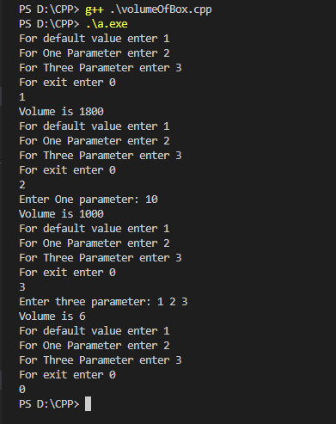

Q2. Imagine a tollbooth at a bridge. Cars passing by the booth are expected to pay a fifty-cent toll. Mostly they do, but sometimes a car goes by without paying. The tollbooth keeps track of the number of cars that have gone by and of the total amount of money collected. Model this tollbooth with a class called tollbooth. The two data items are a type unsigned int to hold the total number of cars, and a type double to hold the total amount of money collected. A constructor initializes all data members to 0. A member function called payingCar() increments the car total and adds 0.50 to the cash total. An other function, called nopayCar() increments the car total but adds nothing to the cash total. Finally, a member function called printOnConsole() displays the two totals and number of paying as well as non paying cars total

ANS:

#include <iostream>

using namespace std;

class tollbooth{

int car;

double amount;

int totalcar;

public:

tollbooth(){

car = 0;

amount = 0.0;

totalcar = 0;

}

void paynigCar(){

totalcar++;

amount = amount + 0.50;

}

void nopayCar(){

car++;

totalcar++;

}

void printonConsole(){

cout<<"Total numbers of car are : "<<totalcar<<endl;

cout<<"Totan Number of car have not paying toll "<<totalcar - car<<endl;

cout<<"Total Amount is : "<<amount<<endl;

}

};

int menu(){

int n;

cout<<"For freeToll enter 1 "<<endl;

cout<<"For Not Free Toll enter 2 "<<endl;

cout<<"For Printing result enter 3 "<<endl;

cout<<"For exit enter 0 "<<endl;

cin>>n;

return n;

}

int main(){

tollbooth t1;

int men;

while ((men=menu()) !=0)

{

switch (men)

{

case 1:

t1.nopayCar();

break;

case 2:

t1.paynigCar();

break;

case 3:

t1.printonConsole();

break;

default:

cout<<"Wrong Input";

break;

}

}

return 0;

}

