DATABASE TECHNOLOGY ASSIGNEMENT NO.1

NAME : PRATHAMESH HENDRE

ROLL NO. 86752 GROUP : KD3

TABLE SALESPERSONE:

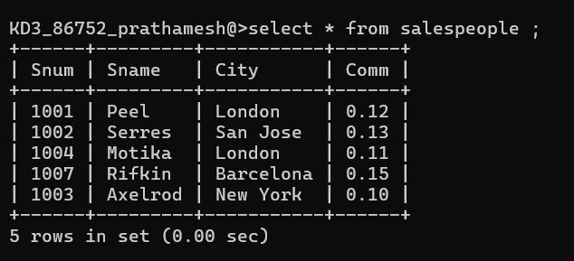

TABLE CUSTOMERS:

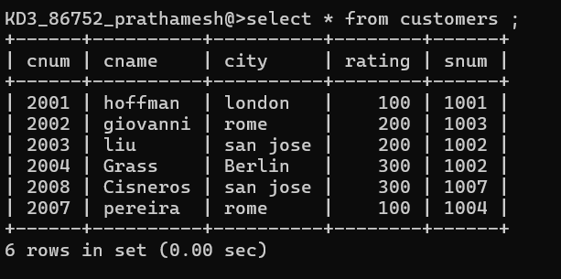

TABLE ORDERS:

