**Assignment –1**

**Creating sample tables and inserting values.**

Create the following tables with the given structures and insert sample data as specified: -

create table SALESPEOPLE ( Snum int(4) ,Sname varchar(10) ,City varchar(10) ,Comm float(3,2) );

create table CUSTOMERS (Cnum int(4) ,Cname varchar(10), City varchar(10) ,Rating int(4), Snum int(4));

create table ORDERS (Onum int(4) , Amt float(7,2) , Odate date , Cnum int(4) , Snum int(4) );

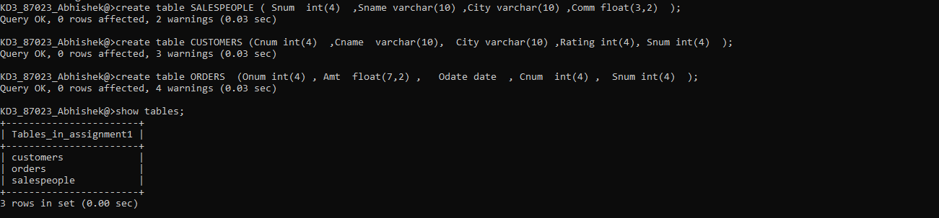

insert into salespeople values (1001,'Peel','London',.12);

insert into salespeople values (1002,'Serres','San Jose',.13);

insert into salespeople values (1004,'Motika','London',.11)

insert into salespeople values (1007,'Rifkin','Barcelona',.15);

insert into salespeople values (1003,'Axelrod ','New York ',.10);

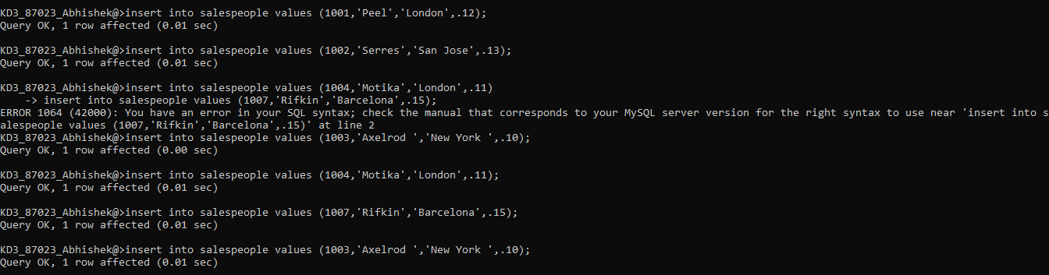

insert into customers values(2001,'Hoffman','London',100,1001);

insert into customers values(2002 ,'Giovanni ','Rome ',200,1003);

insert into customers values(2003,'Liu','San Jose',200,1002);

insert into customers values(2004,'Grass','Berlin',300,1002);

insert into customers values(2006,'Clemens ', ' London', 100,1001 );

insert into customers values(2008,'Cisneros ', 'San Jose ',300,1007 );

insert into customers values(2007,'Pereira ', 'Rome ', 100, 1004);

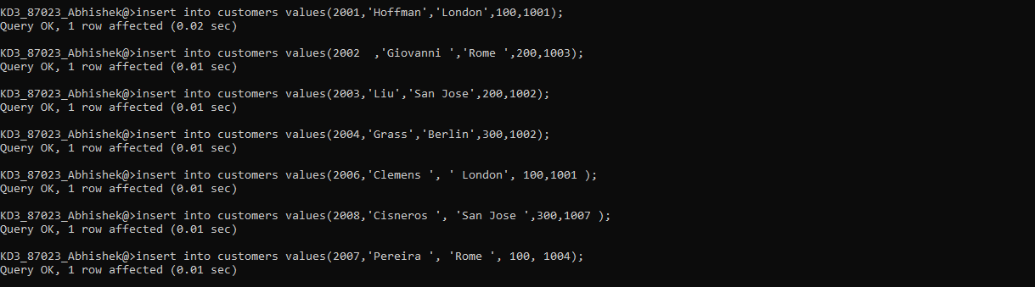

insert into orders values(3001,18.69,'1990-10-03' ,2008 ,1007 );

insert into orders values(3003,767.19,'1990-10-03' ,2001 ,1001 );

insert into orders values(3002,1900.10,'1990-10-03' ,2007 ,1004 );

insert into orders values(3005,5160.45,'1990-10-03' ,2003 ,1002 );

insert into orders values(3006,1098.16,'1990-10-03' ,2008 ,1007 );

insert into orders values(3009,1713.23,'1990-10-04' ,2002 ,1003 );

insert into orders values(3007,75.75,'1990-10-04' ,2004 ,1002 );

insert into orders values(3008,4723.00,'1990-10-05' ,2006 ,1001 );

insert into orders values(3010,1309.95,'1990-10-06' ,2004 ,1002 );

insert into orders values(3011,9891.88,'1990-10-06' ,2006 ,1001 );

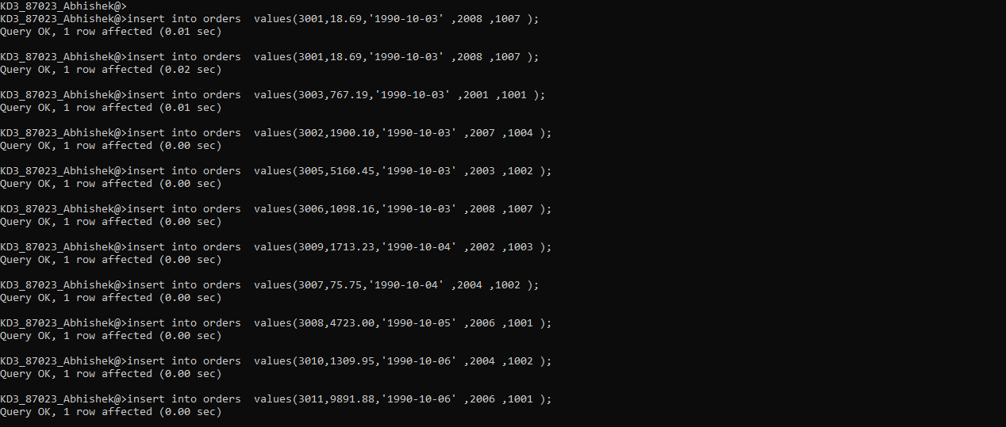

select * from salespeople;

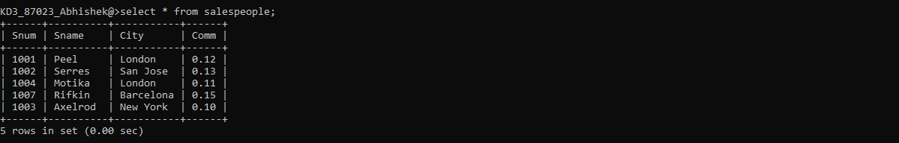

select * from customers;

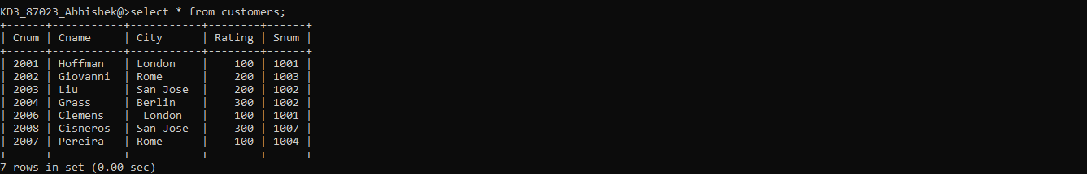

select * from orders;

