Assignment –4

Retrieving Information from Tables.

1) Write a select command that produces the order number, amount, and date for all

rows in the Orders table.

->

select onum,amt,odate from orders;

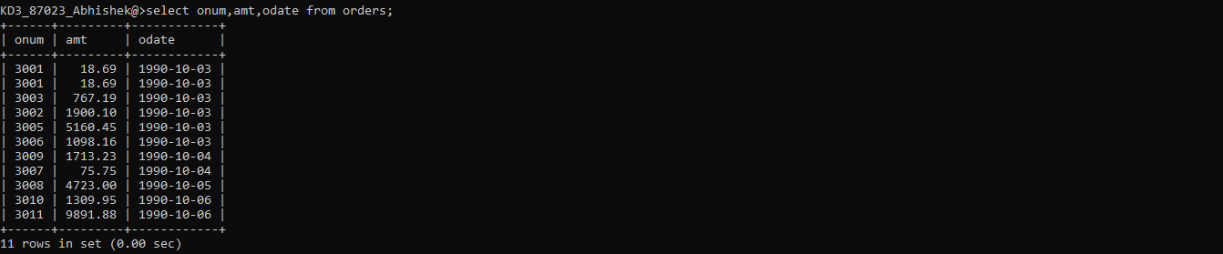

2) Write a query that produces all rows from the Customers table for which the

salesperson’s number is 1001.

->

select \* from customers where snum=1001;

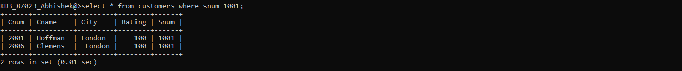

3) Write a query that displays the Salespeople table with the columns in the

following order: city, sname, snum, comm.

->

select city,sname,snum,comm from salespeople;

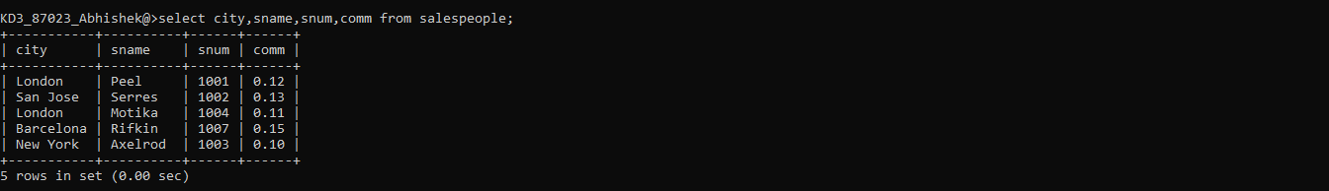

4) Write a select command that produces the rating followed by the name of each

customer in San Jose.

->

select rating,cname from customers where city='San Jose';



5) Write a query that will produce the snum values of all salespeople (suppress the

duplicates) with orders in the Orders table.

->

select distinct snum ,onum from orders;

