MYSQLASSIGNMENT3
Q 1 : Write a query to get unique department ID from employee table.
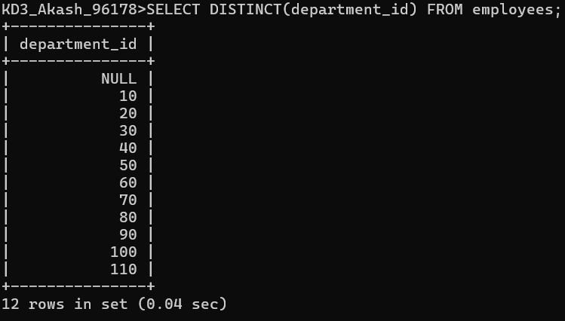
Q 2 : Write a query to get all the employee’s details from the employees table displaying the first names in descending order.
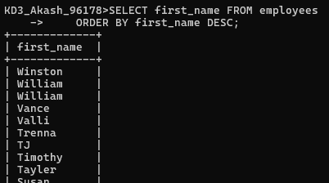
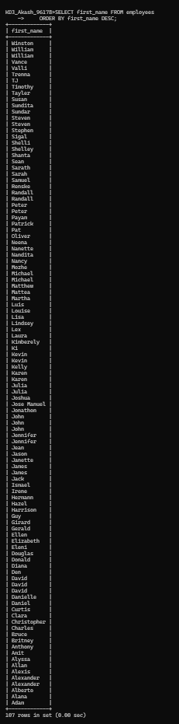
Q 3 : Write a query to get the employee ID, names (first_name and last_name), salary in ascending order of salary.
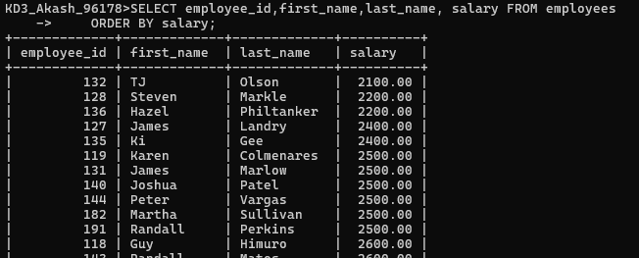


Q 4 : Display first name and joining date of the employees who are either IT Programmer or Sales Man.
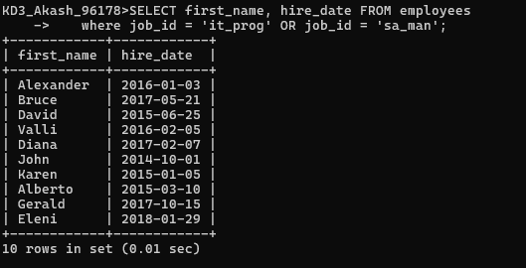
Q 5 : Display details of employees with employee ID 150 or 160.
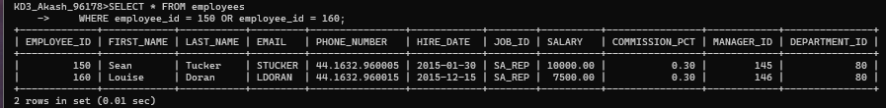
Q 6 :Display first name, salary, commission pct, and hire date for employees with salary less than 10000.
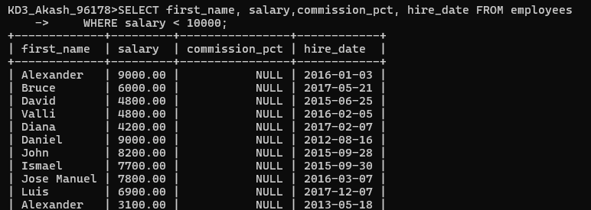
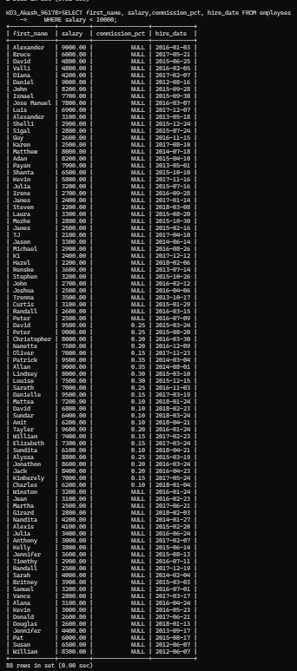

Q 7: Display employees where the first name or last name starts with S
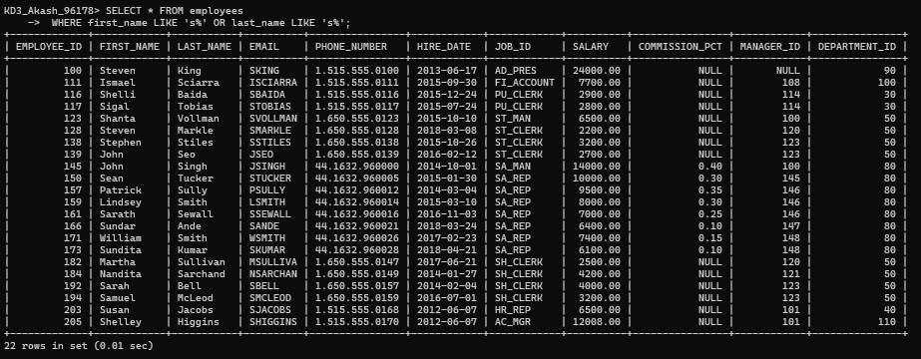
Q 8 : Display details of jobs in the descending order of the title.
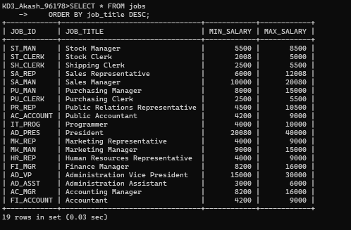
Q 9 : Display the details of the employees from department 30, earning the salary greater 10000 but do not receive the commission.
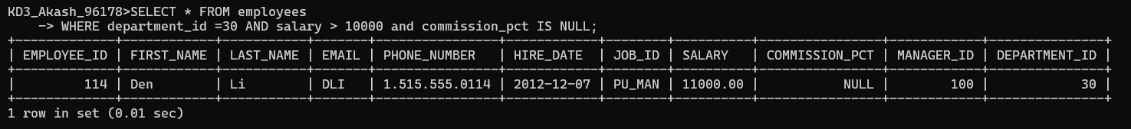
Q 10 : Display the details of employees reporting to the managers with employee id 100 and 120.
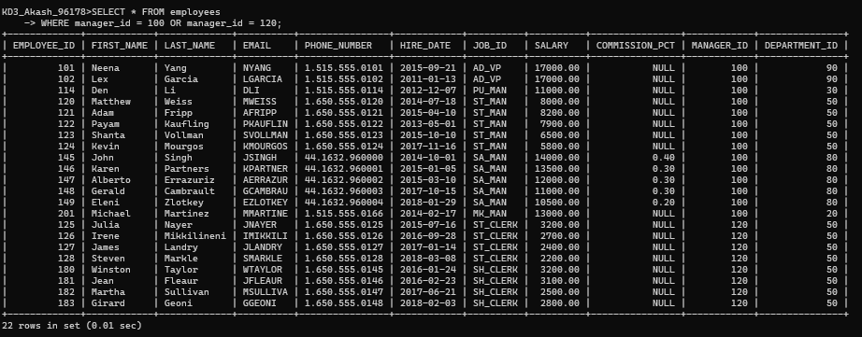
Q 11: Display the unique country_id from locations table.
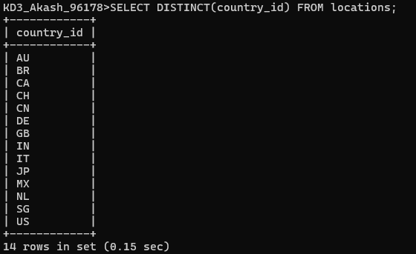
Q 12: Display all employees whose have the job_id as IT_PROG and FI_ACCOUNT.
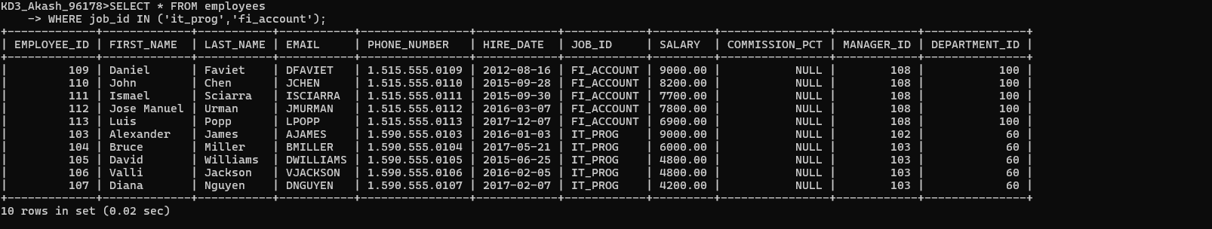

Q 13: Display all countries in ascending order.
