Database Technologies- Assignment 1
1. Create 'spj' database'. (Database for suppliers, parts and jobs).


2. use spj database;


3. Create following tables in spj database.

Table s:
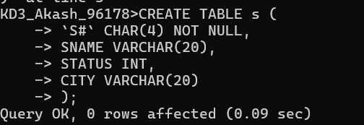

Table j:

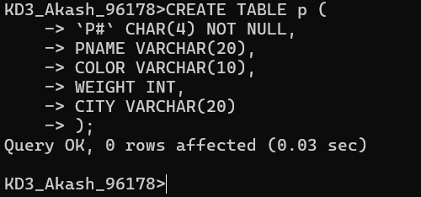

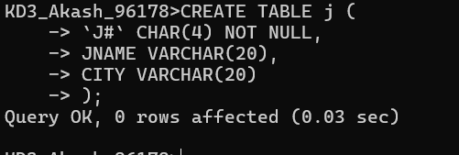

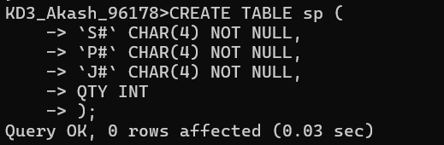
CREATE TABLE sp (S# CHAR(4) NOT NULL, P# CHAR(4) NOT NULL, J# CHAR(4) NOT NULL, QTY INT);
1. Create 'hr' database. Import hr-db.sql. 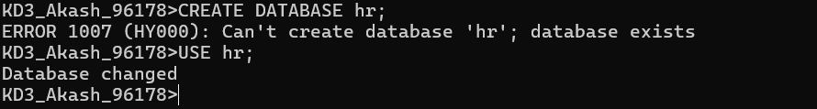
2. Create 'sales' database. Import sales-db.sql. 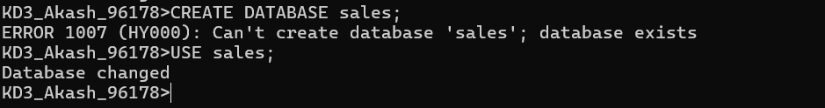
3. List all tables in hr database. Display contents of all tables (one by one).
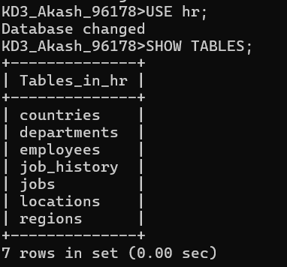
4. List all tables in sales database. Display contents of all tables (one by one).
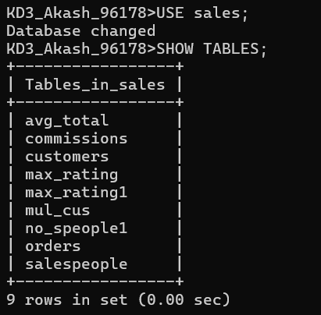

Answer the following questions (by observations only – not queries).
1. How many orders data is present in the database?
Ans: 10
2. How many customers are present in the database?
Ans: 7
3. How many salespeople are present in the database?
Ans:5
4. On which date order with highest amount is placed?
Ans:1990-10-04
5. For which order salesman got maximum commission? Hint: you need to refer data of two tables.
Ans: 3001
6. Which salesmen are handling more than two customers? Hint: you need to refer data of two tables.
Ans: Peel and Serres
7. Which city have single customer?
Ans: Berlin
8. Which city has multiple salespeople?
Ans: London
9. What is name of customer and salesman of the maximum amount order?
Clemens and Peel
10. Study relationship between the tables in sales database.

