LEETCODE PROBLEMS

JOINS PROBLEMS
1. Replace Employee ID With The Unique Identifier https://leetcode.com/problems/replace-employee-id-with-the-unique-identifier 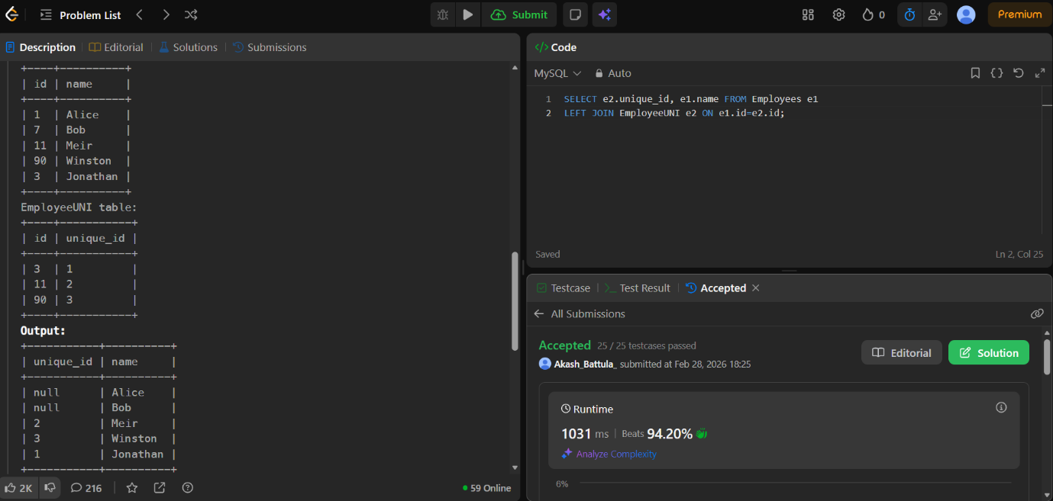

2. Product Sales Analysis I https://leetcode.com/problems/product-sales-analysis-i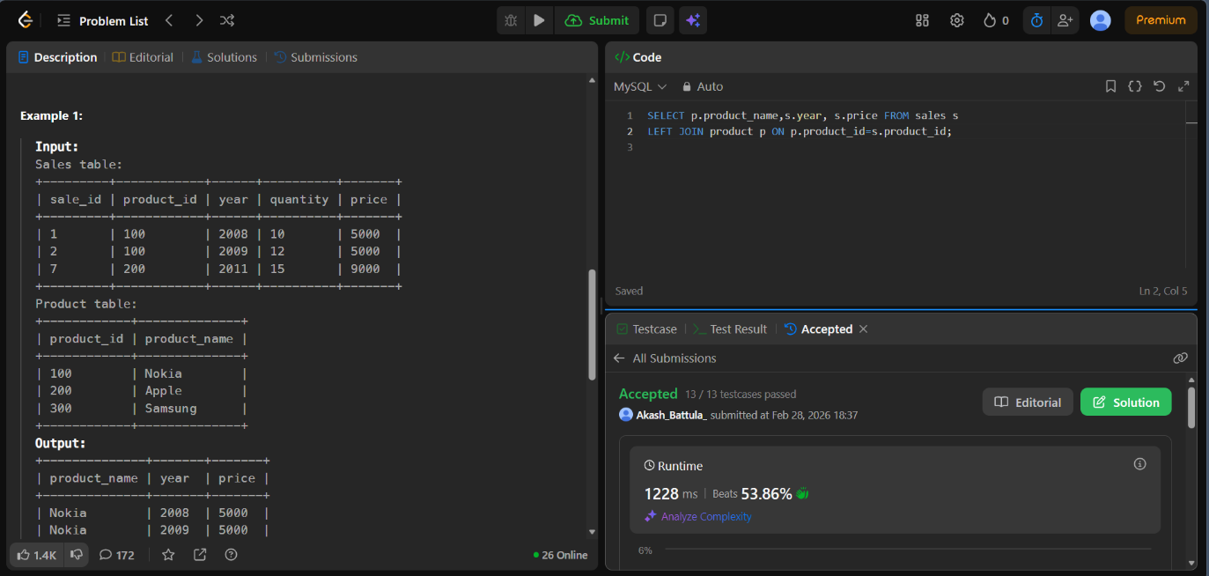

3. Employee Bonus https://leetcode.com/problems/employee-bonus
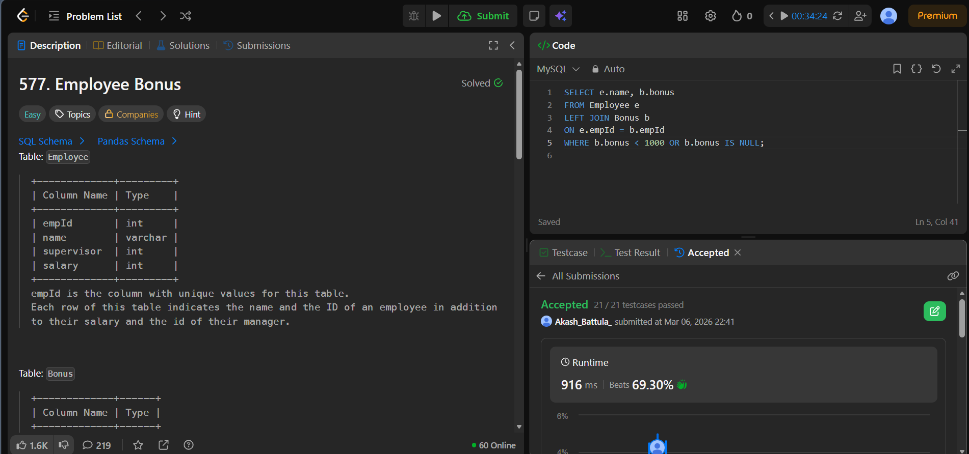
4. Students and Examinations https://leetcode.com/problems/students-and-examinations
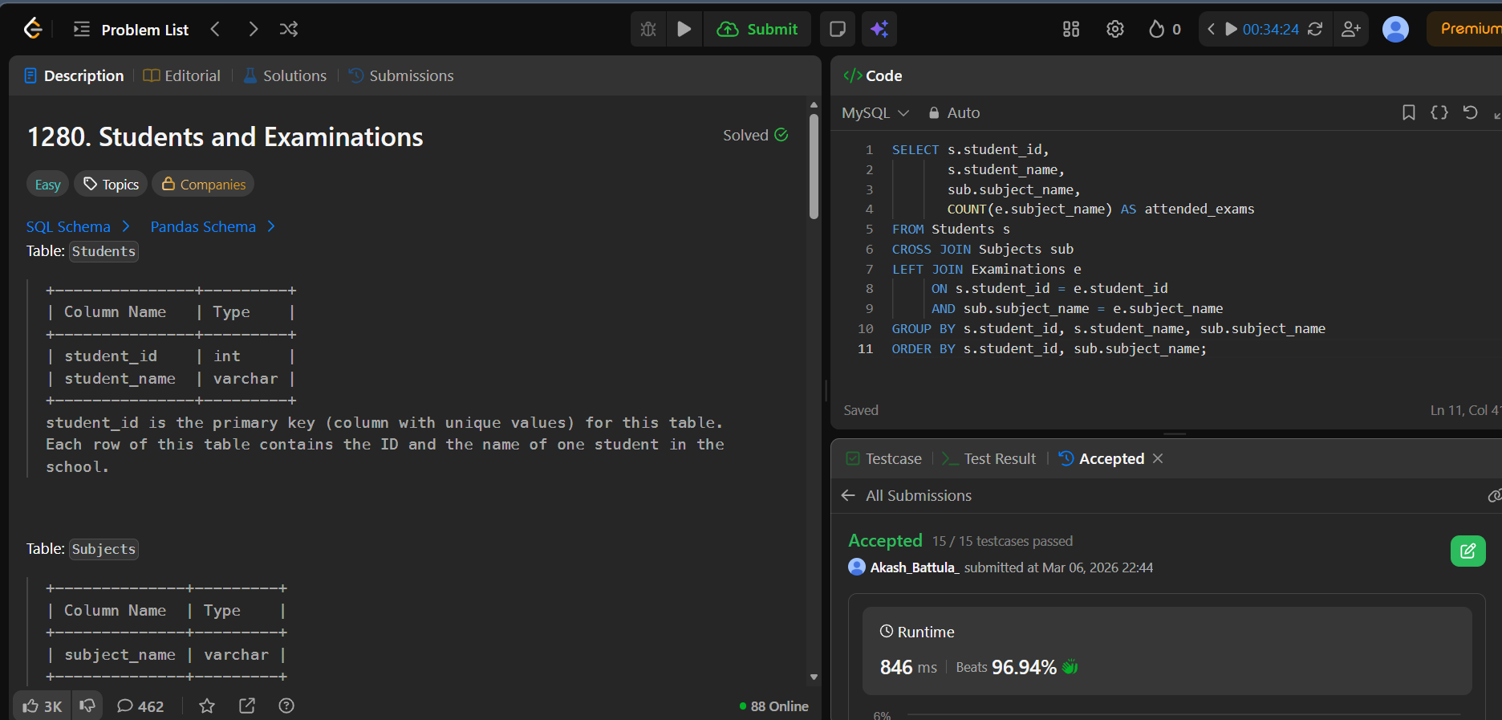

5. Managers With At Least 5 Direct Reports https://leetcode.com/problems/managers-with-at-least-5-direct-reports
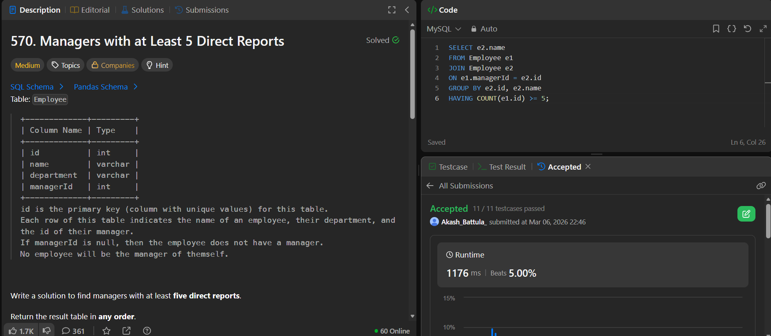

6. Asian Population https://www.hackerrank.com/challenges/asian-population
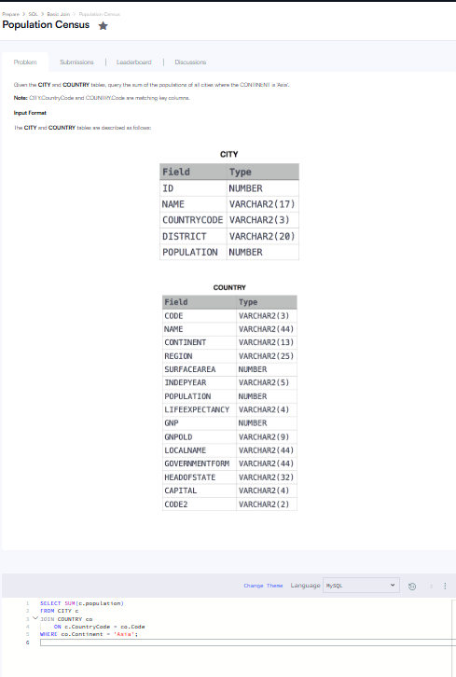

7. Average Population of Each Continent https://www.hackerrank.com/challenges/average-population-of-each-continent
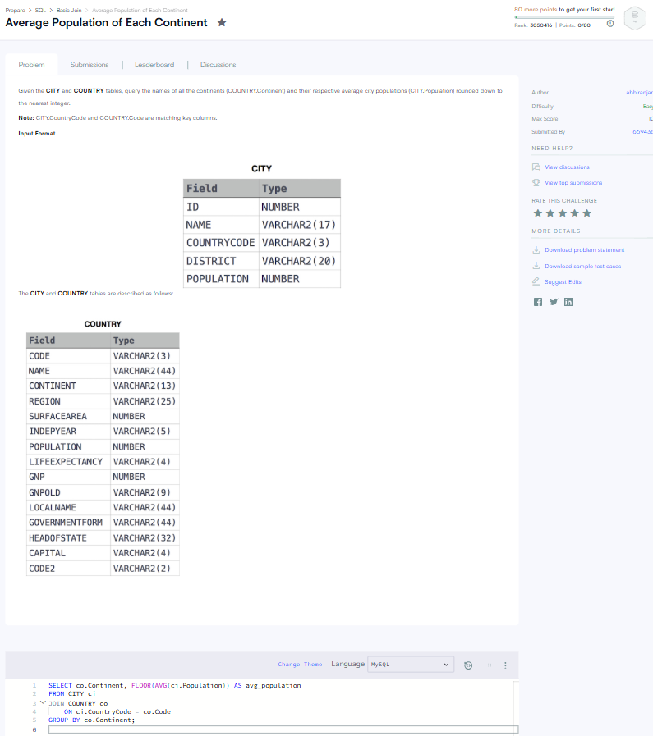

8. Last Person to Fit in the Bus https://leetcode.com/problems/last-person-to-fit-in-the-bus
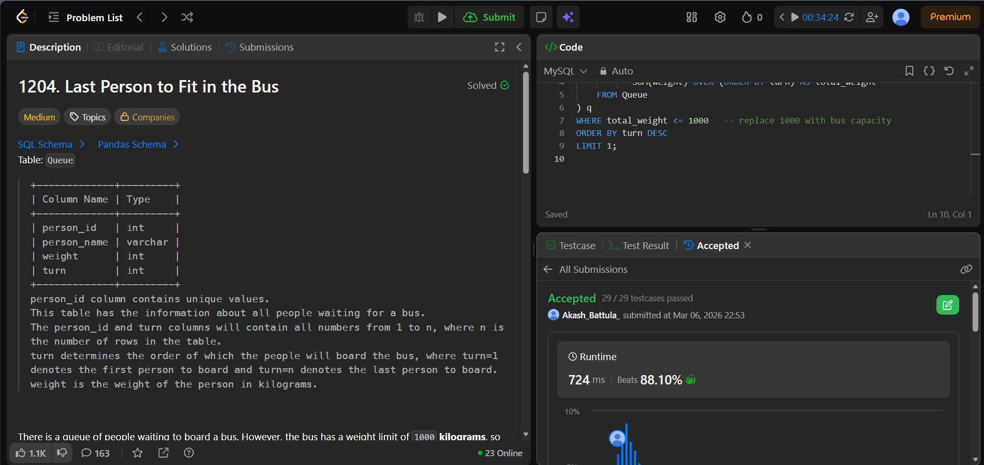

9. Product Price at a Given Date https://leetcode.com/problems/product-price-at-a-given-date
