Subquery Problems
181. Employees Earning More Than Their Managers https://leetcode.com/problems/employees-earning-more-than-their-managers/

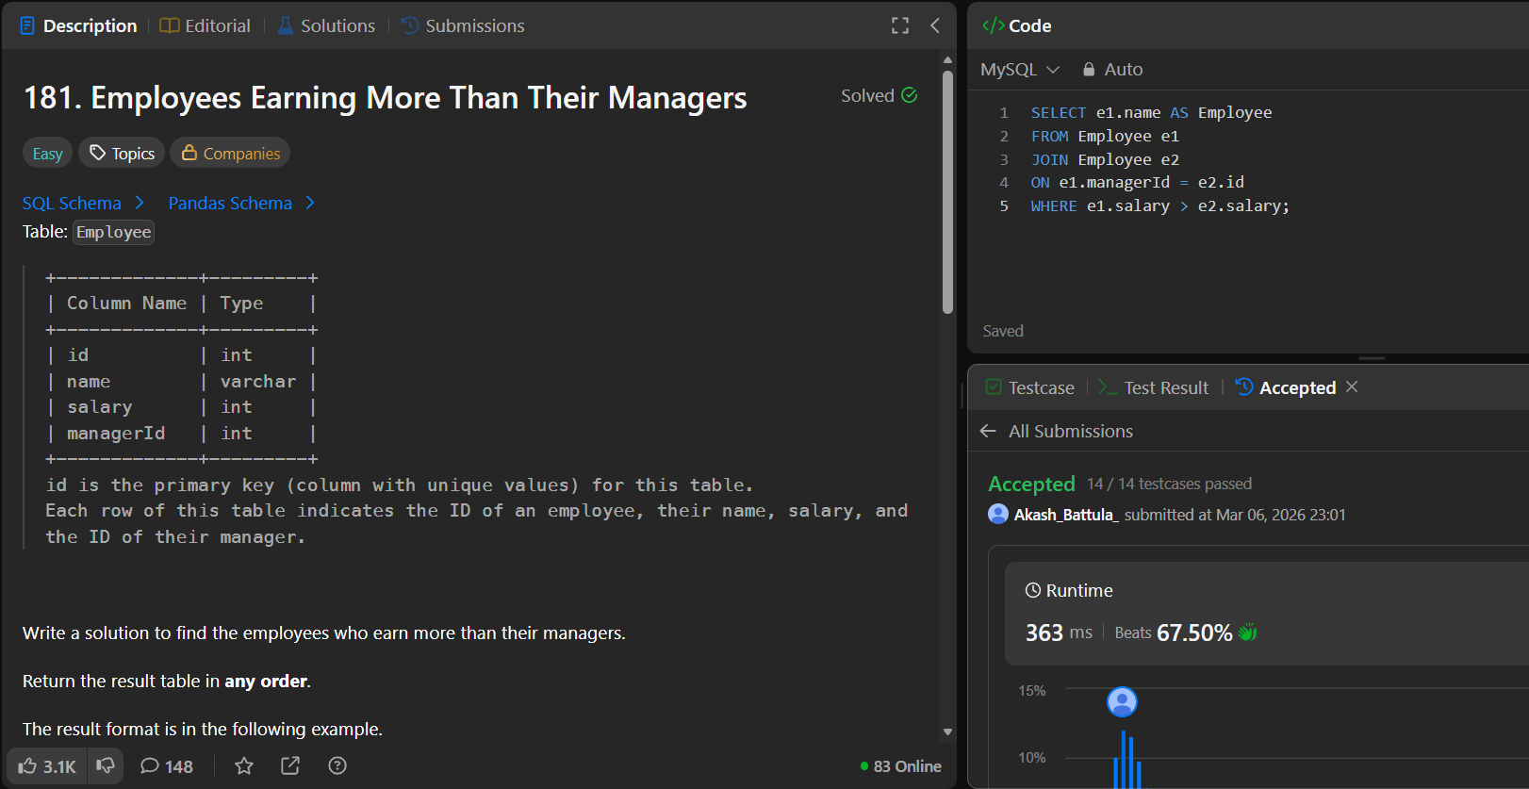

183. Customers Who Never Order https://leetcode.com/problems/customers-who-never-order/
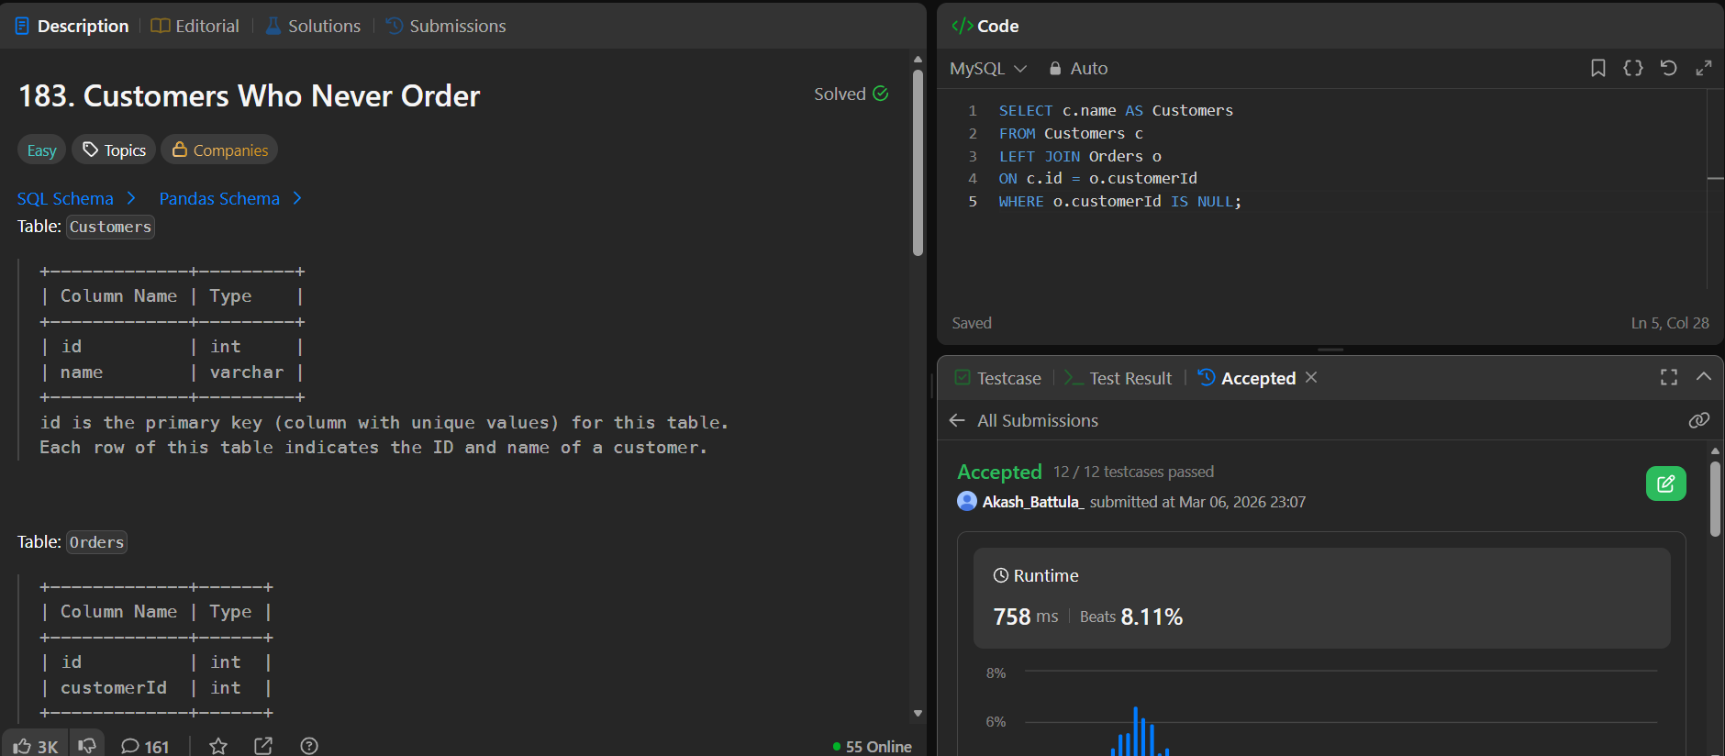
197. Rising Temperature https://leetcode.com/problems/rising-temperature/ 607. Sales Person https://leetcode.com/problems/sales-person/
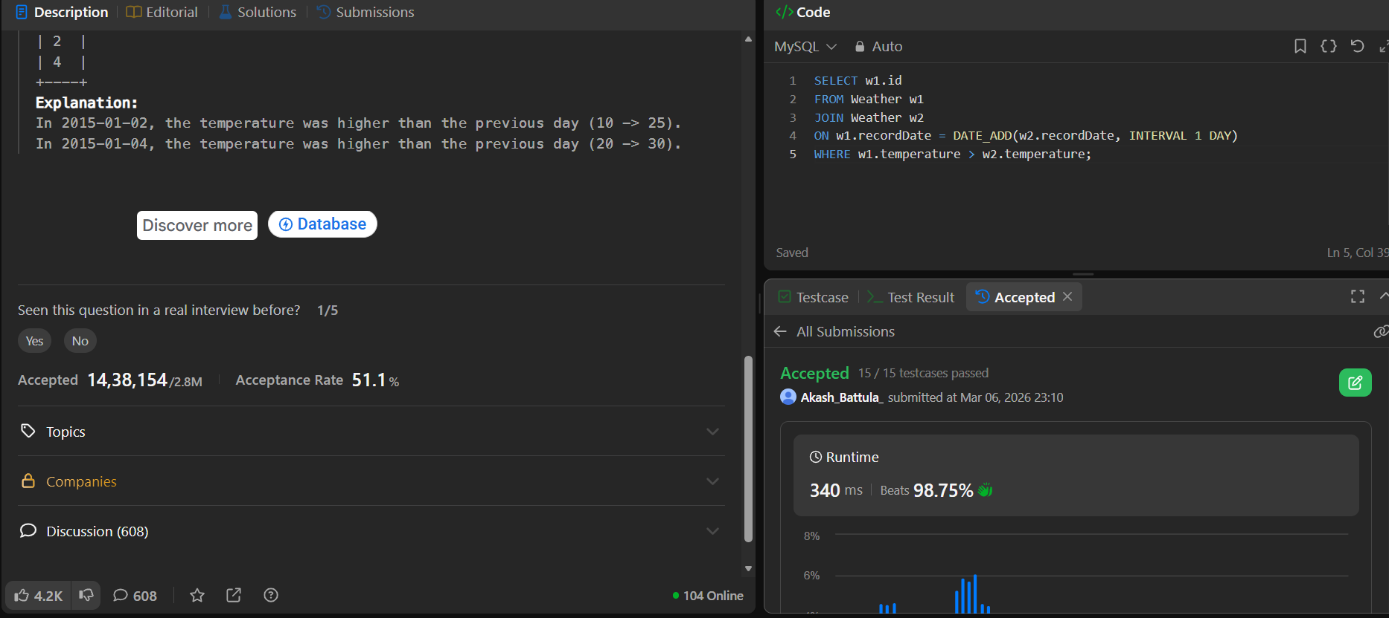
180. Consecutive Numbers https://leetcode.com/problems/consecutive-numbers/
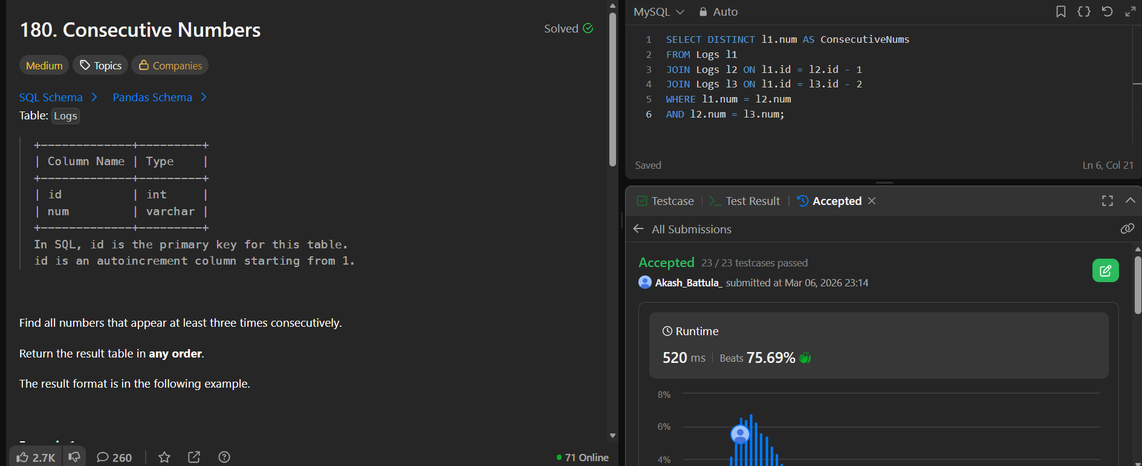
175. Combine Two Tables https://leetcode.com/problems/combine-two-tables/

178. Rank Scores https://leetcode.com/problems/rank-scores/ 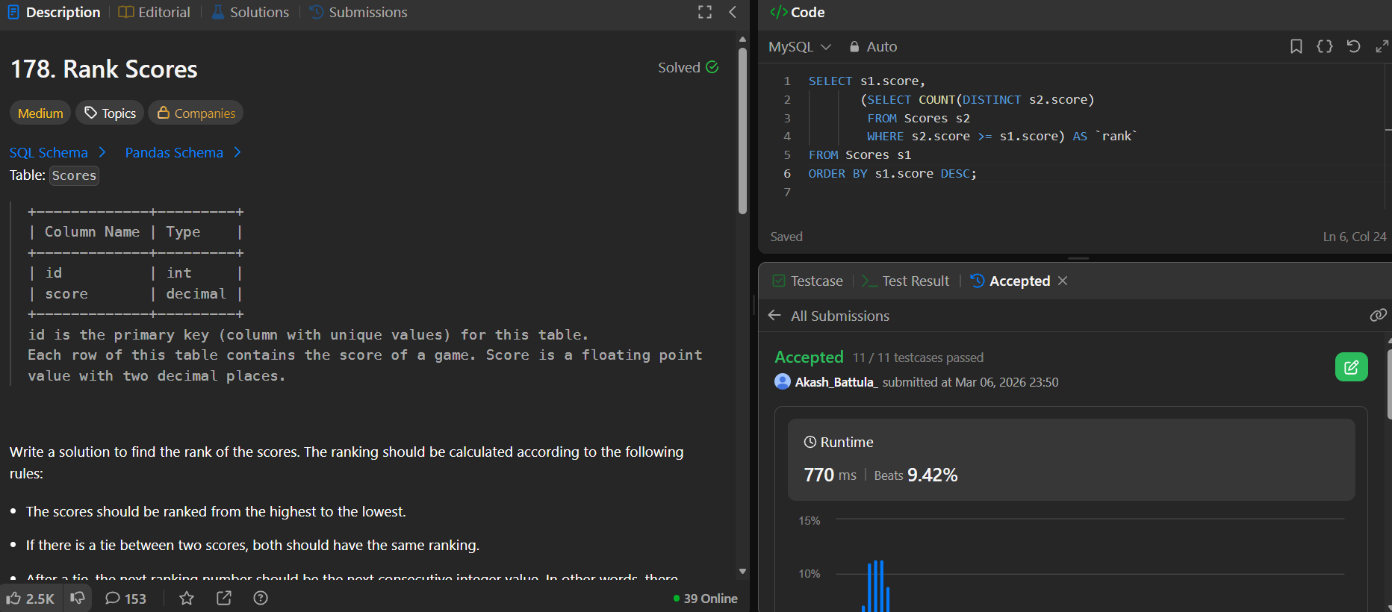

570. Managers with at Least 5 Direct Reports https://leetcode.com/problems/managers-with-at-least-5-direct-reports
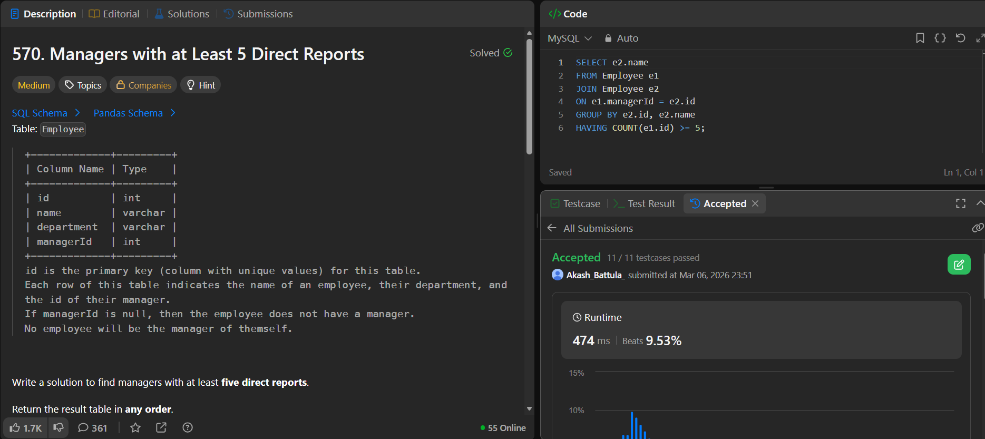

196. Delete Duplicate Emails https://leetcode.com/problems/delete-duplicate-emails/ 10.
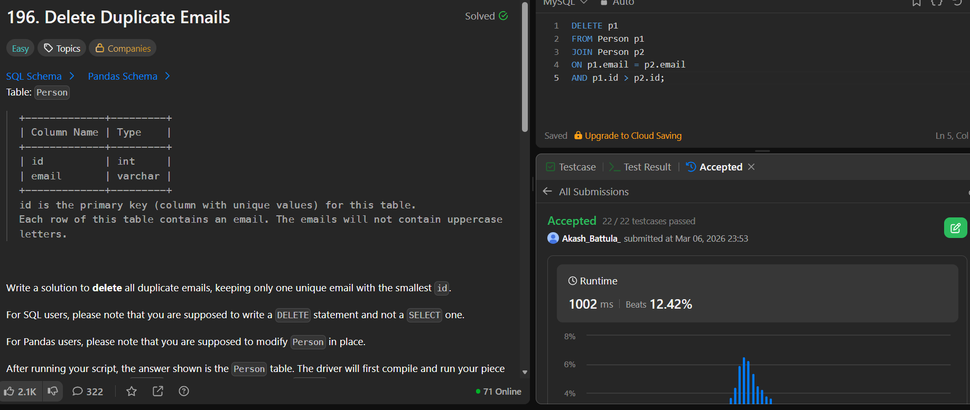
1204. Last Person to Fit in the Bus https://leetcode.com/problems/last-person-to-fit-in-the-bus/
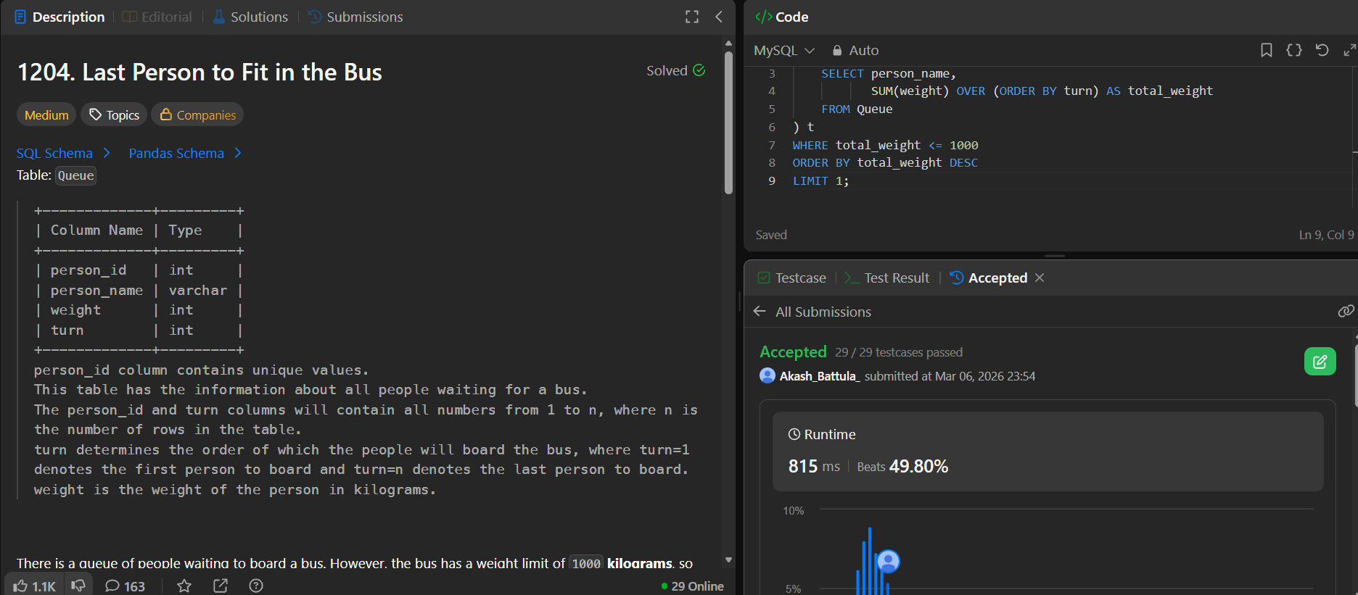

11. 176. Second Highest Salary https://leetcode.com/problems/second-highest-salary
