- Write a procedure that computes the perimeter and the area of a rectangle. Define your own values for the length and width. (Assuming that L and W are the length and width of the rectangle, Perimeter = 2*(L+W) and Area = L*W.

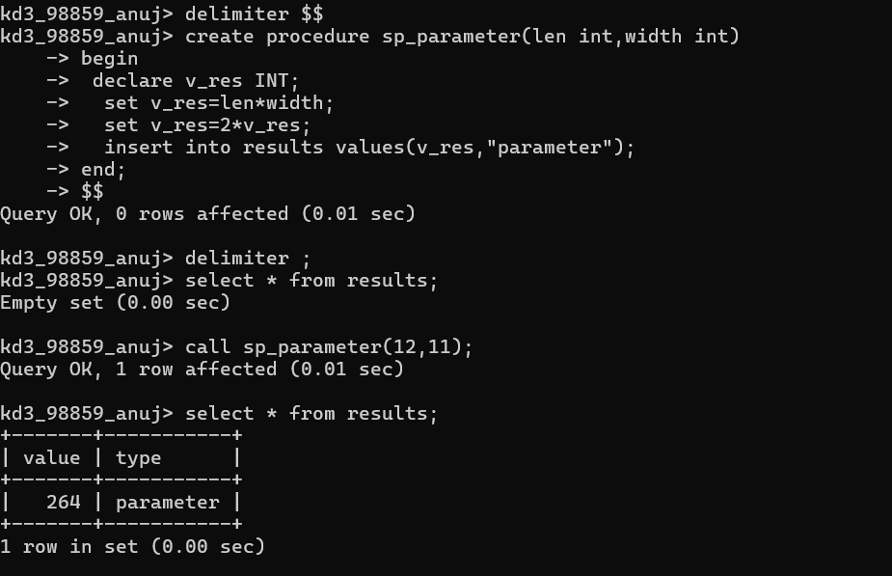

- Write a procedure that declares an integer variable called num, assigns a value to it, computes and inserts into the temp table the value of the variable itself, its square, and its cube.

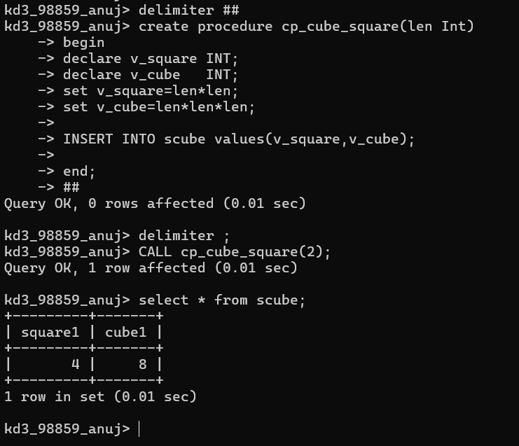

- Create a procedure to Convert a temperature in Fahrenheit (F) to its equivalent in Celsius (C) and vice versa. The required formulae are C= (F-32) *5/9 F= 9/5*C + 32
ANS :
delimiter ##
create procedure sp_fahrenheit(cel double) begin

declare fahren double; set fahren=9/5*cel+32;
select fahren AS FARENHEIT; end;
##
delimiter ;

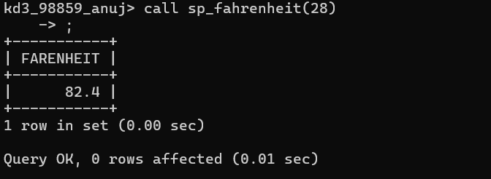

- Create a procedure to Convert a number of inches into yards, feet, and inches. For example, 124 inches equals 3 yards, 1 foot, and 4 inches.

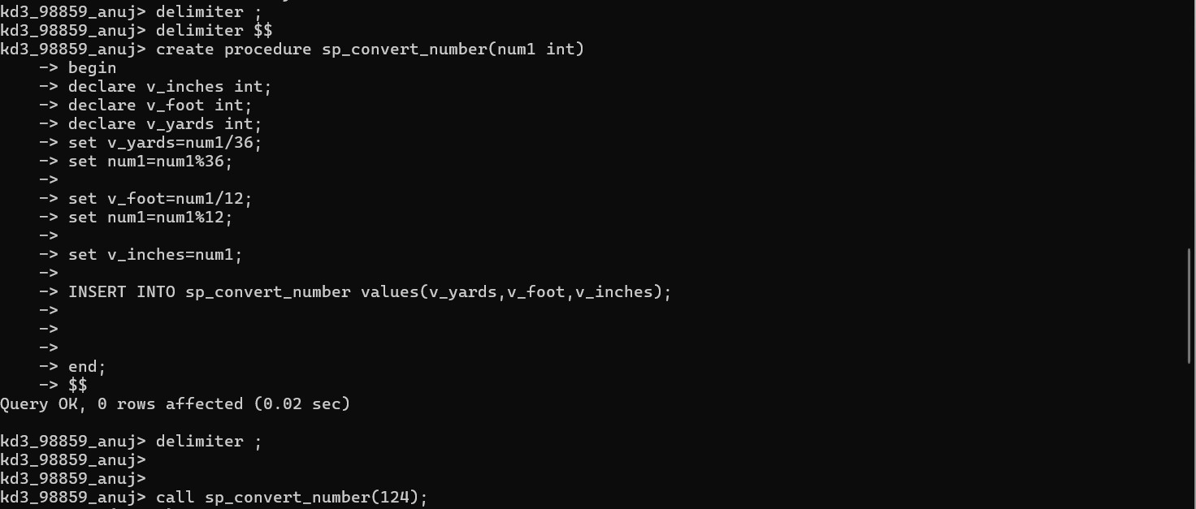
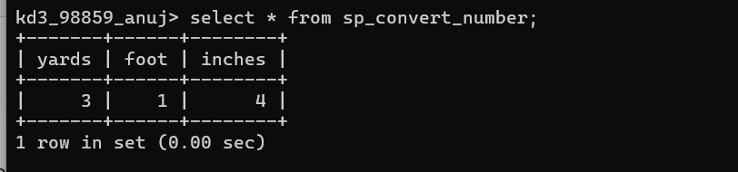
- Create a procedure to read two real numbers and tell whether the product of the two numbers is equal to or greater than 100.

