- CREATE TABLE S (S# CHAR(5) NOT NULL, Sname CHAR(20), status SMALLINT, city CHAR(15));
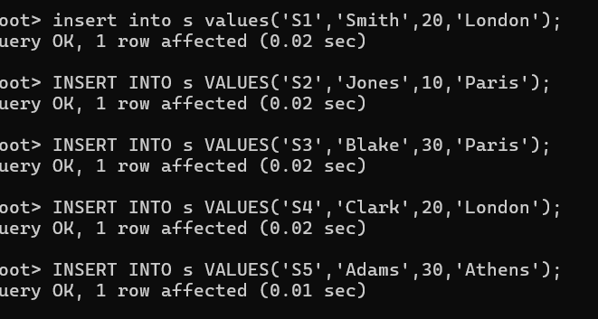

- Note : P denotes the Parts table.
CREATE TABLE P (P# CHAR(6) NOT NULL, Pname CHAR(20), color CHAR(6), weight SMALLINT, city CHAR(15));
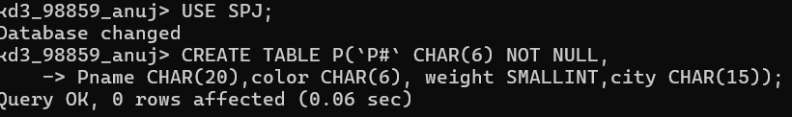
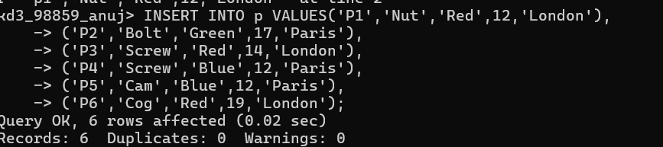
- . Note : J denotes the Jobs table. CREATE TABLE J (J# CHAR(4) NOT NULL, Jname CHAR(10), City CHAR(15));

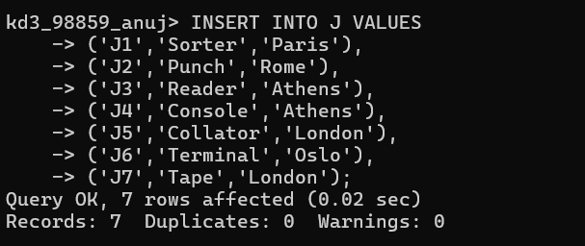

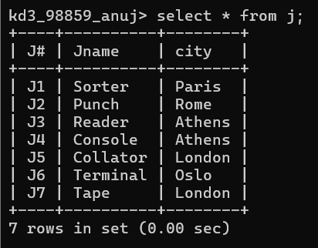

  - Create 'hr' database. Import hr-db.sql.

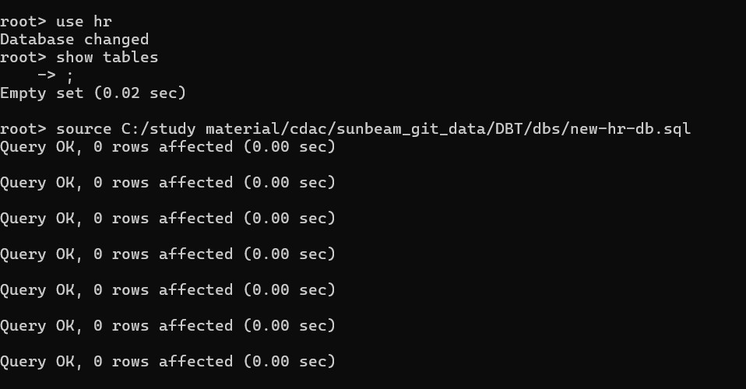

  - Create 'sales' database. Import sales-db.sql.

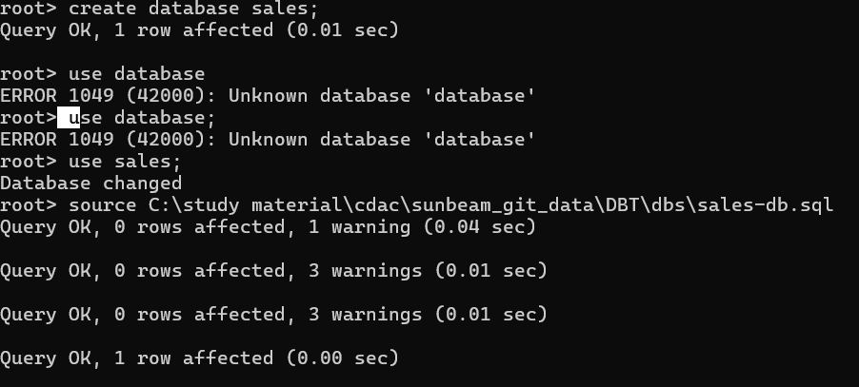
3 List all tables in hr database. Display contents of all tables (one by one).

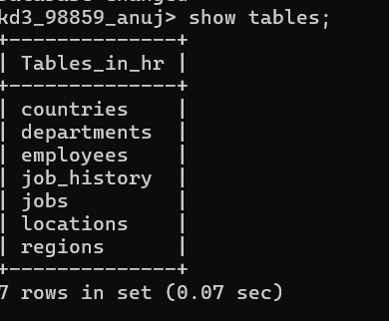
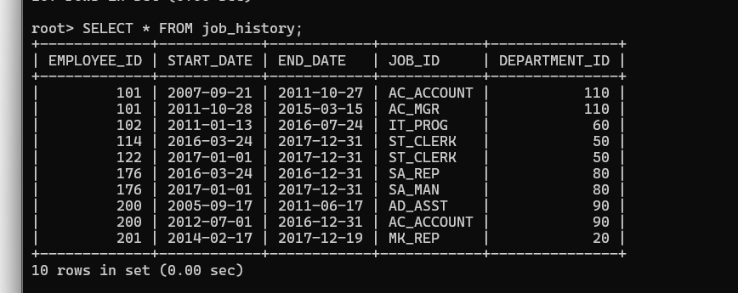

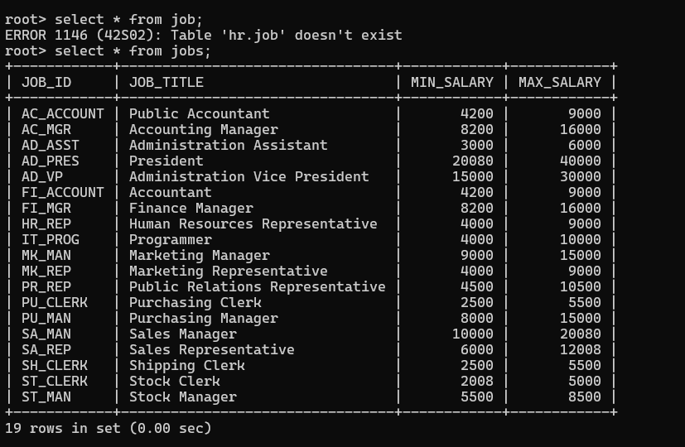

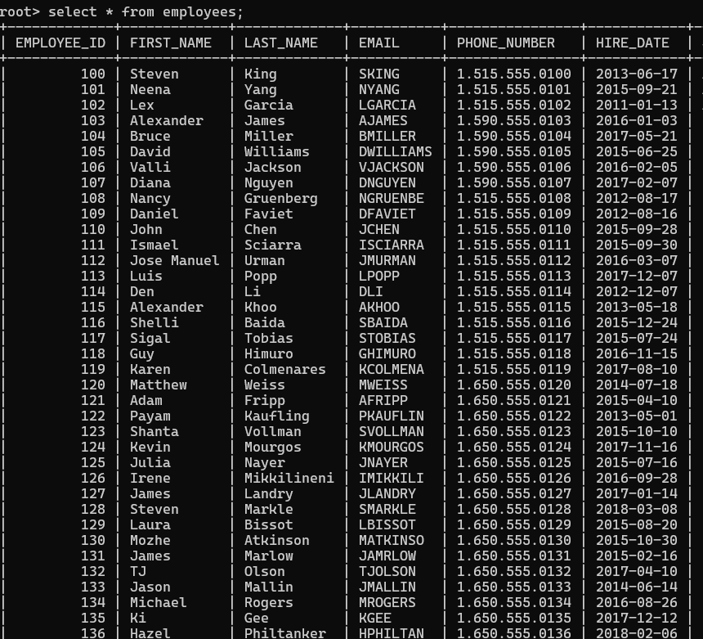
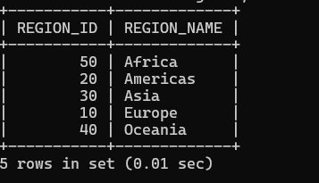

  - How many salespeople are present in the database? Ans: there are 10 orders in sales table
  - On which date order with highest amount is placed? Ans: 1990-10-04
  - For which order salesman got maximum commission? Hint: you need to refer data of two tables.
Ans: 3006| 1098.16 | 1990-10-03 | 2008 | 1007|
  - Which salesmen are handling more than two customers? Hint: you need to refer data of two tables.
Ans: Peel ,grass
  - Which city have single customer? Ans: Berlin
  - Which city has multiple salespeople? Ans: London
  - What is name of customer and salesman of the maximum amount order? Ans: Peels,Cleamans
  - Study relationship between the tables in sales database.
Ans in sales three entity is there(customers,orders,salespeople) Every one conected to each other

