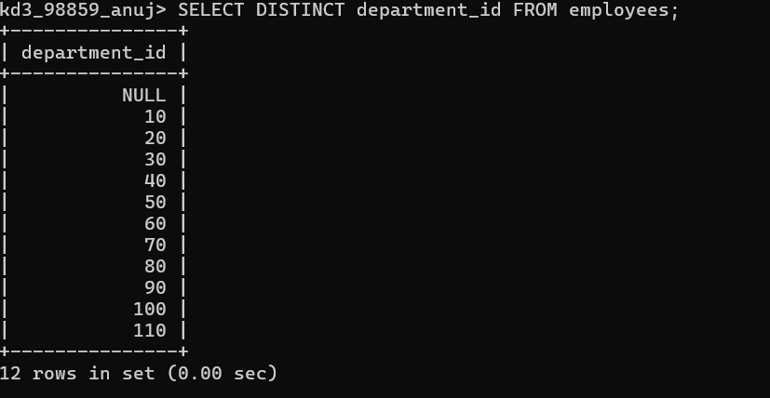
- Write a query to get unique department ID from employee table. Ans

- Write a query to get all the employee’s details from the employees table displaying the first names in descending order.
Ans kd3_98859_anuj> SELECT * FROM employees order by first_name desc;
- Write a query to get the employee ID, names (first_name and last_name), salary in ascending order of salary.
Ans: kd3_98859_anuj> SELECT employee_id,first_name,last_name,salary FROM employees ORDER BY salary ;

- Display first name and joining date of the employees who are either IT Programmer or Sales Man.
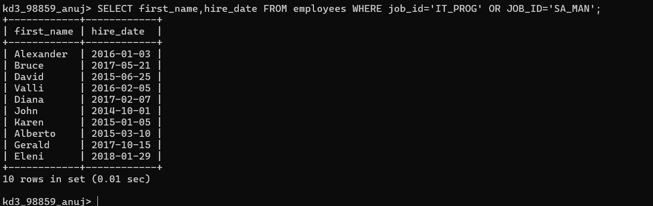
ANS

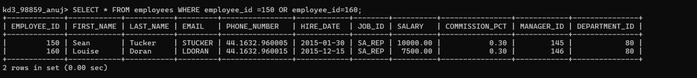
- Display details of employees with employee ID 150 or 160. Ans

- Display first name, salary, commission pct, and hire date for employees with salary less than 10000.
Ans

- Display employees where the first name or last name starts with S. Ans :

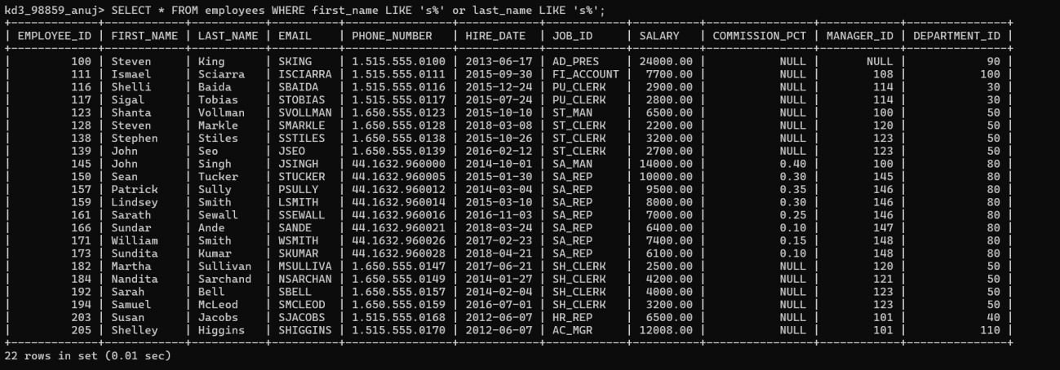

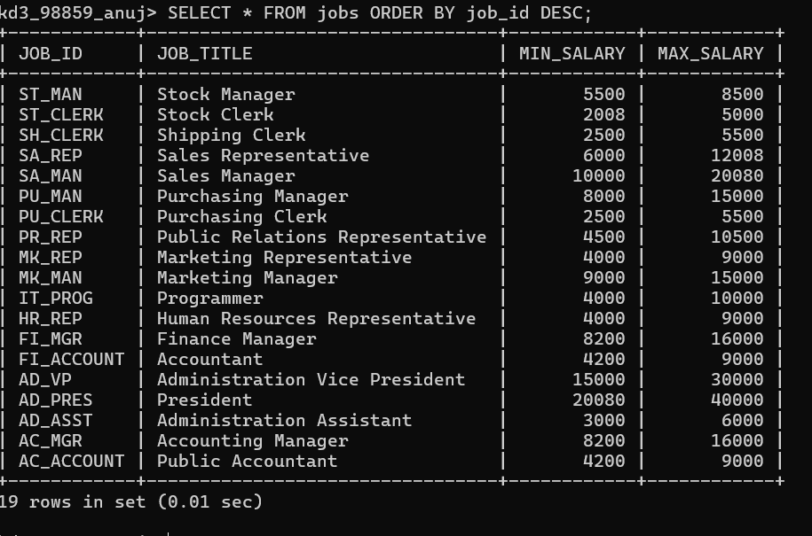
- Display details of jobs in the descending order of the title. ANS

- Display the details of the employees from department 30, earning the salary greater 10000 but do not receive the commission.

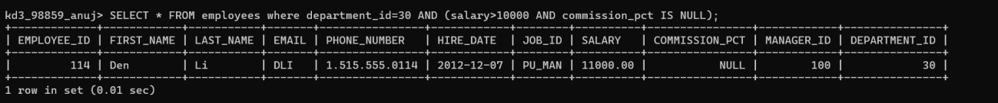
ANS

- Display the details of employees reporting to the managers with employee id 100 and 120.
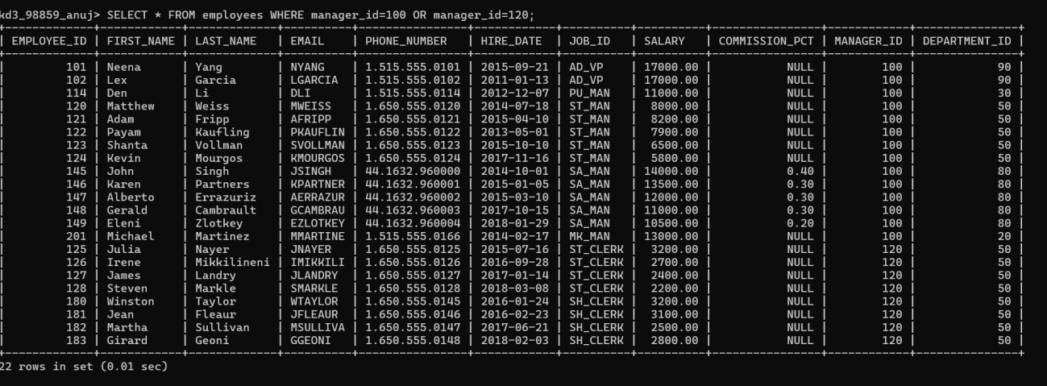
ANS

- Display the unique country_id from locations table. ANS

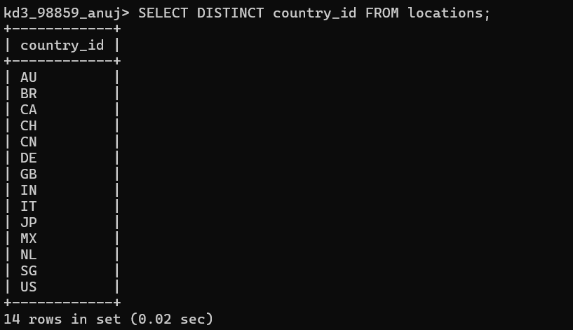

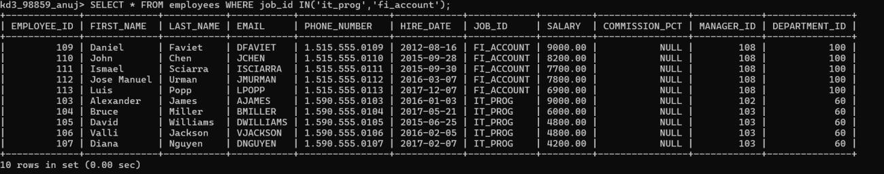
- Display all employees whose have the job_id as IT_PROG and FI_ACCOUNT.

- Display all countries in ascending order.

