SELF STUDY DBT
- Implement a trigger to update the product price in cart, when price is updated in products table.
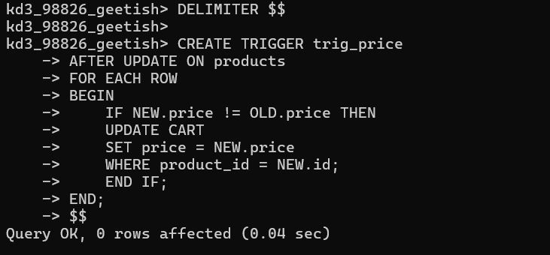
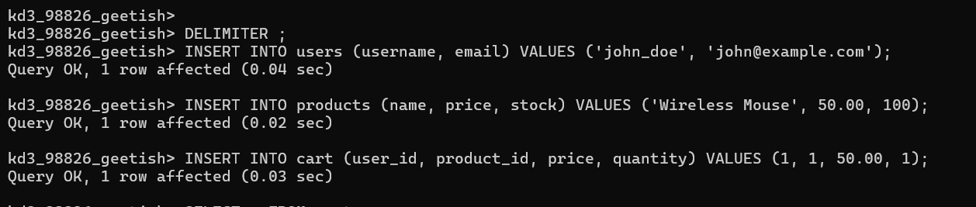
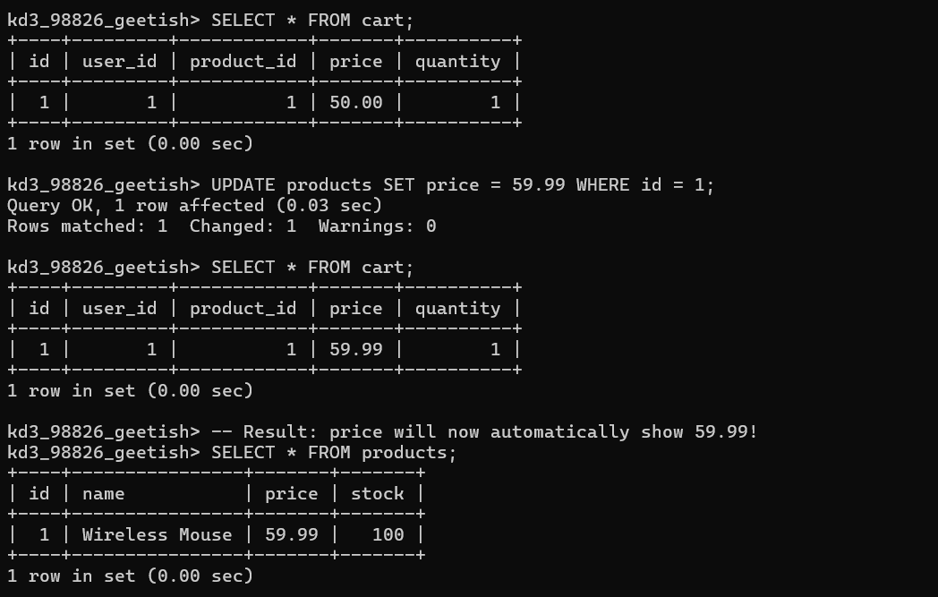

- Understand ON DELETE CASCADE, ON UPDATE CASCADE. Write emp, dept CREATE TABLE statements and apply CASCADE for all foreign keys.

MongoDb Lab Exercises:
1. Practice CRUD operations on Mongo.
1. Create two collections -- emp and dept.
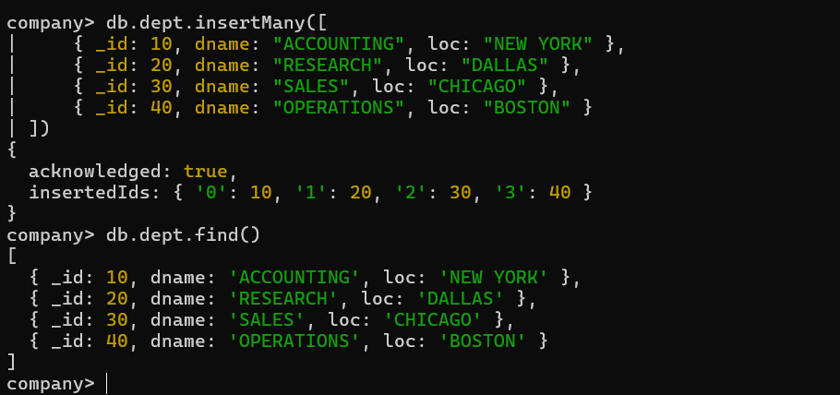
2. Insert the emp and dept records.
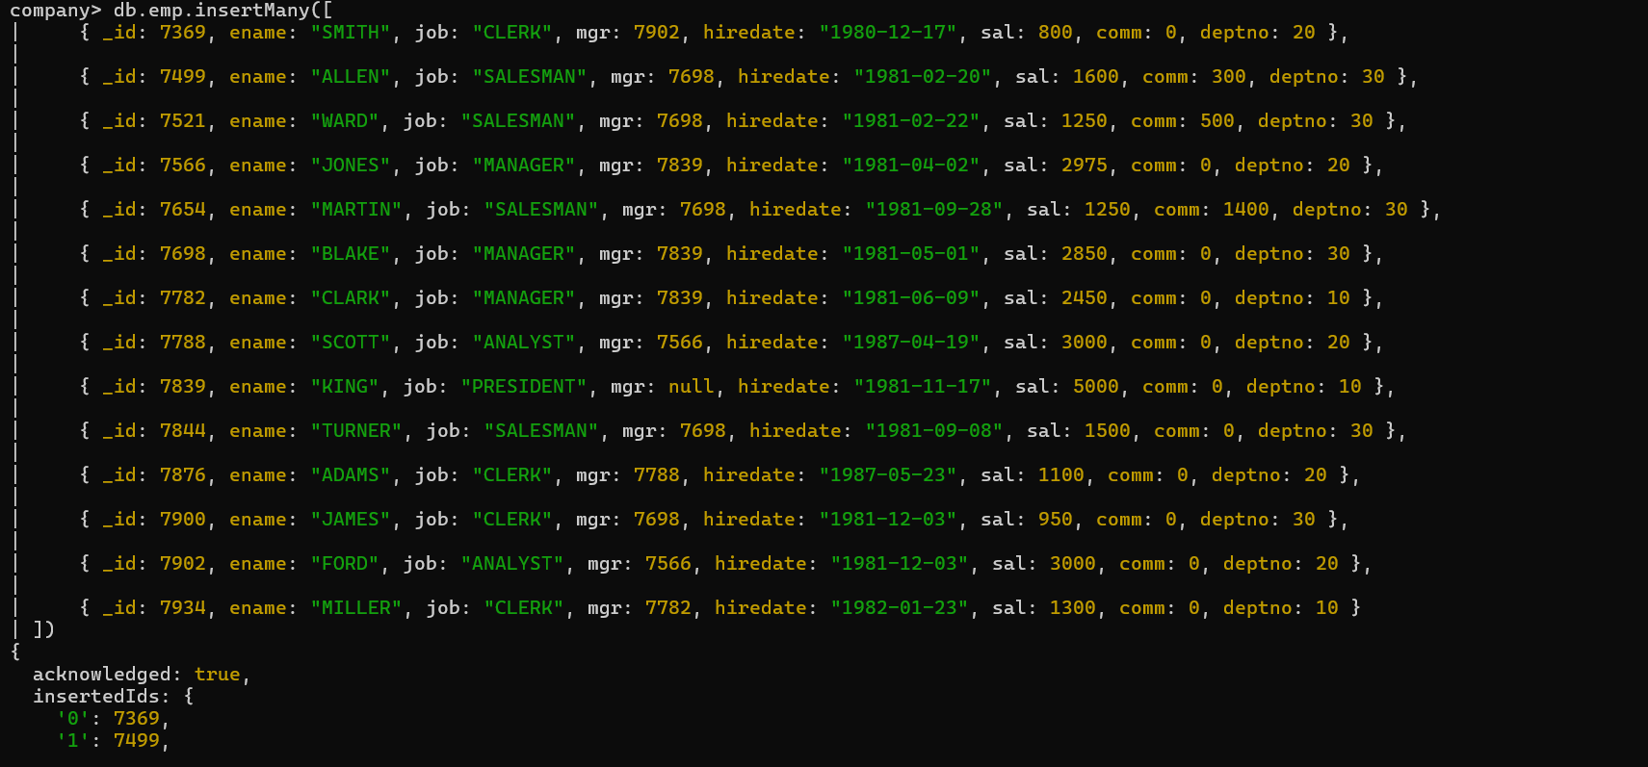
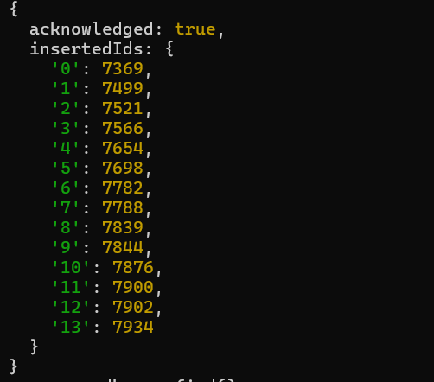
- Increase salary of dept 10 emps by 100.
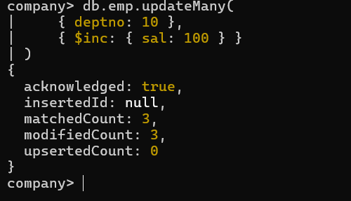
- Display emp name, job, deptno, sal in sorted order of deptno, job, sal (desc) for all emps whose sal more than 1000.

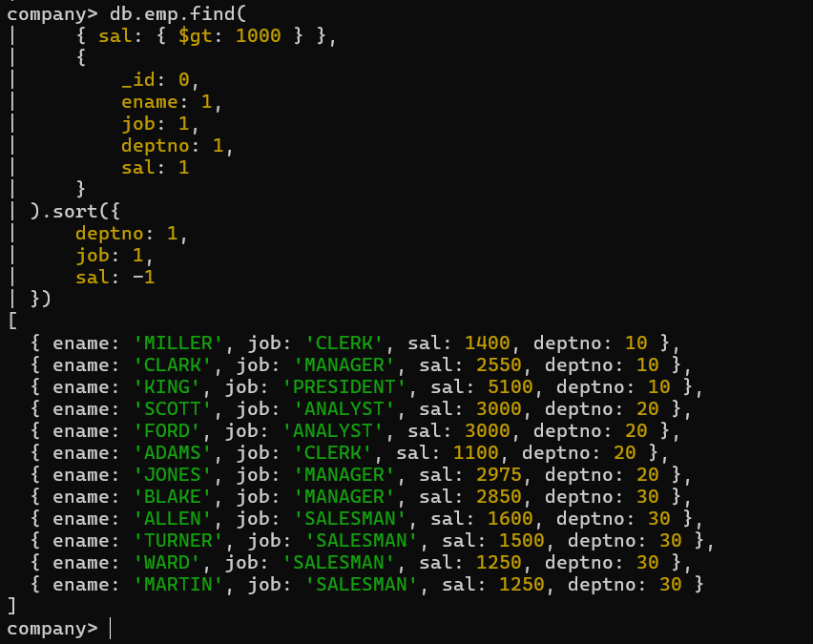
- Delete the dept with id 40.
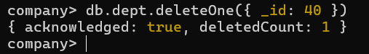
2. Learn grouping operations using Mongo aggregation pipeline
1. Display job wise total sal, max sal, min sal, and avg sal for all jobs other than PRESIDENT.
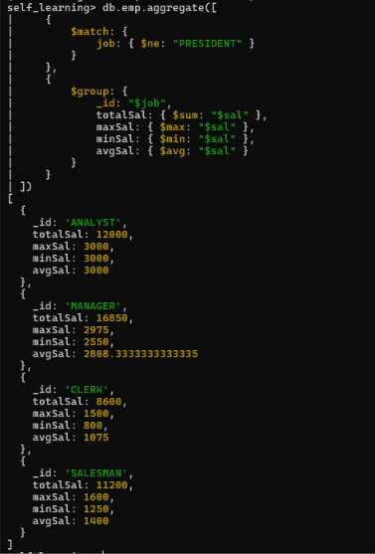
2. Display emp name, dept name, income (sal + comm) in sorted order of their income.
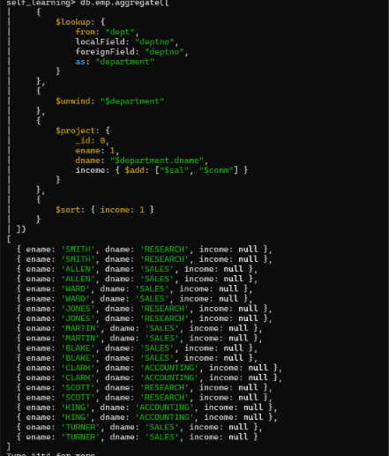

Leetcode Exercises
- GROUP BY Problems
586. Customer Placing the Largest Number of Orders https://leetcode.com/problems/customer-placing-the-largest-number-of-orders
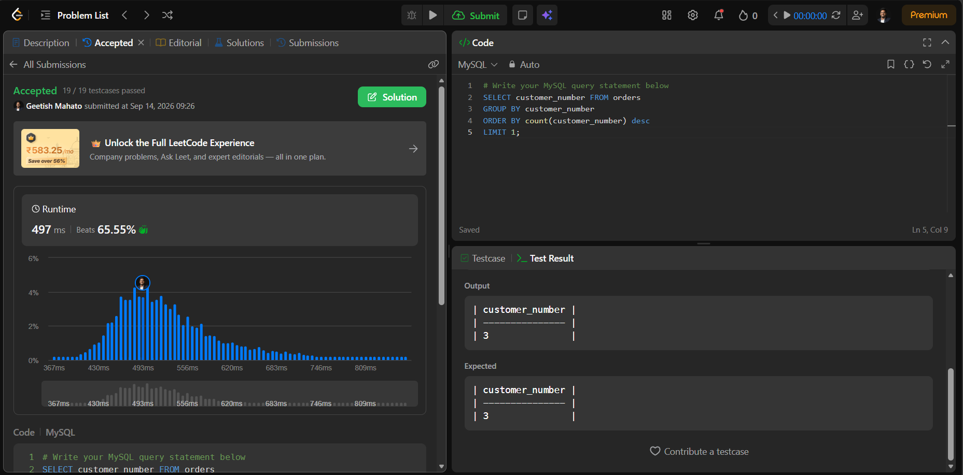

619. Biggest Single Number https://leetcode.com/problems/biggest-single-number
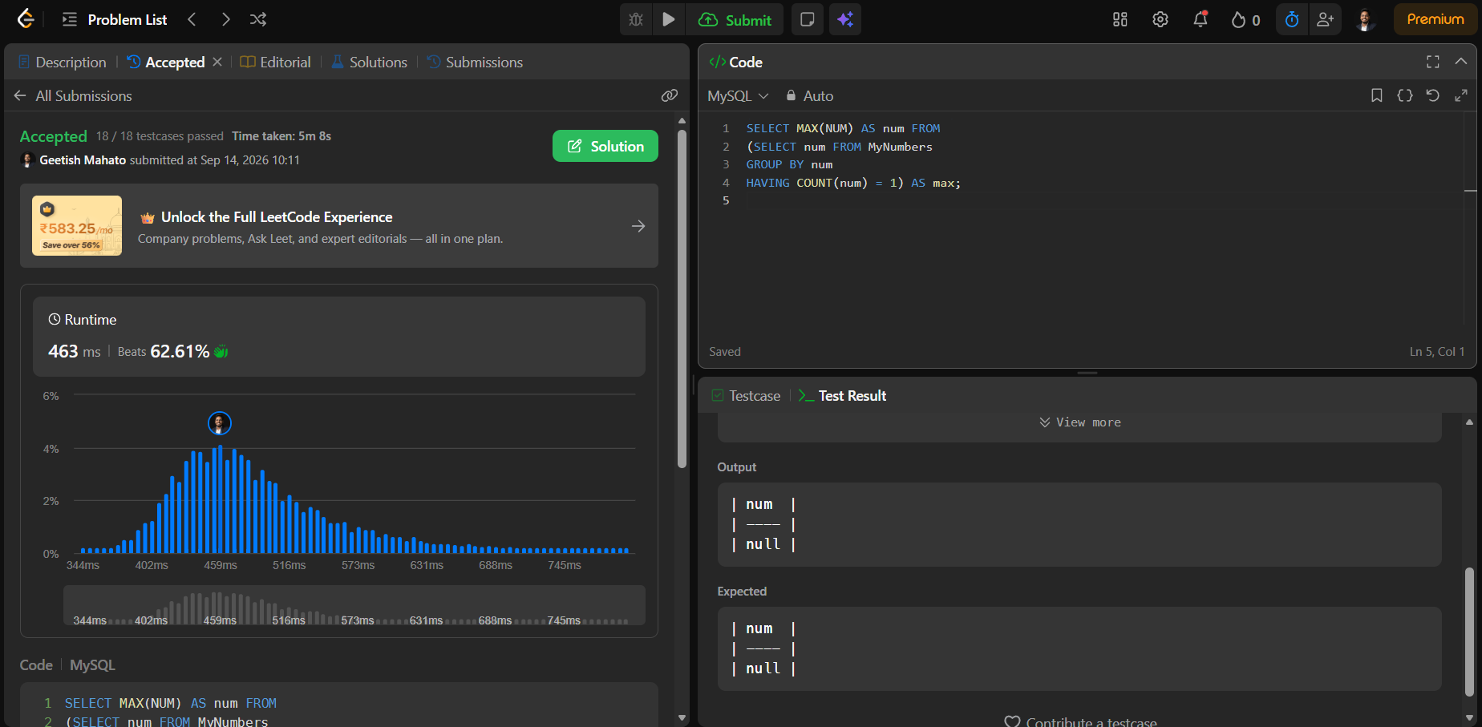

511. Game Play Analysis I https://leetcode.com/problems/game-play-analysis-i
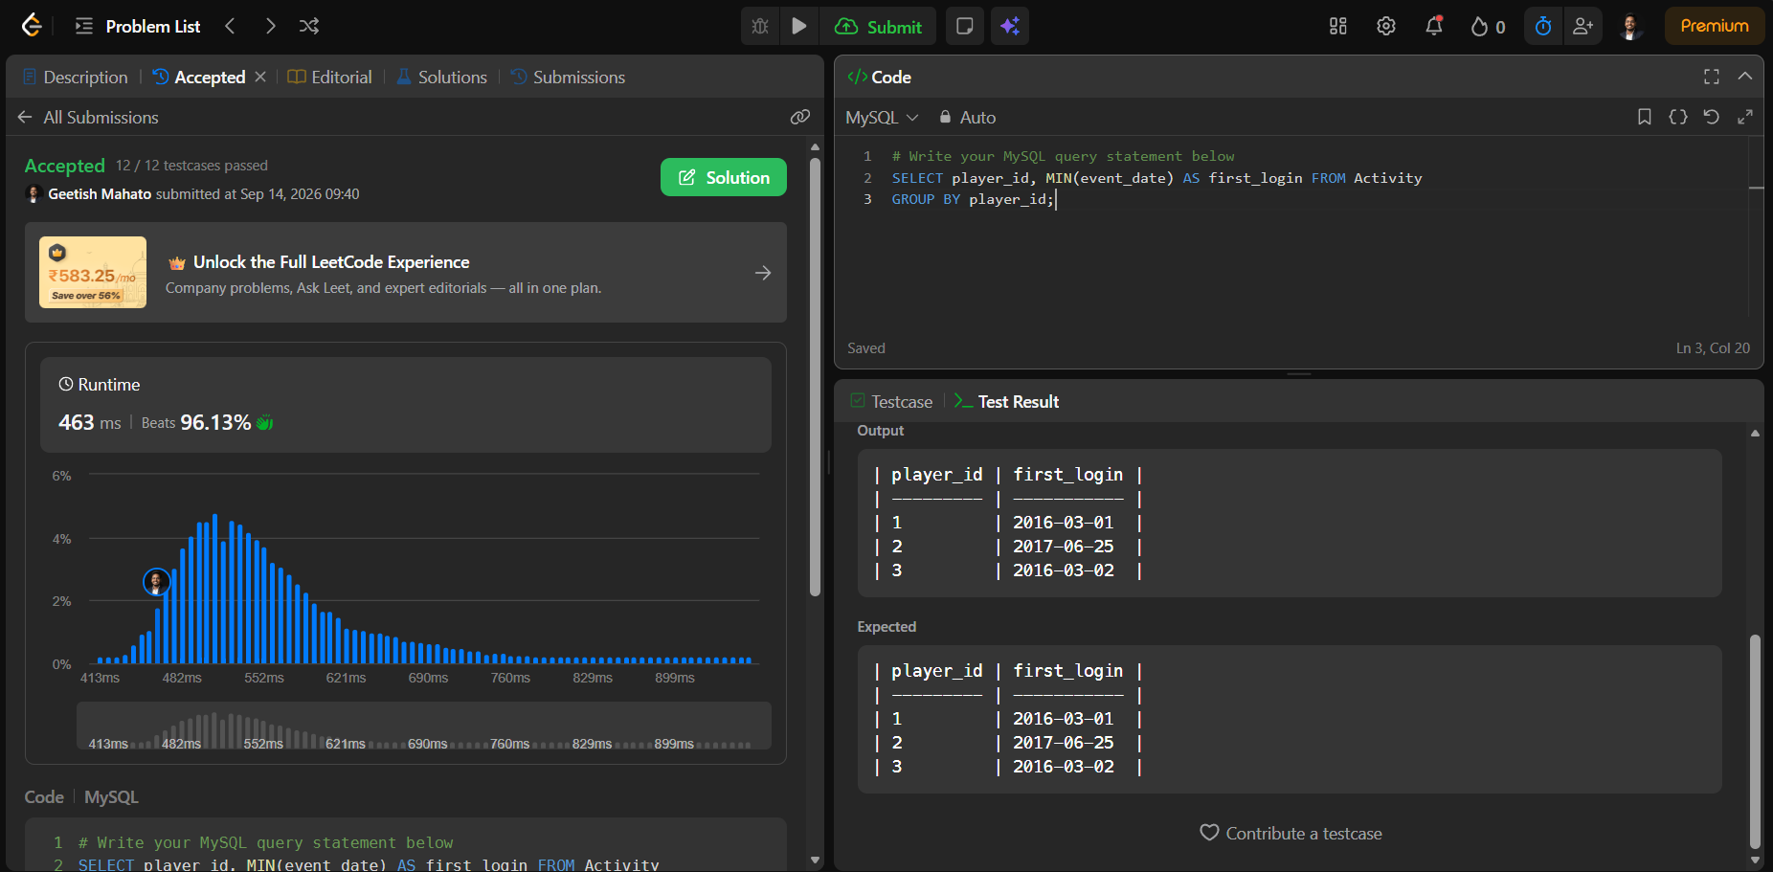

1693. Daily Leads and Partners https://leetcode.com/problems/daily-leads-and-partners
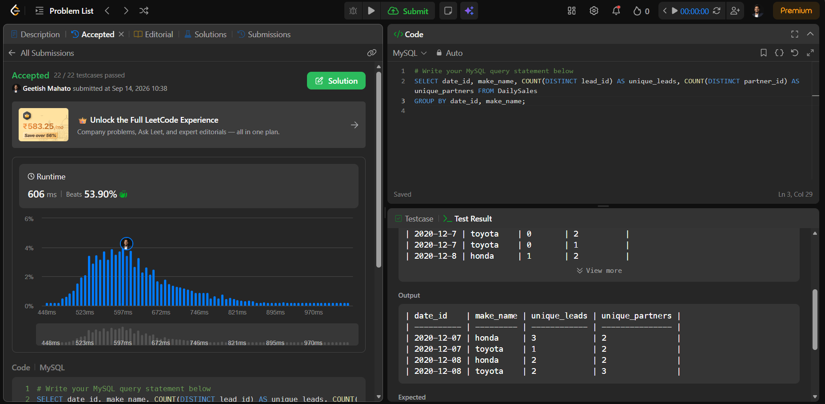
1741. Find Total Time Spent by Each Employee https://leetcode.com/problems/find-total-time-spent-by-each-employee
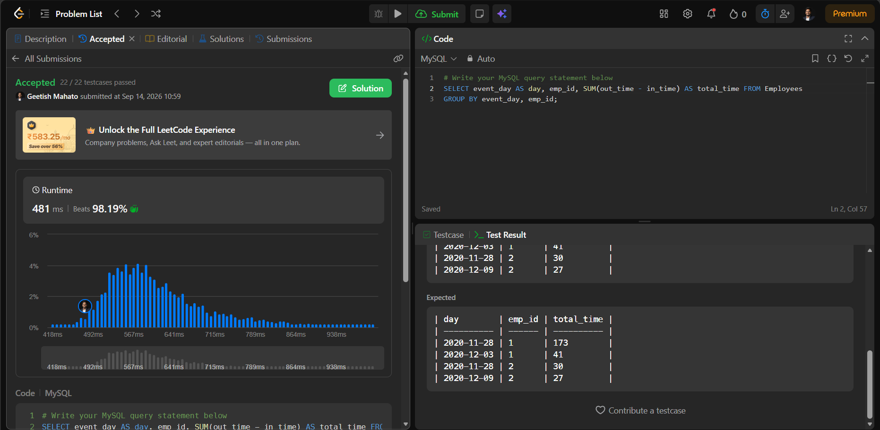
1050. Actors and Directors Who Cooperated at Least Three Times https://leetcode.com/problems/actors-and-directors-who-cooperated-at-least- three-times
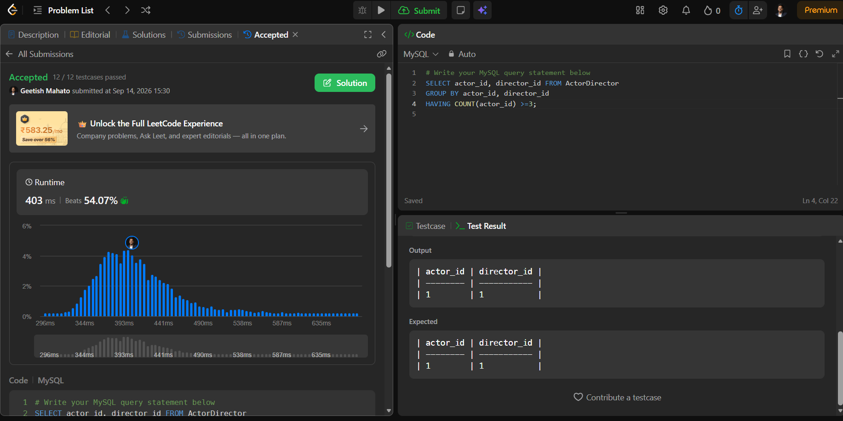
1890. The Latest Login in 2020 https://leetcode.com/problems/the-latest-login-in-2020
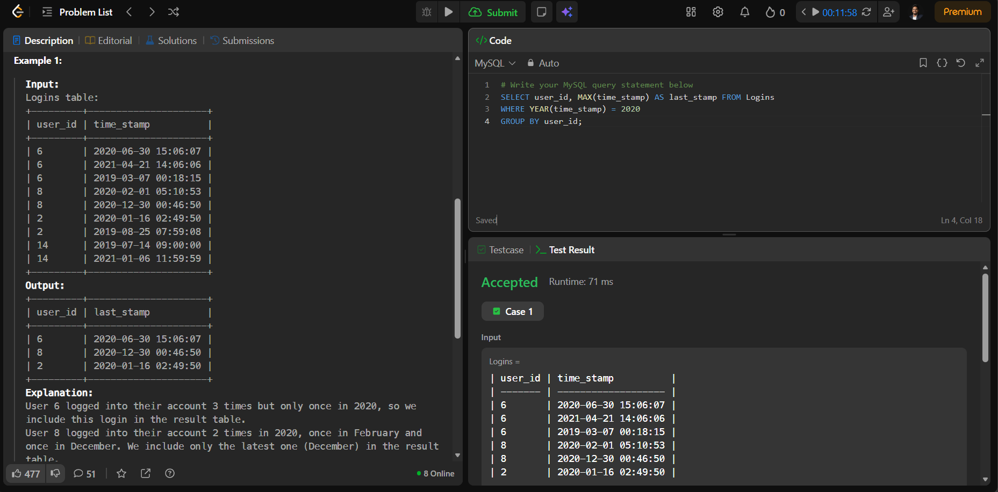
1211. Queries Quality and Percentage https://leetcode.com/problems/queries-quality-and-percentage
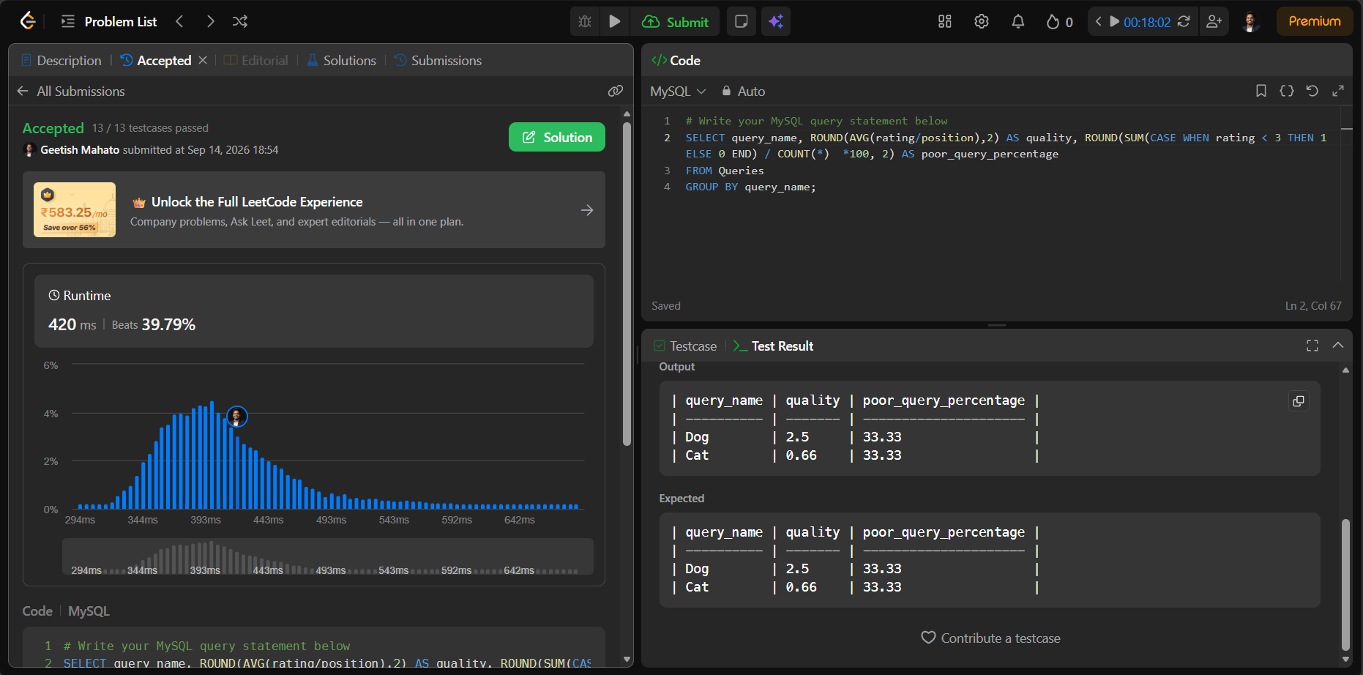
1141. User Activity for the Past 30 Days I https://leetcode.com/problems/user-activity-for-the-past-30-days-i
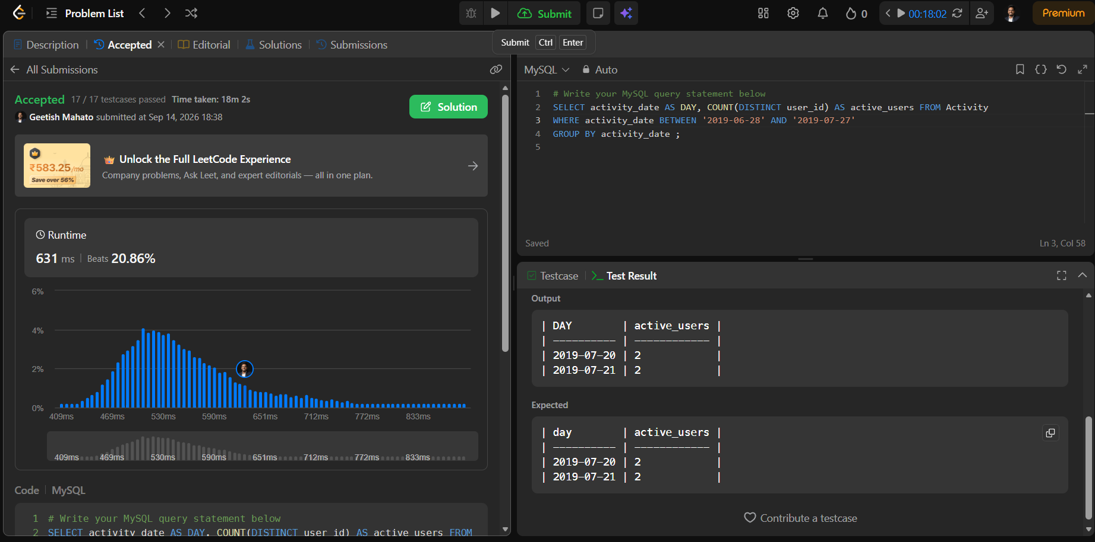
596. Classes With At Least 5 Students https://leetcode.com/problems/classes-with-at-least-5-students

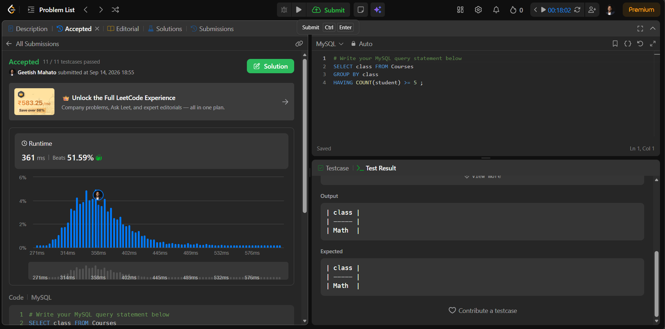

- JOINs Problems
- Replace Employee ID With The Unique Identifier https://leetcode.com/problems/replace-employee-id-with-the-unique-identifier
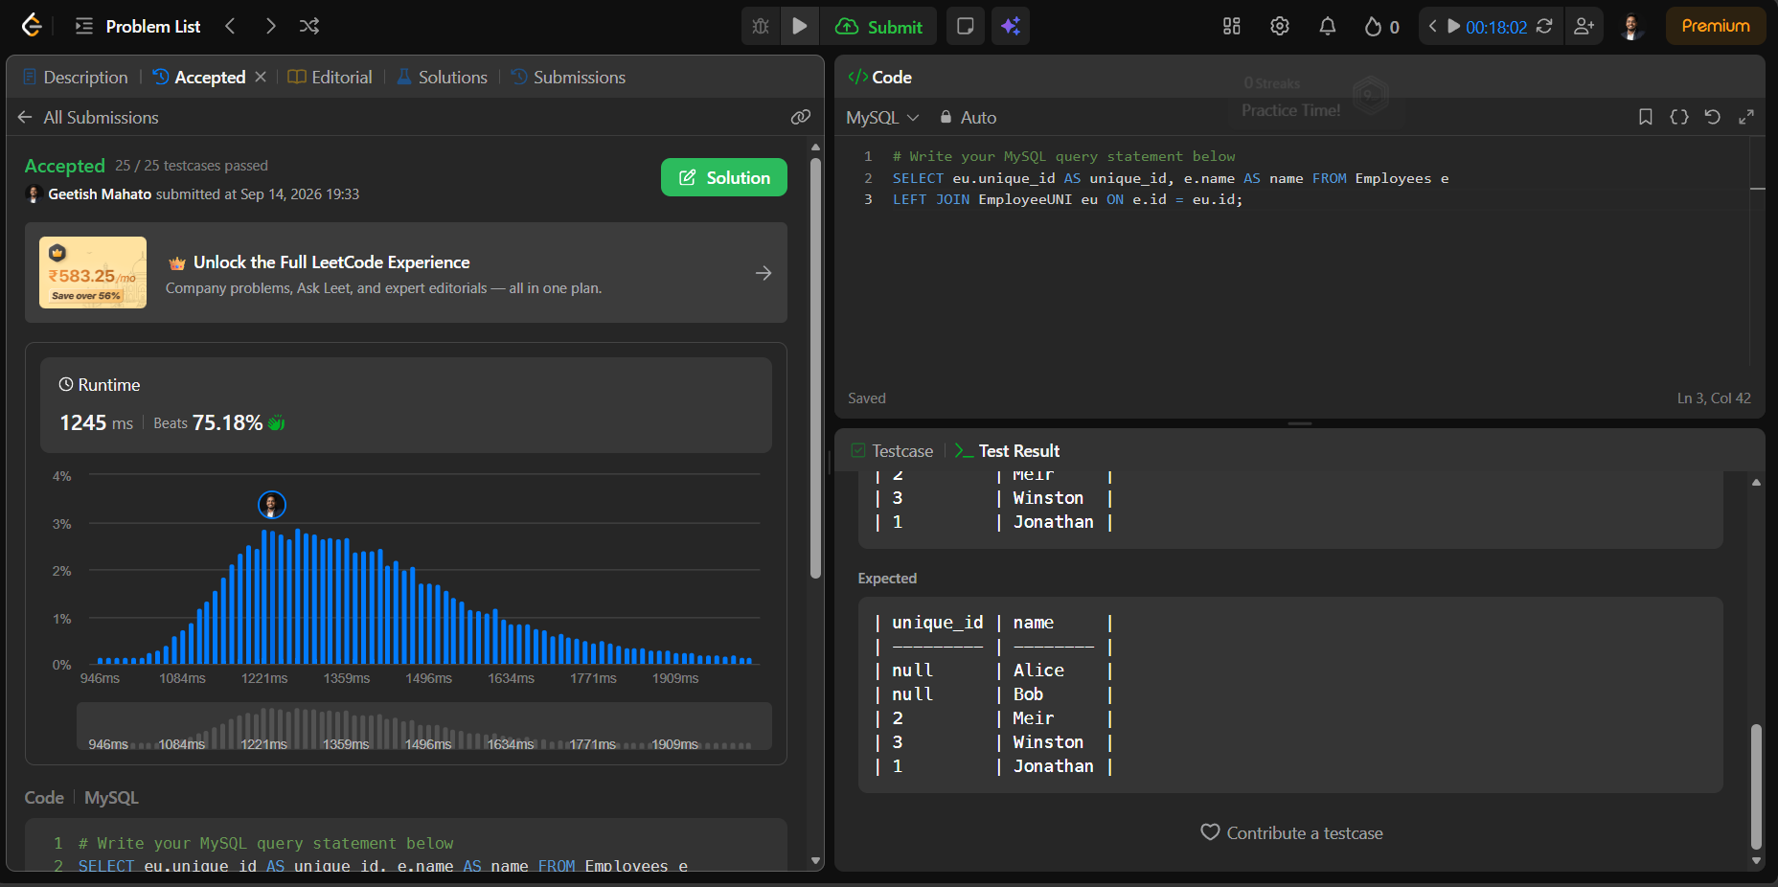
- Product Sales Analysis I https://leetcode.com/problems/product-sales-analysis-i
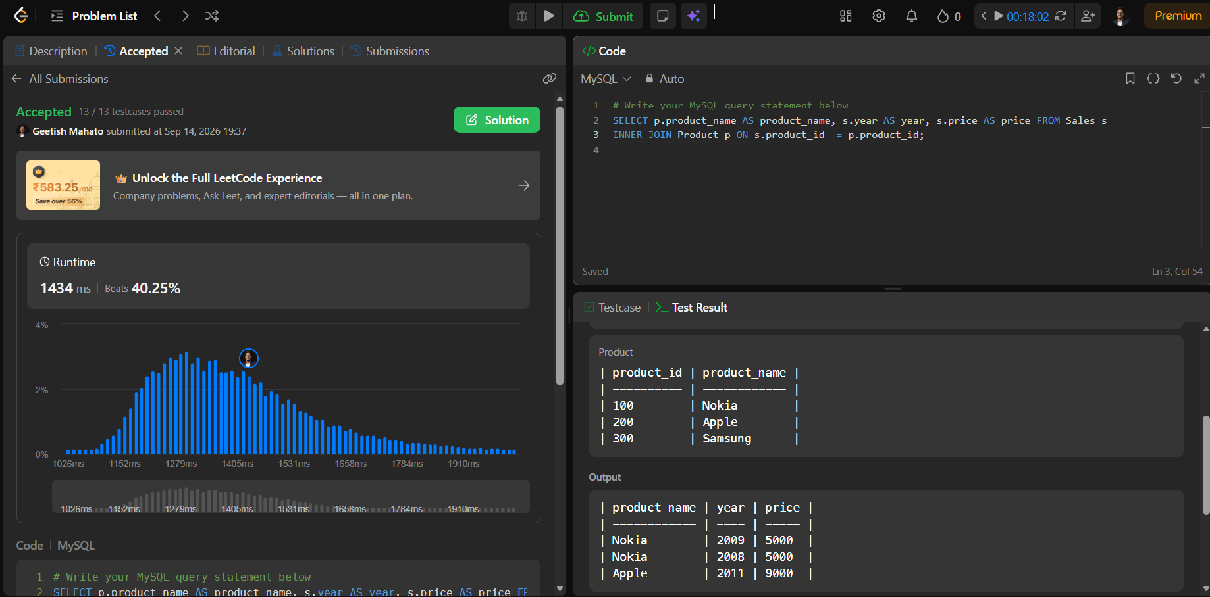
- Employee Bonus https://leetcode.com/problems/employee-bonus
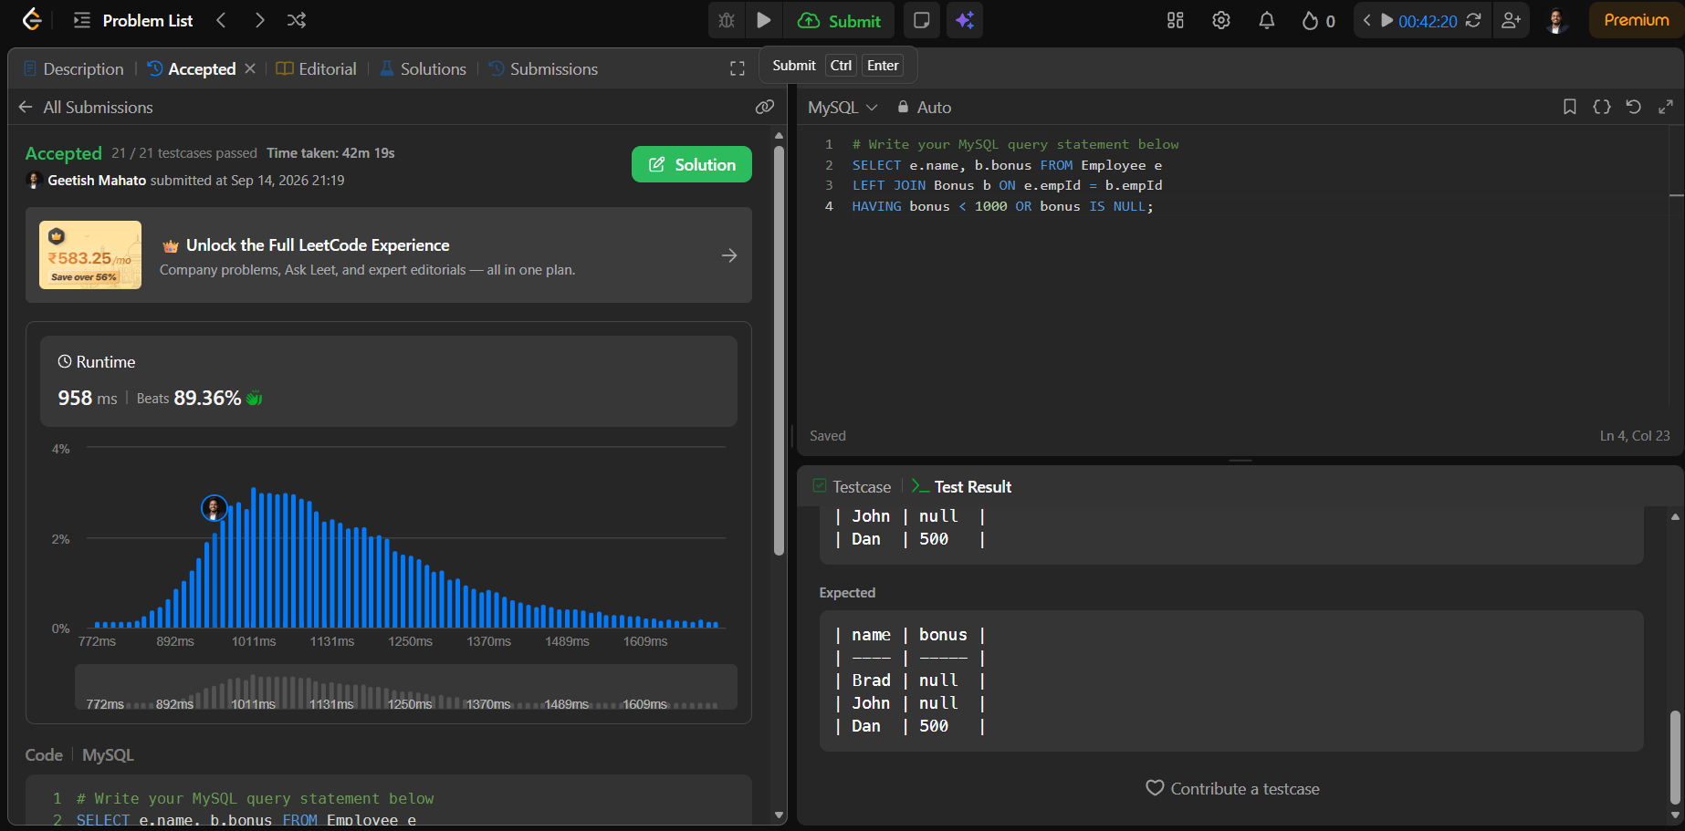
- Students and Examinations https://leetcode.com/problems/students-and-examinations
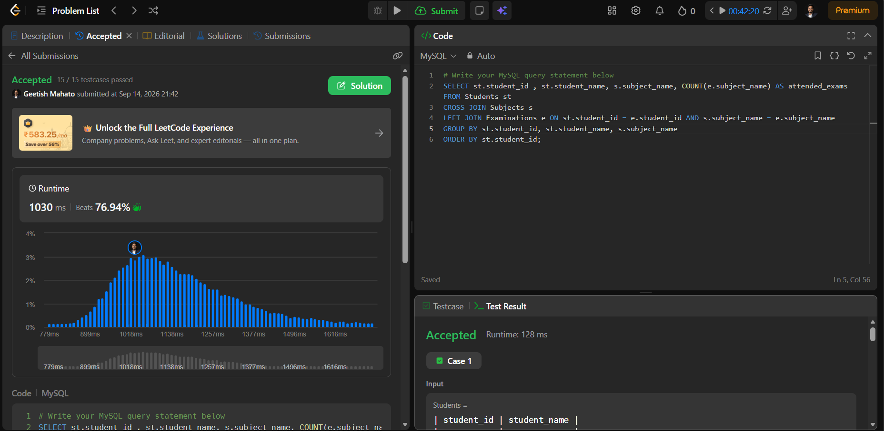
- Managers With At Least 5 Direct Reports https://leetcode.com/problems/managers-with-at-least-5-direct-reports
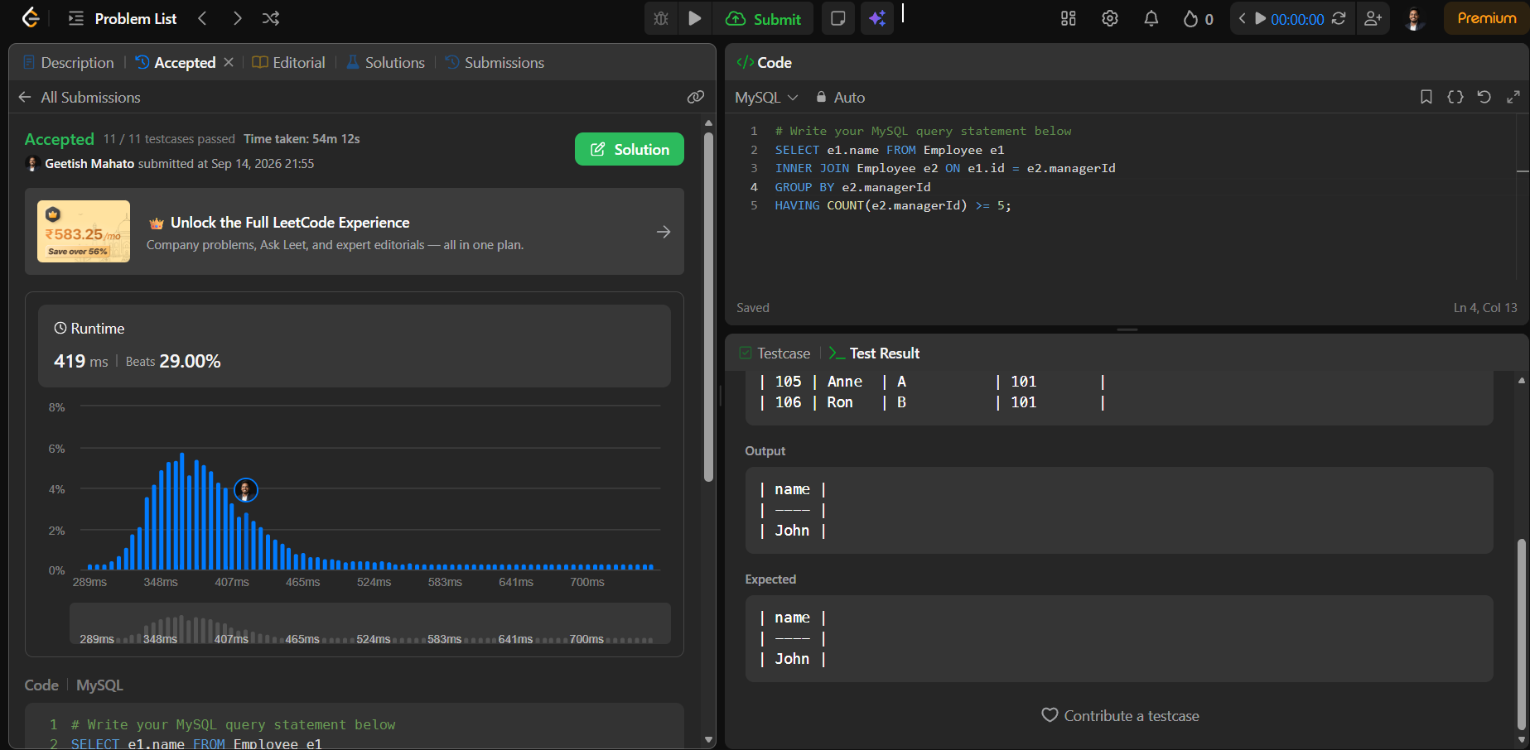
- Asian Population https://www.hackerrank.com/challenges/asian-population
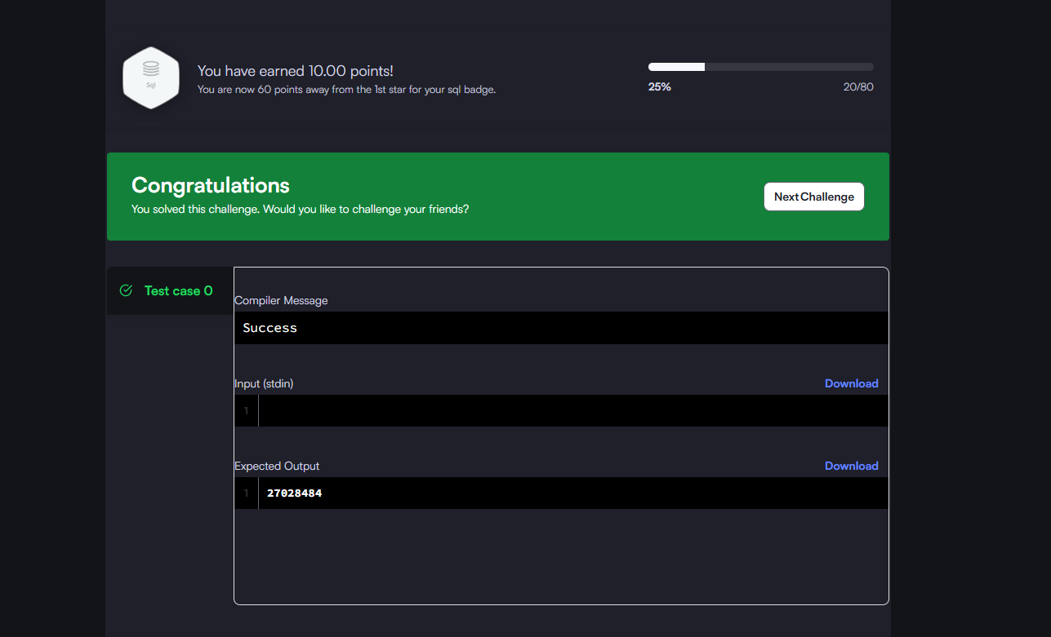
- Average Population of Each Continent https://www.hackerrank.com/challenges/average-population-of-each-continent
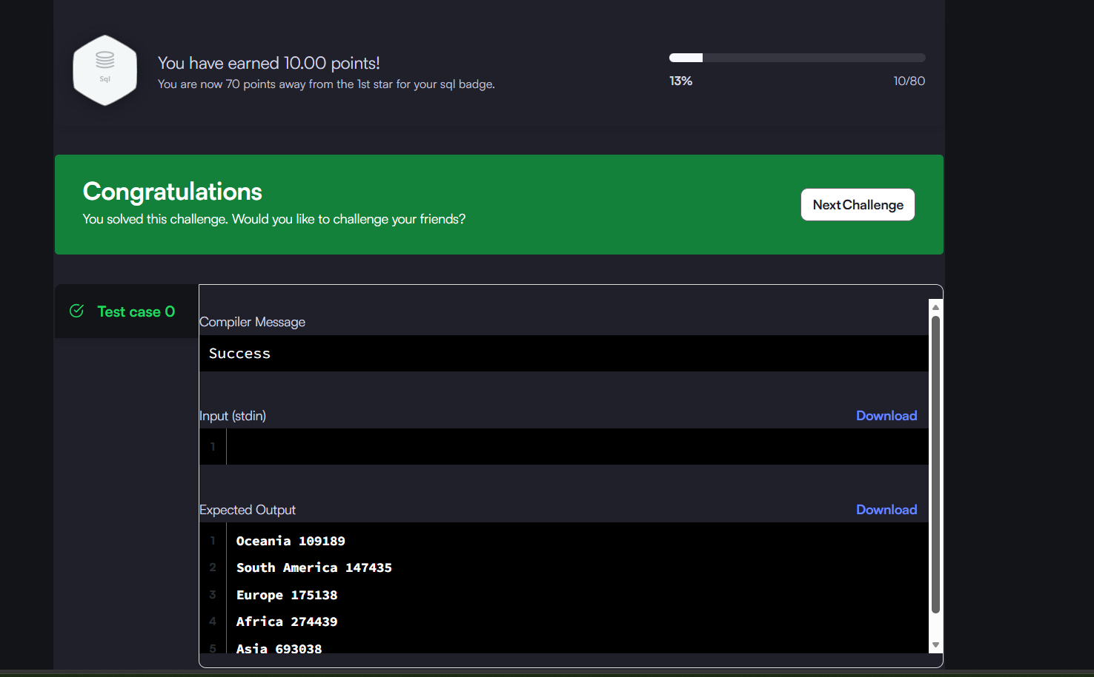

- Last Person to Fit in the Bus https://leetcode.com/problems/last-person-to-fit-in-the-bus

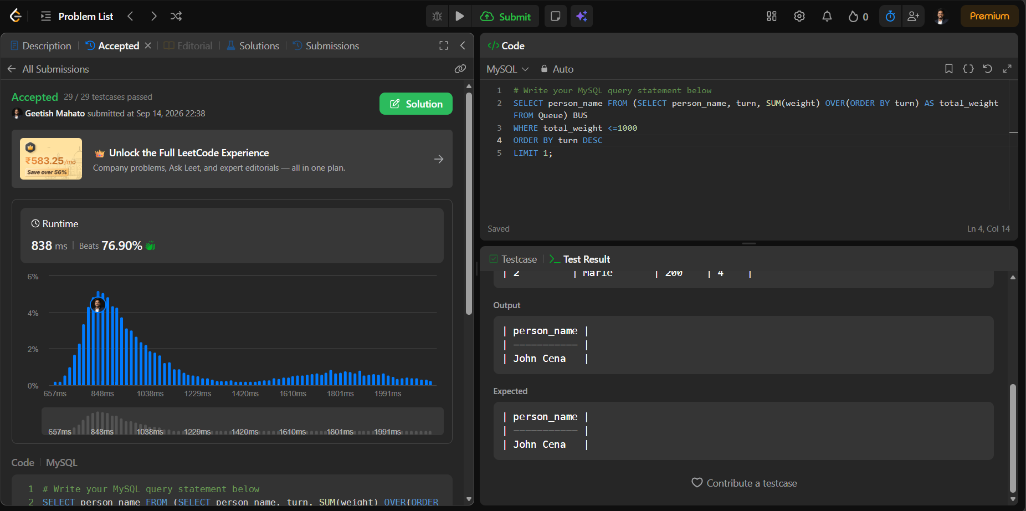
- Product Price at a Given Date https://leetcode.com/problems/product-price-at-a-given-date
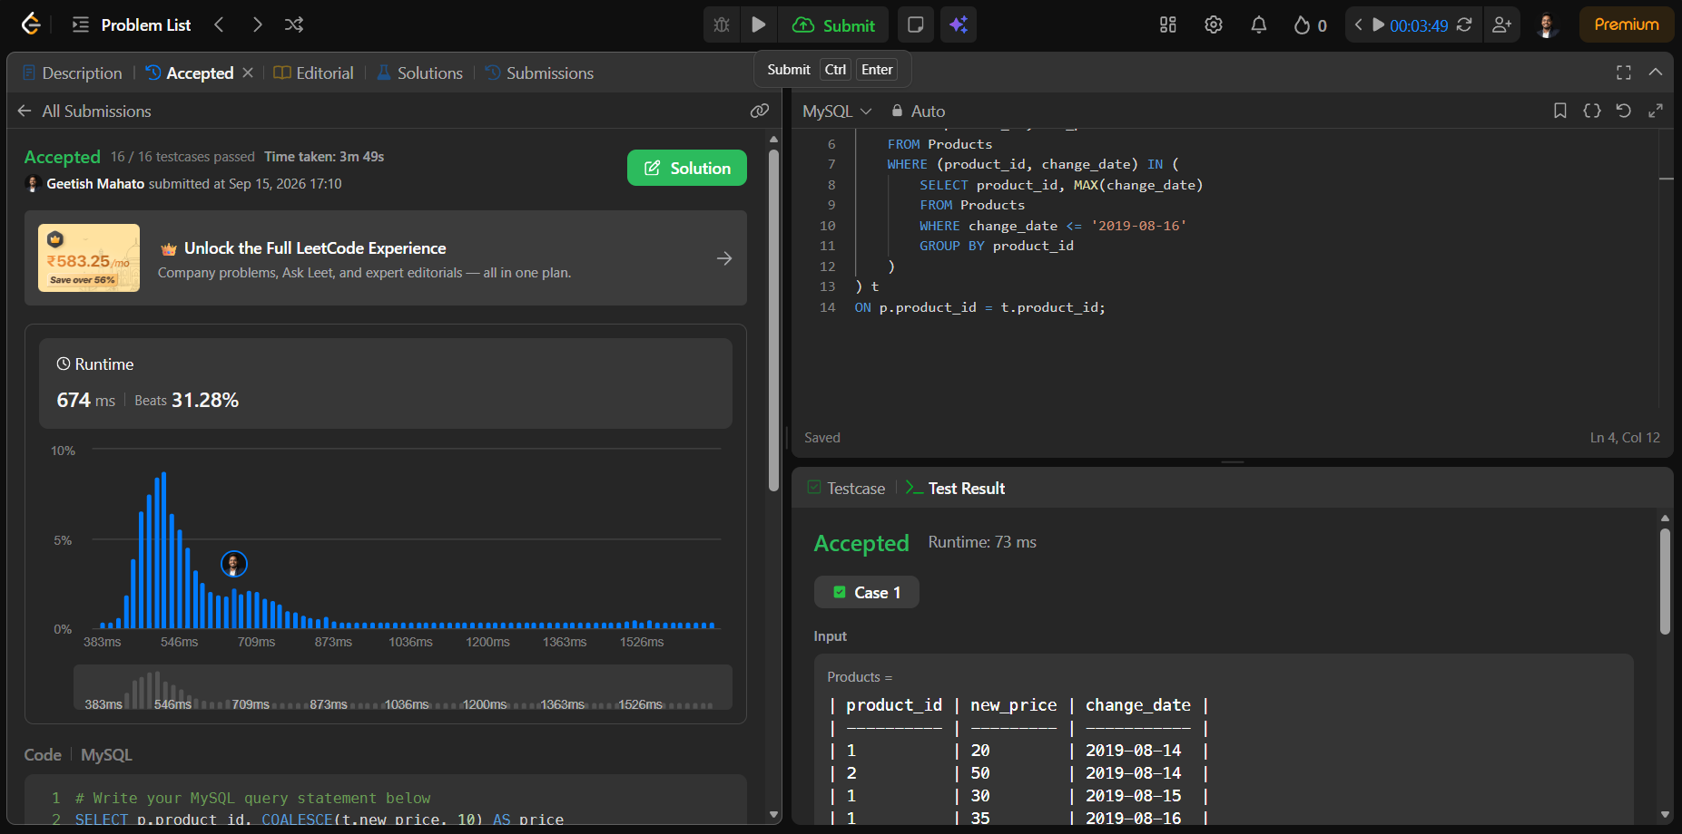
- Subquery Problems
181. Employees Earning More Than Their Managers https://leetcode.com/problems/employees-earning-more-than-their-managers/
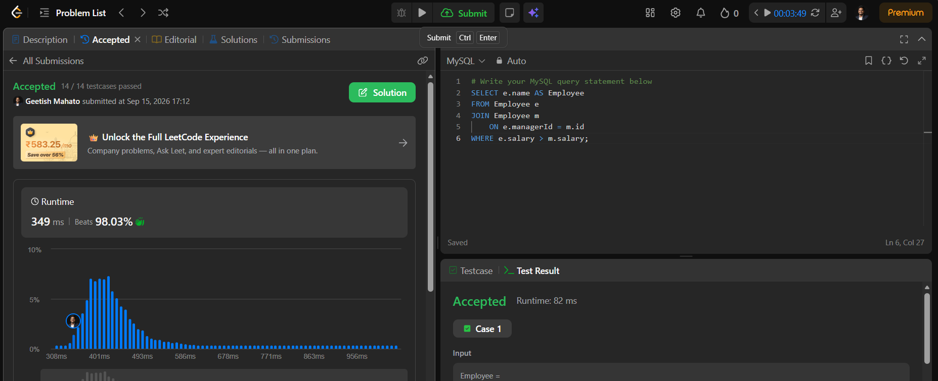

183. Customers Who Never Order https://leetcode.com/problems/customers-who-never-order/
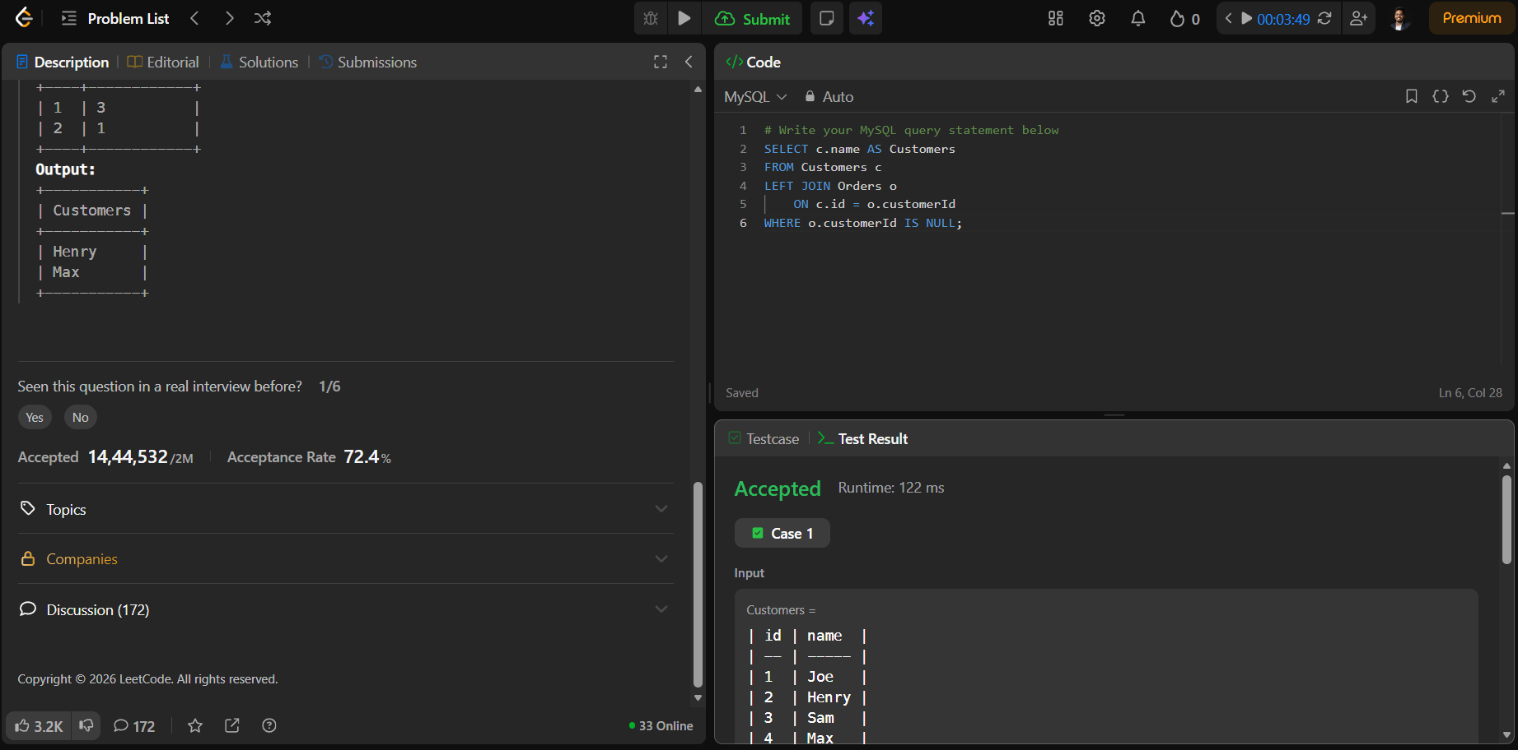
197. Rising Temperature https://leetcode.com/problems/rising-temperature/
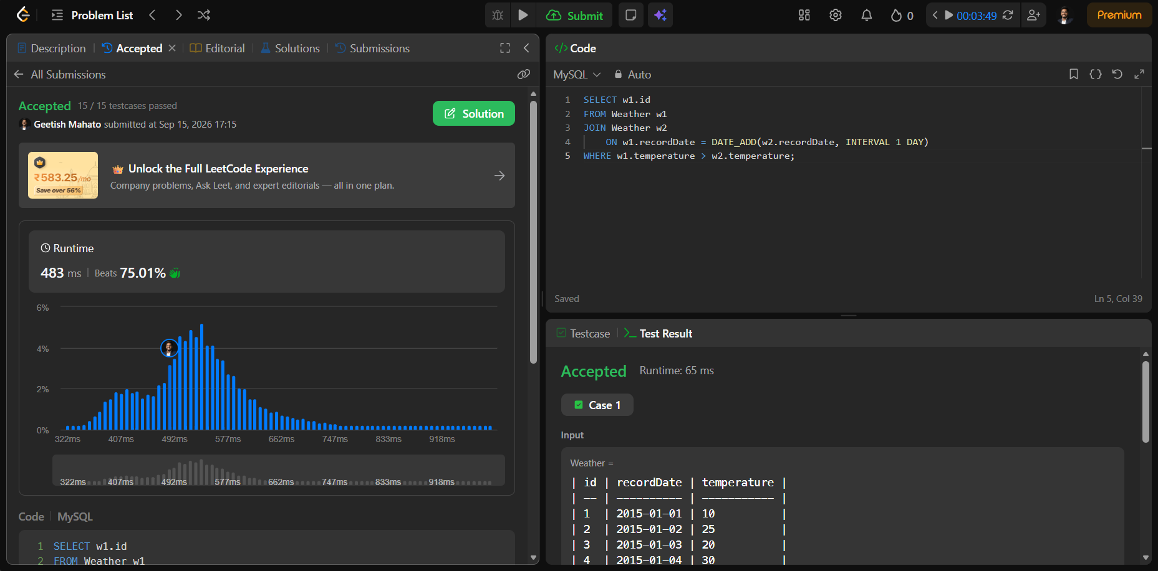
607. Sales Person https://leetcode.com/problems/sales-person/
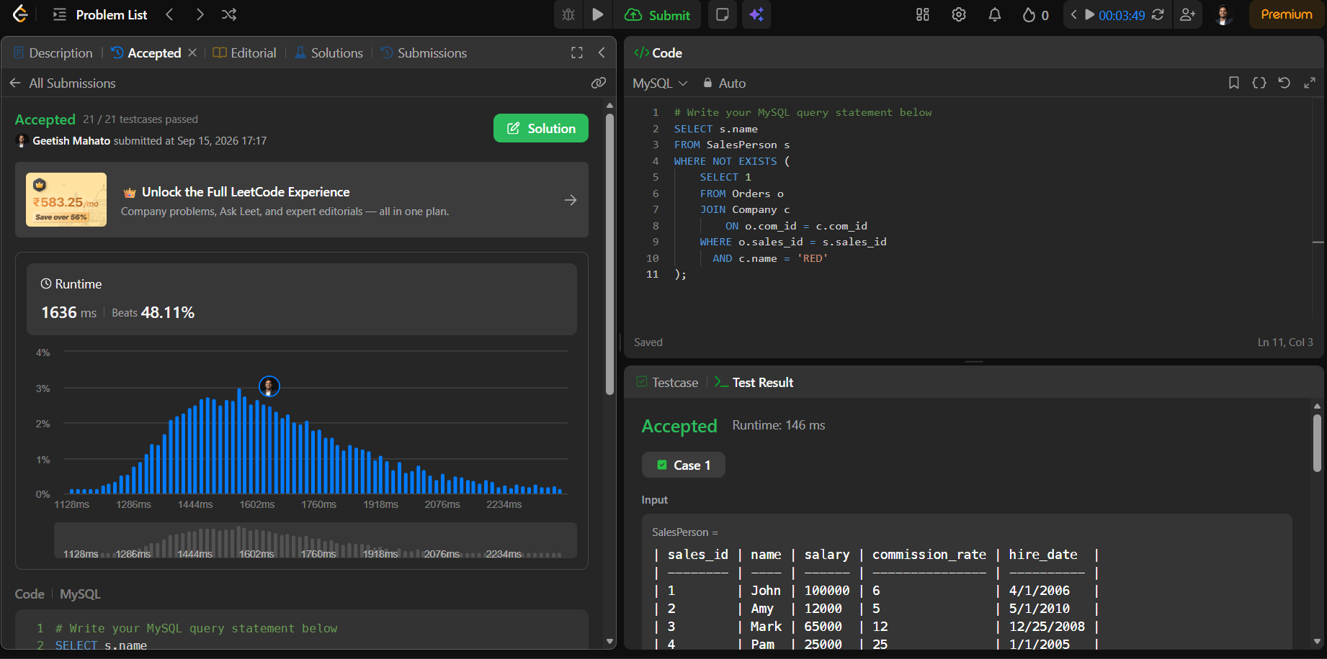
180. Consecutive Numbers https://leetcode.com/problems/consecutive-numbers/
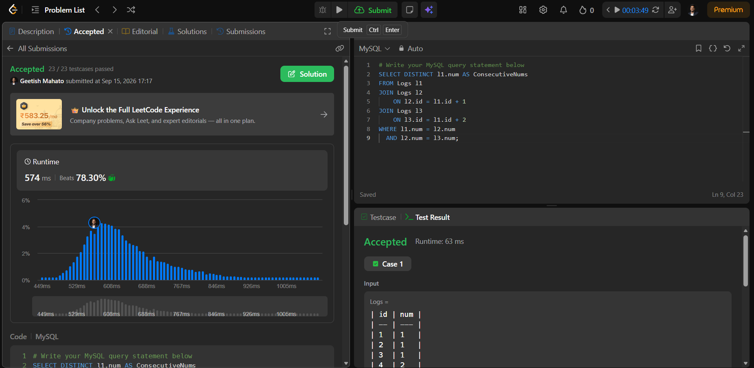
175. Combine Two Tables https://leetcode.com/problems/combine-two-tables/
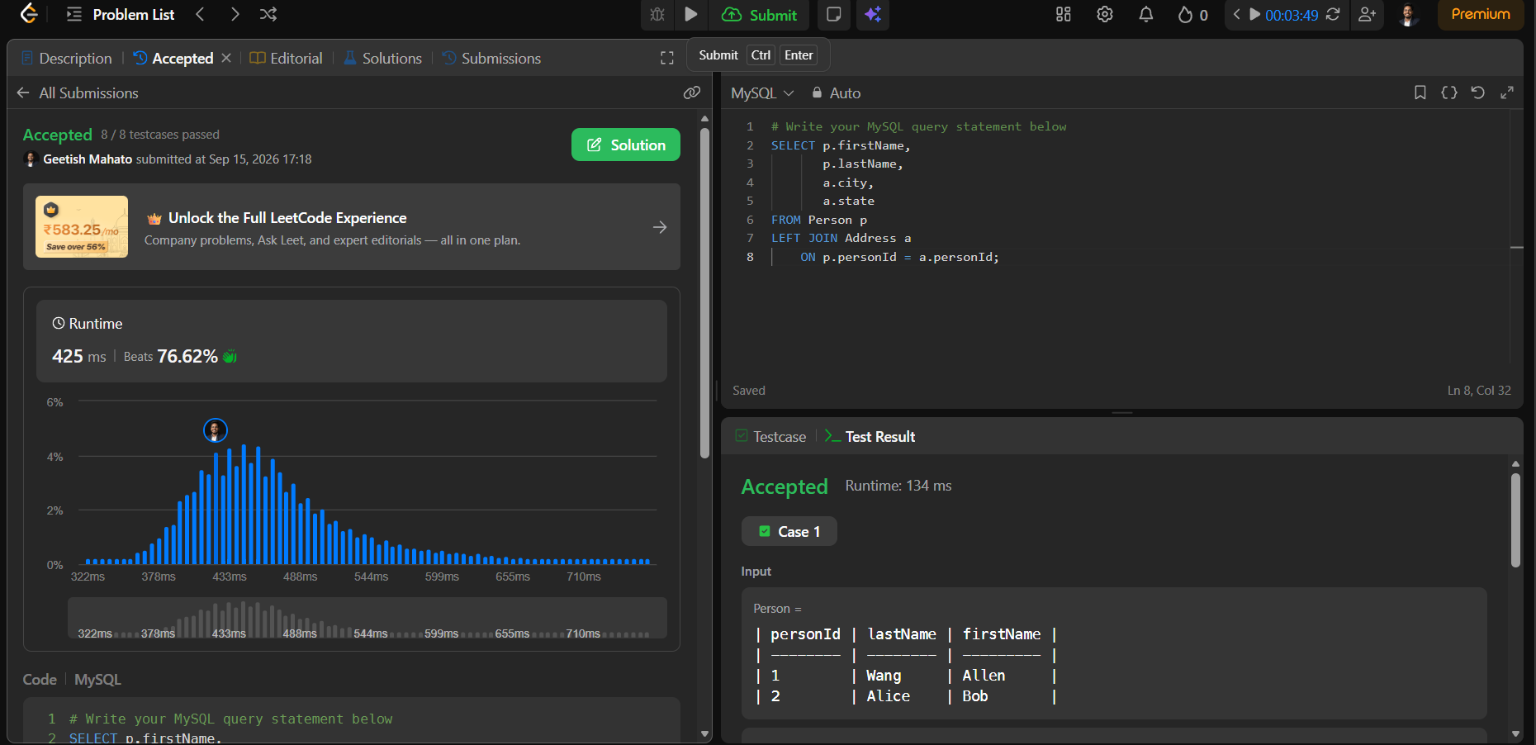
178. Rank Scores https://leetcode.com/problems/rank-scores/
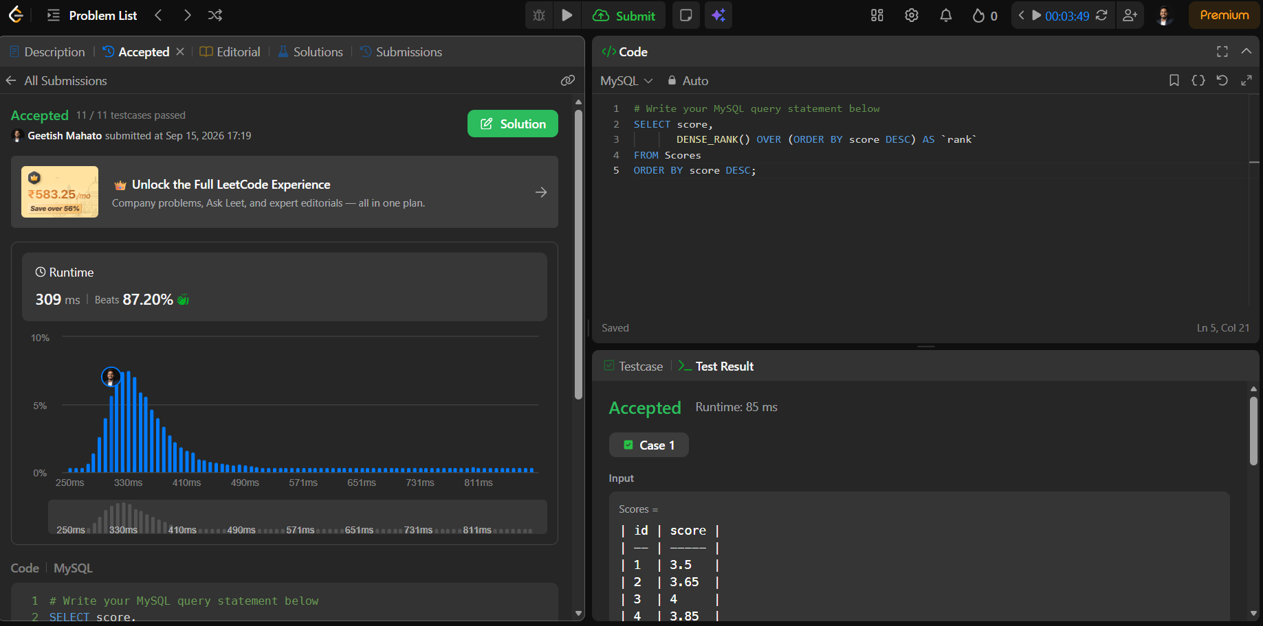
570. Managers with at Least 5 Direct Reports https://leetcode.com/problems/managers-with-at-least-5-direct-reports
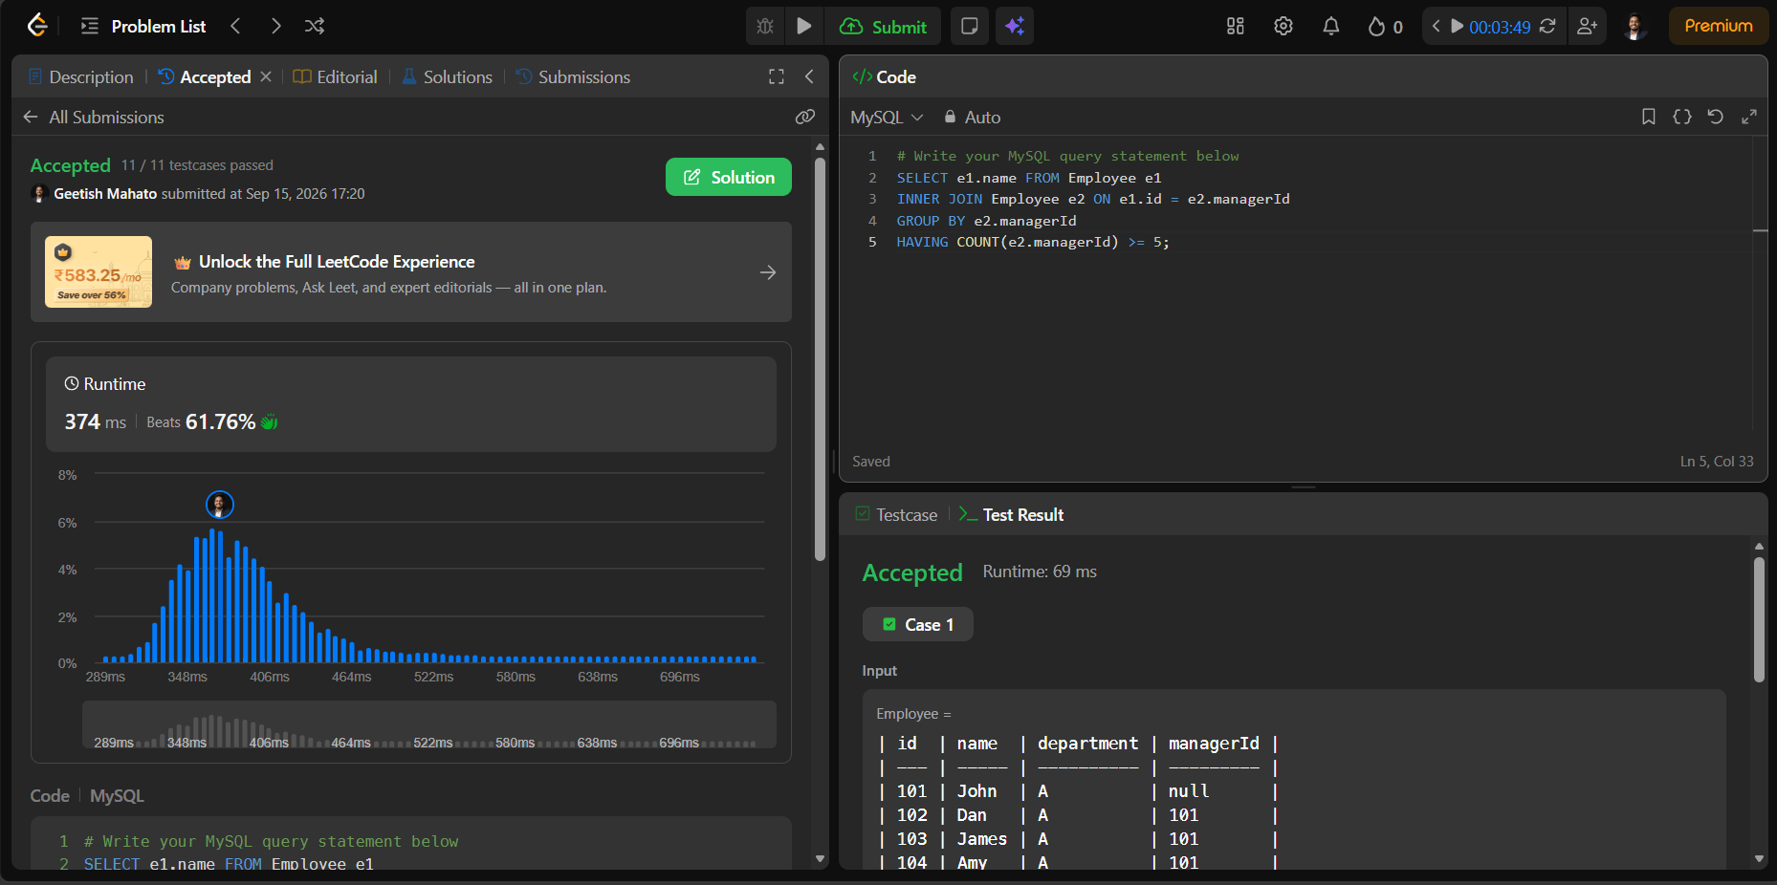
196. Delete Duplicate Emails https://leetcode.com/problems/delete-duplicate-emails/
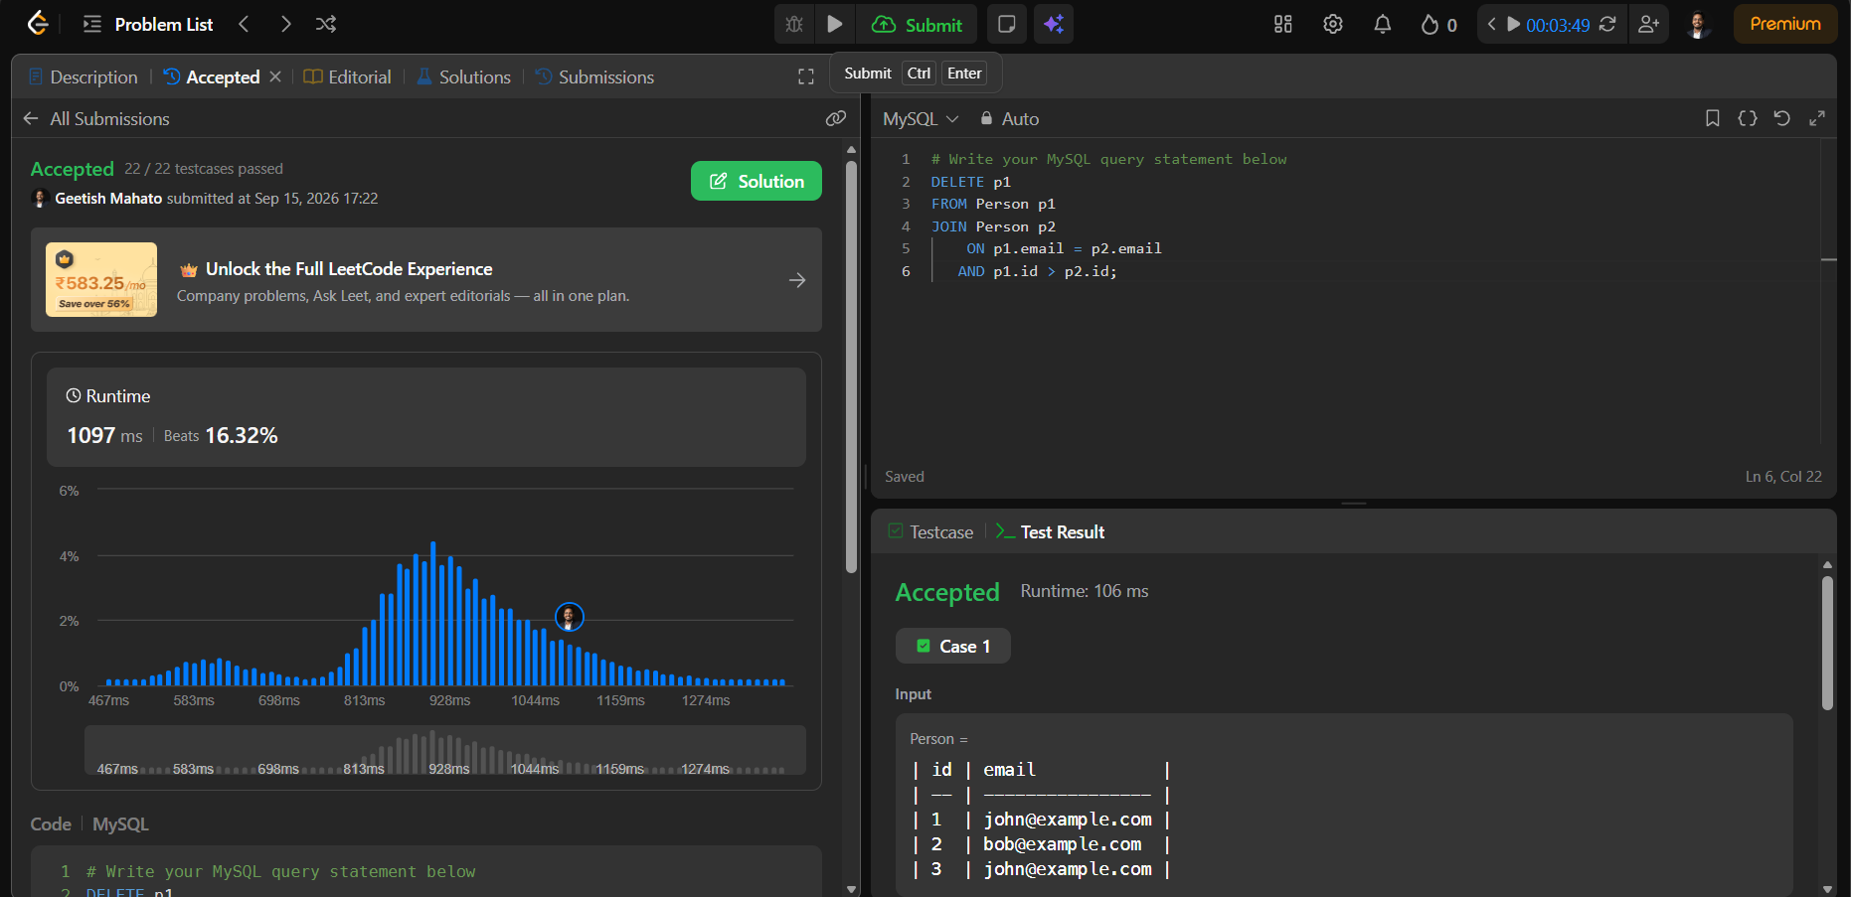
1204. Last Person to Fit in the Bus https://leetcode.com/problems/last-person-to-fit-in-the-bus/
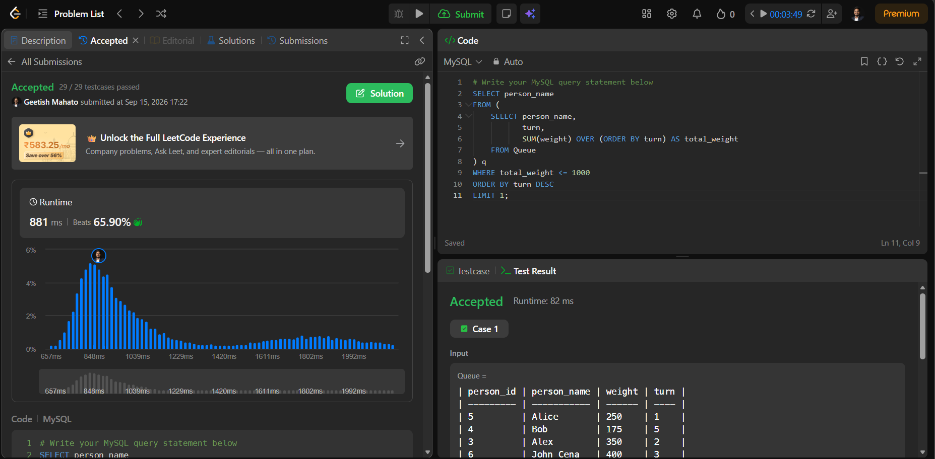
176. Second Highest Salary https://leetcode.com/problems/second-highest-salary
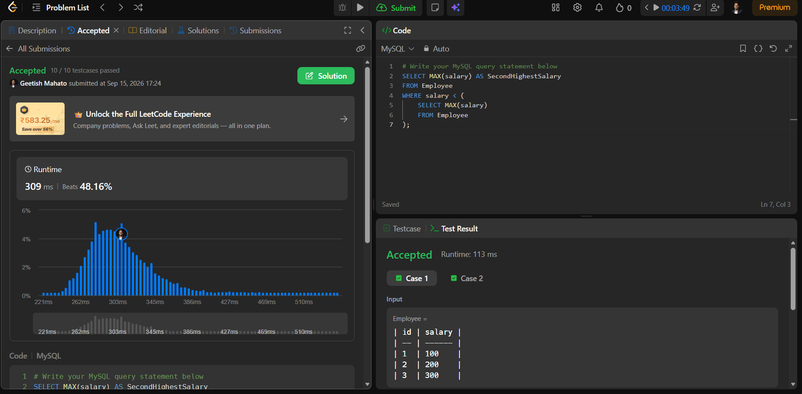

CDAC Admission Process Case Study
- Design database for CDAC Admission System.
  - Create appropriate tables and insert sample records.
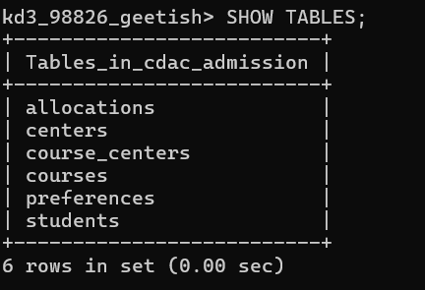

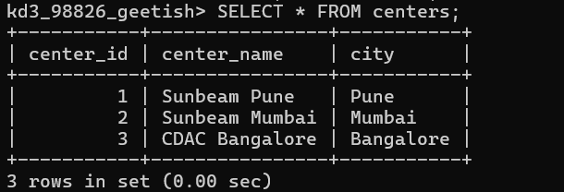
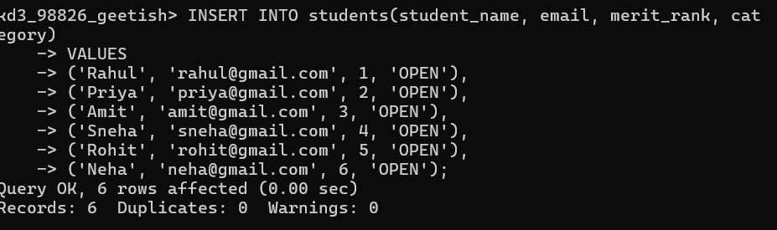

  - Write a Stored Procedure for Round1 allocation.
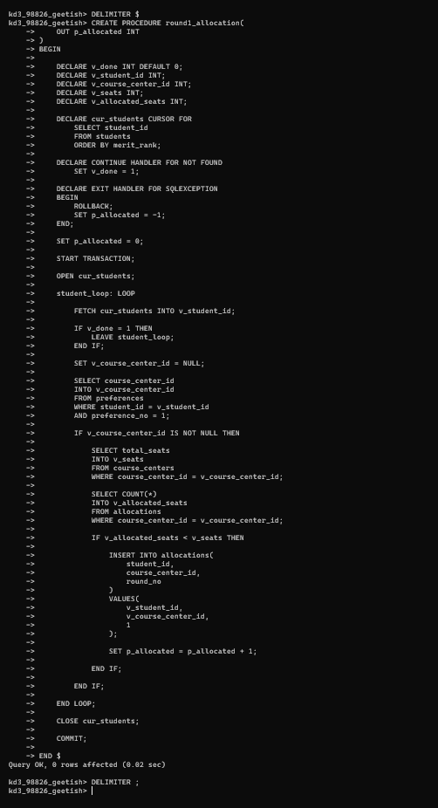
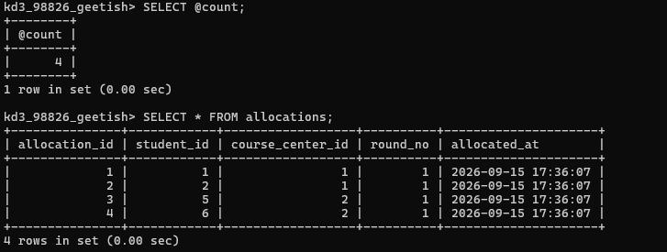
  - Write a Stored Procedure for Round2 allocation.
