- Write a query that uses a subquery to obtain all orders for the customer named Cisneros. Assume you do not know his customer number (cnum).
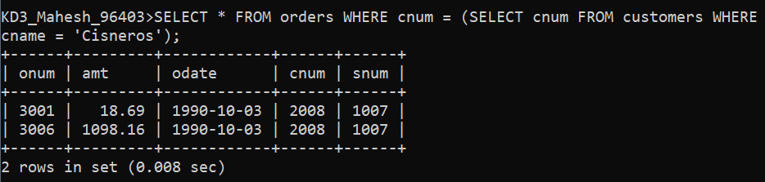

- Write a query to display the order amount, customer names and ratings of all customers where the amount is greater than the average amount from the orders table.
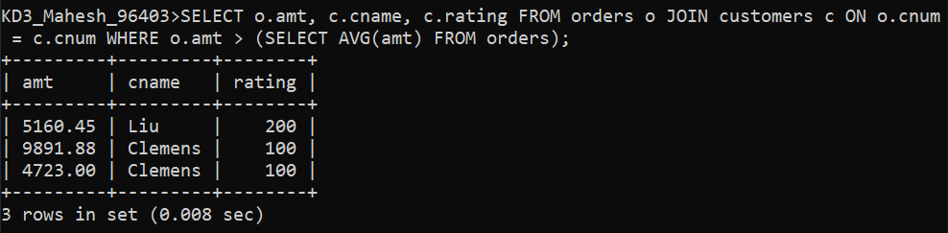

- Write a query that selects the total amount in orders for each salesperson for whom this total is greater than the amount of the largest order in the table.
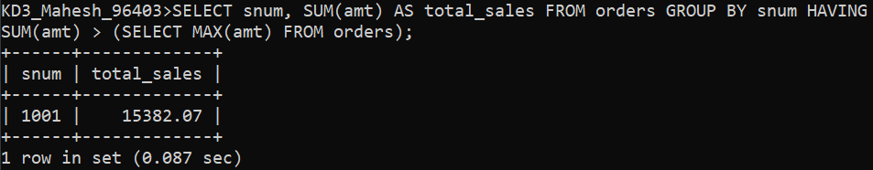

- Write a query that selects all customers whose ratings are equal to or greater than ANY of Serres’. (Hint: find all customers of serres salesperson).
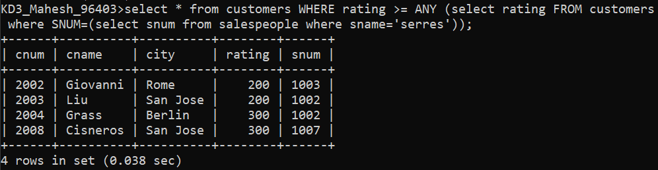

- Write a query that will find all salespeople who have no customers located in their city. (Hint: Choose the correct keyword ANY/ALL).
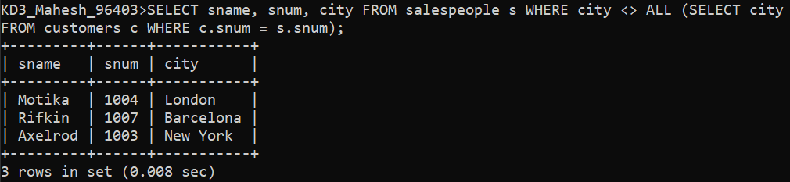

- Write a query that selects all orders for amounts greater than any for the customers in London.
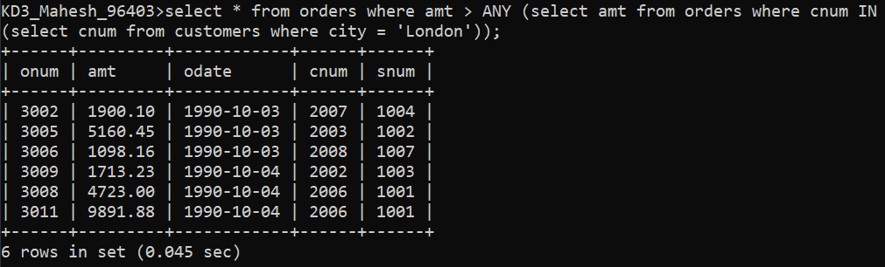

- Extract all the orders of Motika.
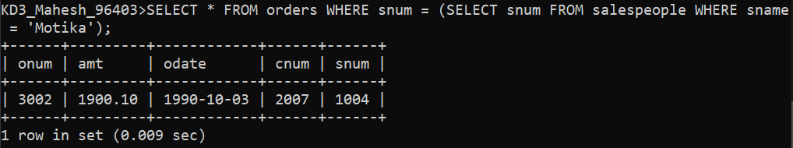

- Find all the orders of salespeople servicing customers in London.
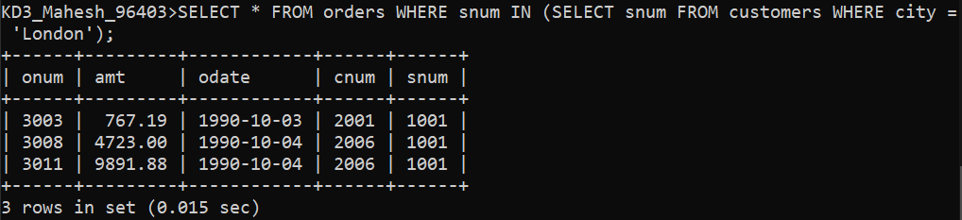

- Find names and numbers of all salesperson who have more than one customer.
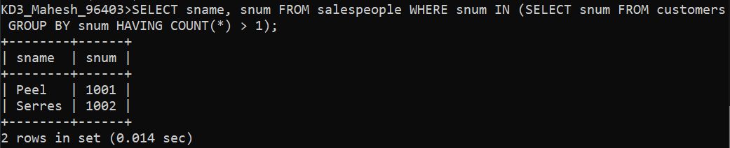

- Find salespeople number, name and city who have multiple customers. Display the count of customers as well.
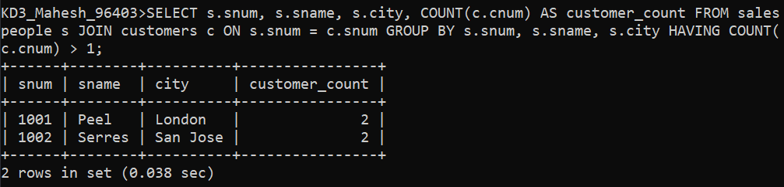

- Select customers who have a greater rating than any other customer in Rome.
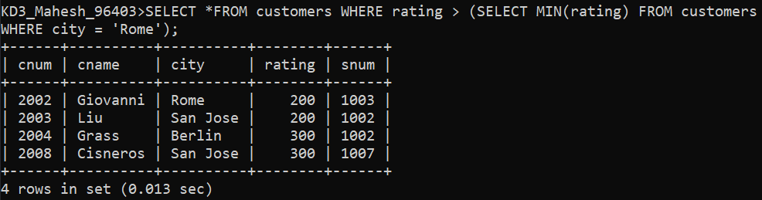

- Select all orders that had amounts that were greater that at least one of the orders from ‘1990-10-04’.
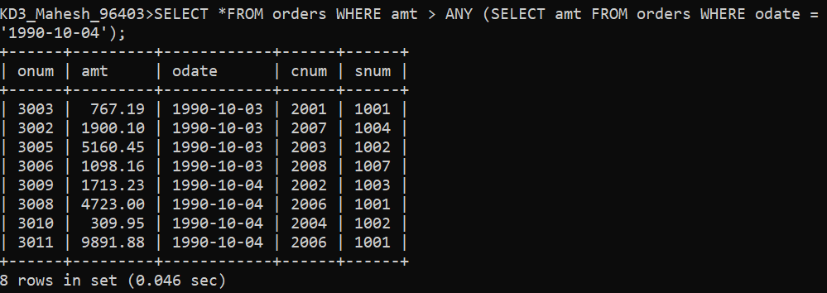

- Find all orders with amounts smaller than any amount for a customer in San Jose.
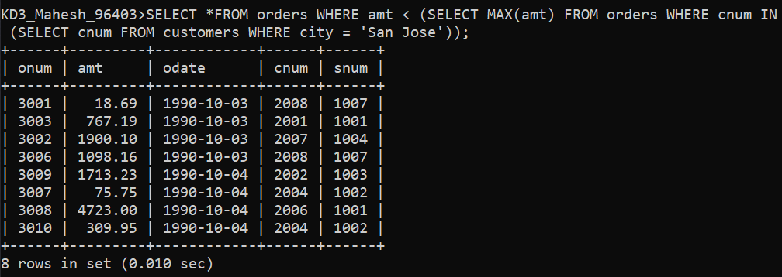

- Select those customers whose rating are higher than every customer in London.
