Views - Assignment 11

- Create a view that shows all of the customers who have the highest rating

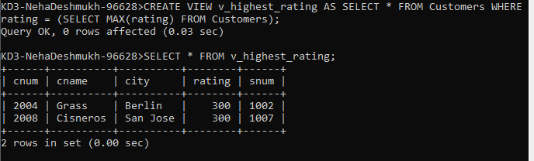

- Create a view that shows the number of salespeople in each city.

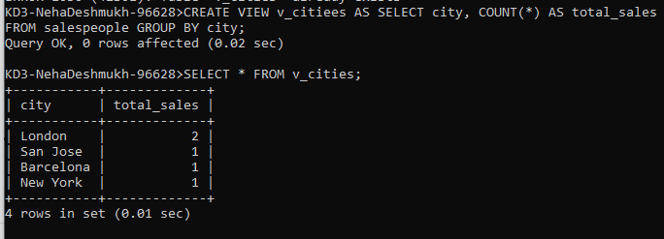

- Create a view that shows the average and total orders for each salesperson after his or her name. Assume all names are unique.

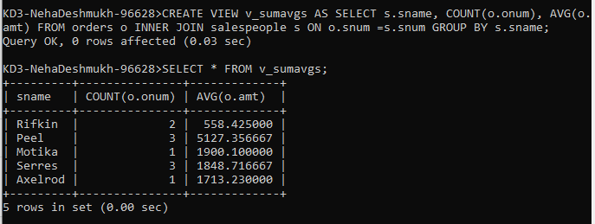

4) Create a view that shows each salesperson with multiple customers

