ASSIGNMENT 2

1.
Write a query that produces all rows from the Customers
table for which the salesperson’s number is 1001.

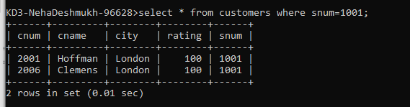

2.
Write a select command that produces the rating followed
by the name of each customer in San Jose.

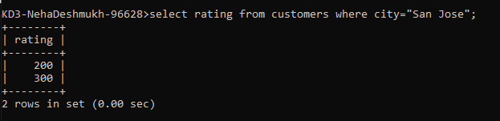

3.
Write a query that will produce the snum values of all
salespeople from the Orders table (with the duplicate values
suppressed).

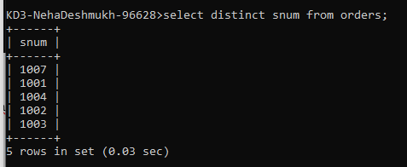

4.
Write a query that will display all the orders for amount
more than Rs. 1,000.

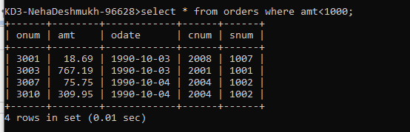

5.
Write a query that will give you the names and cities of
all salespeople in London with a commission above 0.10.

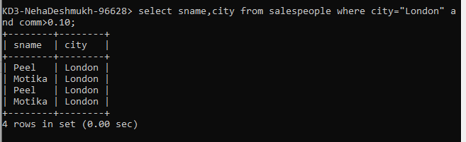

6. Write an SQL query that returns all customers who have a
rating greater than 100, along with the customers located in
Rome regardless of their rating.

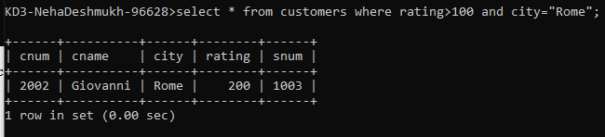

7. What will be the output from the following query?
Select * from Orders where (amt < 1000 OR NOT (odate = ‘1990-10-
03’ AND cnum > 2003));

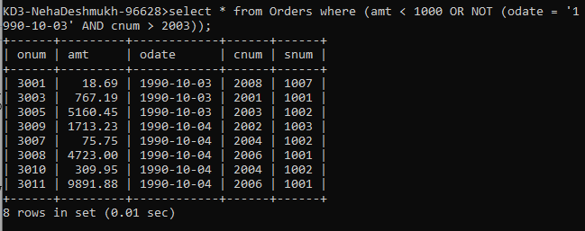

8. What will be the output of the following query?
Select * from Orders where NOT (odate = ‘1990-10-03’ OR snum
>1006) AND amt >= 1500;

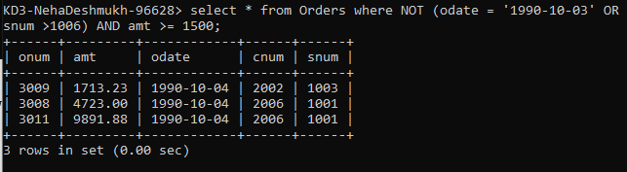

9.
What is a simpler way to write this query?
Select snum, sname, city, comm from Salespeople
Where (comm >= .12 AND comm <= .14);

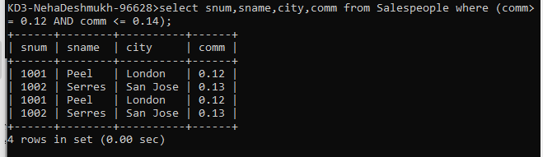

10. Write a query that selects all orders except those
with amount less than 100.

