1. Write a query that lists each order number followed by the name of
the customer who made the order.

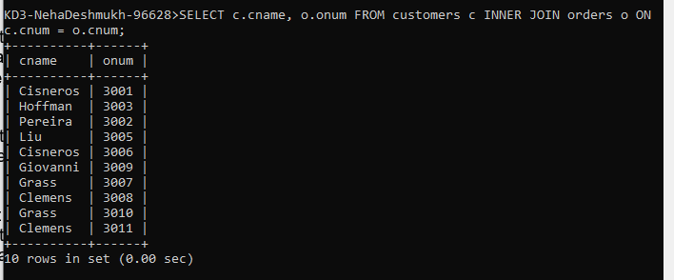

2. Write a query that gives the names of both the salesperson and
the customer for each order along with the order number.

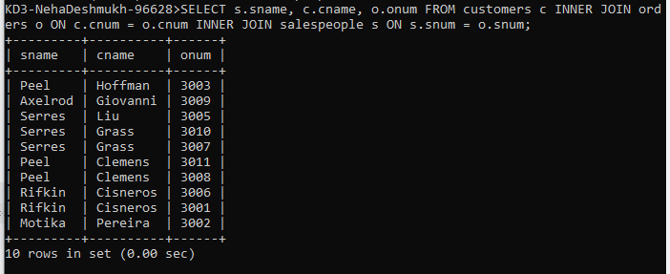

3.

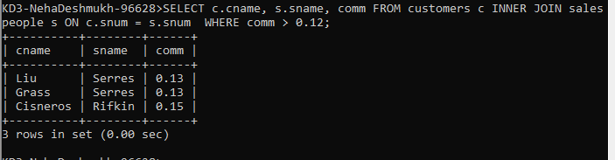

4. Write a query that calculates the commission earned by each
salesperson for orders placed by customers with a rating above 100.

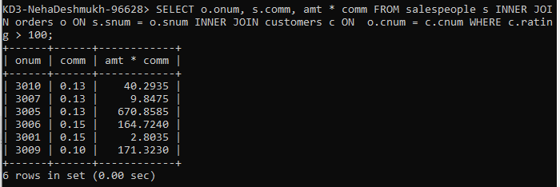

5. Write a query that produces all pairs of salespeople who are
living in the same city. Exclude combinations of salespeople with
themselves as well as duplicate rows with the order reversed.

