Database Technologies – Assignment 9
- Create an index that will enable a user to pull orders for ‘1990-10-03’ out of the Orders table quickly.
- 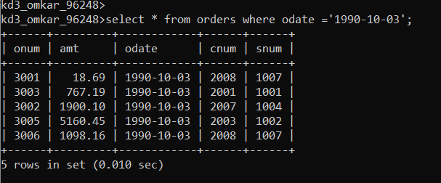
2.If the Orders table has already been created, how can you force the onum field to be unique (assume all current values are unique)?
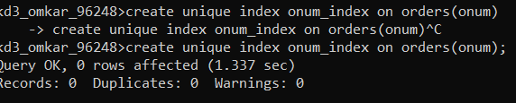
3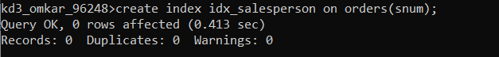

4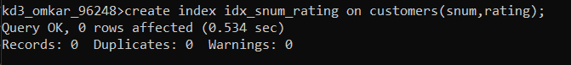
5. 