- Write a query that uses a subquery to obtain all orders for the customer named Cisneros. Assume you do not know his customer number (cnum).
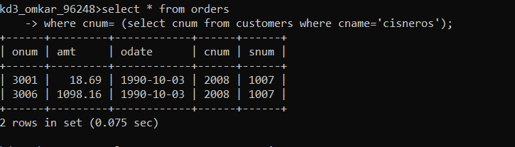
- 2. Write a query to display the order amount, customer names and ratings of all customers where the amount is greater than the average amount from the orders table. 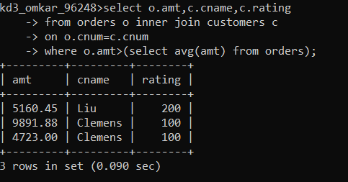
- Write a query that selects the total amount in orders for each salesperson for whom this total is greater than the amount of the largest order in the table.
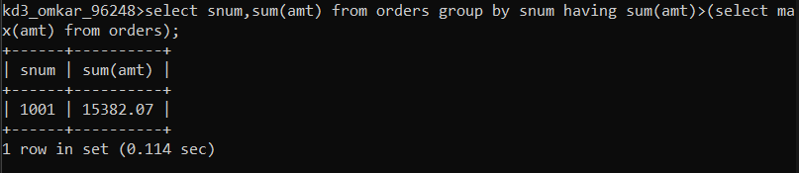
- Write a query that selects all customers whose ratings are equal to or greater than ANY of Serres’. (Hint: find all customers of serres salesperson).
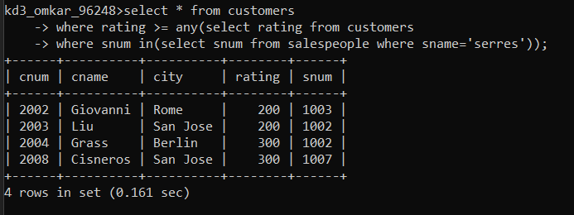
- rite a query that will find all salespeople who have no customers located in their city. (Hint: Choose the correct keyword ANY/ALL). 
 